HOW CHANGING TEMPERATURE AFFECTS BODY SIZE AND METABOLIC RATE OF ANIMAL SPECIES

By

KRISTINA RIEMER

A DISSERTATION PRESENTED TO THE GRADUATE SCHOOL  
OF THE UNIVERSITY OF FLORIDA IN PARTIAL FULFILLMENT  
OF THE REQUIREMENTS FOR THE DEGREE OF  
DOCTOR OF PHILOSOPHY

UNIVERSITY OF FLORIDA

2019

© 2019 Kristina Riemer

To my friends and family, who supported me through the ups and downs of doctoral work.

ACKNOWLEDGMENTS

I would like to thank my advisor, Dr. Ethan White, for his excellent and supportive mentorship through the process of my doctoral work. I could not have done this without his guidance. I additionally appreciate Dr. Bart De Stasio for introducing me to ecological research and encouraging me to pursue a graduate degree, Dr. Mark Bevelhimer for further research experiences and financial support, and Dr. Morgan Ernest for being an informal advisor whose door was always open.

A huge thanks goes out to all members of the Weecology lab, both past and present. In particular, Erica Christensen, Glenda Yenni, Joan Meiners, and Ellen Bledsoe for keeping me sane with many adventures in the forest, mountains, and desert and endless emotional support. The Carpentries community was another source of support and learning during this process, due to which I discovered my passion for teaching and using computational skills for scientific research.

I thank all of the support staff at both Utah State University and University of Florida for helping me navigate the bureaucratic intricacies of those institutions, especially Kami McNeil and Claire Williams. I also could not have done this without funding from the National Science Foundation and the Moore Foundation.

Lastly, endless gratitude to my family, especially many trips to Florida beaches with my sister, and my running club for their support while pounding the pavement and dirt.

TABLE OF CONTENTS

page

ACKNOWLEDGMENTS 4

LIST OF TABLES 7

LIST OF FIGURES 8

LIST OF ABBREVIATIONS 9

ABSTRACT 10

CHAPTER

1 GENERAL INTRODUCTION 12

2 NO GENERAL RELATIONSHIP BETWEEN MASS AND TEMPERATURE IN ENDOTHERMIC SPECIES 15

Introduction 15

Results 18

Discussion 19

Methods 24

Data 24

Analysis 28

3 TEMPORAL RESPONSES OF MAMMAL BODY SIZE TO INCREASING TEMPERATURE 35

Introduction 35

Methods 37

Datasets 37

Analysis 39

Results 40

Discussion 40

4 BODY SIZE SHIFTS INFLUENCE EFFECTS OF INCREASING TEMPERATURES ON ECTOTHERM METABOLISM 49

Introduction 49

Methods 52

Data 52

Metabolic Rate Calculations 53

Compensation Mass 55

Metabolic Rates Comparisons 55

Linear Mixed Model 57

Results 58

Compensation Mass 58

Metabolic Rates Comparison 59

Linear Mixed Model 60

Discussion 60

5 CONCLUSIONS 71

APPENDIX

A SUPPLEMENTAL FIGURES FOR CHAPTER 2 73

B SUPPLEMENTAL TABLES AND FIGURES FOR CHAPTER 3 111

C SUPPLEMENTAL FIGURES FOR CHAPTER 4 181

LIST OF REFERENCES 189

BIOGRAPHICAL SKETCH 201

LIST OF TABLES

Table page

1-1 Table captions go at the top of the table but should not be part of the table itself. 16

1-2 The best practice is to place Tables and Figures at the end of the Chapter. 17

1-3 Tables that can’t fit on a single page must be split across two of more pages. 19

2-1 Table captions go at the top of the table but should not be part of the table itself. 25

2-2 The best practice is to place Tables and Figures at the end of the Chapter. 26

2-3 Tables that can’t fit on a single page must be split across two of more pages. 28

3-1 Table captions go at the top of the table but should not be part of the table itself. 34

3-2 The best practice is to place Tables and Figures at the end of the Chapter. 35

3-3 Tables that can’t fit on a single page must be split across two of more pages. 37

LIST OF FIGURES

Figure page

1-1 Figure numbers take the form of Chapter number-Figure number and the figure caption uses the style 014 Figure Caption. 16

1-2 Multi-part figures should be clearly labeled, without punctuation. And have a description of the whole figure as the first part of the caption. 17

1-3 There should be a space between a figure and the figure caption, while the Table caption sits right on top of the Table. 20

2-1 Figure numbers take the form of Chapter number-Figure number and the figure caption uses the style 014 Figure Caption. 25

2-2 Multi-part figures should be clearly labeled, without punctuation. And have a description of the whole figure as the first part of the caption. 26

2-3 There should be a space between a figure and the figure caption, while the Table caption sits right on top of the Table. 29

3-1 Figure numbers take the form of Chapter number-Figure number and the figure caption uses the style 014 Figure Caption. 34

3-2 Multi-part figures should be clearly labeled, without punctuation. And have a description of the whole figure as the first part of the caption. 35

3-3 There should be a space between a figure and the figure caption, while the Table caption sits right on top of the Table. 38

LIST OF ABBREVIATIONS

|  |  |
| --- | --- |
| Word to be defined | Write the definition here. Do not put any hard carriage returns in the definition and it will wrap like this automatically. When you are done with the definition, press the “Tab” key once and you will advance to the next cell |
| Next word | And the list continues. This is actually a table with no boarders and gives the effect of two separate columns so the definitions can wrap in their column and the words (or phrases) to be defined can wrap in their column as well. |
| Another word | Remember to use a tab between the abbreviations and the definitions. A Tab will also advance you to the next line of the Table and will generate a new line if you hit “Tab” in the last cell of the table. Use the “Borders” button in the “Paragraph” section of the “Home” tab to show the cells of the table available, just remember to turn them off when you’re done. |

Abstract of Dissertation Presented to the Graduate School  
of the University of Florida in Partial Fulfillment of the  
Requirements for the Degree of Doctor of Philosophy

HOW CHANGING TEMPERATURE AFFECTS BODY SIZE AND METABOLIC RATE OF ANIMAL SPECIES

By

Kristina Riemer

May 2019

Chair: Ethan White

Major: Wildlife Ecology and Conservation

Climate change will have drastic impacts on ecological systems. A foundational component of these systems are species traits, which are known to be sensitive to changing abiotic conditions. Body size and metabolic rate in animal species, in particular, are predicted to decrease and increase, respectively, due to warming global temperatures. Understanding how these traits will change broadly across most species and systems is necessary to determine the cascading effects of these changes on ecosystems. In order to address this, I first determined how common it is for endothermic species to be smaller in warmer conditions, which has long been accepted knowledge. Contrary to this expectation, I found that the body size of most endothermic species does not have a strong relationship with temperature. To further investigate the nature of this relationship within a climate change context, I next examined the temporal response of mammal body size to warming temperatures in several locations, and again found that there was no directional change in the size of these endotherms. Lastly, it is well-supported that ectothermic species do decrease in size in response to warmer temperatures, which results in lower metabolic rates. I compared this indirect effect of temperature on metabolic rate with the direct effect of temperature and found that ectothermic species, while smaller body sizes lower metabolic rates somewhat, warmer global temperatures will result in metabolic rates increasing.

CHAPTER 1

GENERAL INTRODUCTION

The changing climate of the planet will have diverse impacts on natural systems, especially increasingly warmer global temperatures (IPCC, 2014). Species traits are an aspect of these systems that will be affected by shifting temperatures. Traits of particular interest for animal species with respect to this abiotic variable changing are body size and metabolic rate, which are important determinants of the resource use and energy flux through ecological communities (Sibly et al., 2012). While we know how these traits will respond to temperature change for certain animal species (e.g., Ohlberger et al., 2011), it is crucial to know how broadly these patterns hold across most species to be able to predict how species traits will change. These changes will have substantial cascading effects on ecological systems, from the population level (Ozgul et al., 2010) up to the ecosystem (Savage, 2004). It has only recently become possible to address this open-ended question effectively, as increasingly large amounts of ecological data, and the tools to deal with these, become accessible (Hampton et al., 2013). Such data-intensive approaches are used in this dissertation to address several aspects of determining the generality of animal species mass response to temperature change from climate change.

In Chapter 2, I determine how temperature affects body size within many endothermic species. There is a widely held ecological “rule” that individuals within a species tend to be smaller in warmer environments. The observation of this negative temperature-mass relationship for endothermic species has been termed Bergmann’s rule (Bergmann, 1847). Though there has been no substantial support for any of the mechanisms proposed for this rule (Watt et al., 2010) there has been an accumulation of empirical evidence related to the pattern. These studies have limited applicability for determining how generally a negative temperature-mass relationship is among endothermic species because most have used latitude as a proxy for temperature (e.g., Boyer et al., 2010) and document the relationship in only one or a few species at a time (e.g., Langvatn and Albon, 1986). I address these limitations by using a large compilation of museum records in combination with extensive temperature data to determine the strength and direction of the relationship between intraspecific mass and temperature for nearly 1,000 bird and mammal species (Riemer et al., 2018).

In Chapter 3, I expand upon this work by determining how mass varies in endothermic species with increasing temperatures across time explicitly. Bergmann’s rule primarily concerns intraspecific mass variation across space, and has been extrapolated to apply similarly to mass variation across time, resulting in predictions that species will be smaller due to increasing global temperatures (Gardener et al., 2011; Sheridan and Bickford, 2011). While substituting spatial patterns for temporal patterns is done often in ecology due to data limitations, it is not always accurate (Fisher et al., 2010). In order to predict how climate change will affect species size, the temporal response of size to temperature has to be isolated. I use long-term time series of mammal communities at three sites, which resulted in over 125,000 individual body mass measurements, to determine if directional temperature change resulted in consistent shifts in species masses.

In Chapter 4, I investigate how a negative temperature-mass relationship affects metabolic rates of ectothermic species. Unlike for endotherms, there is mechanistic evidence for ectothermic species begin smaller in warmer environments, which is often referred to as the size-temperature rule (Forster and Hirst, 2012). Specifically, temperature affects growth rates differently than development rates, impacting adult body masses of ectotherms (Walters and Hassall, 2006). There is additionally a well-established positive relationship between temperature and metabolic rates in ectotherms, which is due to biochemical reaction rates (Brown et al., 2004). Therefore, ectothermic species are expected to have higher metabolic rates due to the direct effect of warmer temperatures, but warmer temperatures will also result in individuals with smaller masses and therefore decreased metabolic rates. In order to predict how climate change will impact metabolic rates, these relationships have to be considered together. In order to determine the relative impacts of the direct and indirect effects of temperature on metabolic rates, we estimated how increasing temperatures affect the metabolic rates of over 100 ectothermic species, both with and without the accompanying size shift, using experimental data (Riemer et al., 2018). Whether metabolic rates increase or decrease for ectothermic species will have varying implications for energy flows in ecological systems.

CHAPTER 2

NO GENERAL RELATIONSHIP BETWEEN MASS AND TEMPERATURE IN ENDOTHERMIC SPECIES

Introduction

Bergmann's rule describes a negative relationship between body mass and temperature across space that is believed to be common in endothermic species (Bergmann, 1847; Brown and Lee, 1969; Kendeigh, 1969; Freckleton et al., 2003; Carotenuto et al., 2015)[1]*. Many hypotheses have been proposed to explain this pattern (Blackburn et al., 1999; Ashton, 2002; Watt et al., 2010) including the heat loss hypothesis, which argues that the higher surface area to volume ratio of smaller individuals results in improved heat dissipation in hot environments (Bergmann, 1847). Though originally described for closely-related species (i.e., interspecific; Blackburn et al., 1999), the majority of studies have focused on the intraspecific form of Bergmann's rule (Rensch, 1938; Meiri, 2011) by assessing trends in individual size within a species (Langvatn and Albon, 1986; Gardner et al., 2009; Yom-Tov and Geffen, 2006). Bergmann's rule has been questioned both empirically and mechanistically (McNab, 1971; Geist, 1987; Huston and Wolverton, 2011; Teplitsky & Millien, 2014) but the common consensus from recent reviews is that the pattern is general (Ashton, 2002; Watt et al., 2011; Ashton et al., 2000; Meiri and Dayan, 2003).

It has recently been suggested that this negative relationship between mass and temperature could result in decreasing individual size across species in response to climate change (Sheridan and Bickford, 2011) and that this may be a “third universal response to warming” (Gardner et al., 2011). The resulting shifts in size distributions could significantly alter ecological communities (Brose et al., 2012), especially if the rate of size decrease varies among species (Sheridan and Bickford, 2011). While there is limited empirical research on body size responses to changes in temperature through time (but see Teplitsky and Millien, 2014; Smith et al., 1995; Caruso et al., 2014), the apparent generality of Bergmann's rule across space indicates the likelihood of a similar relationship in response to temperature change across time.

The generality of Bergmann's rule is based on many individual studies that analyze empirical data on body size across an environmental gradient (e.g., Langvatn and Albon, 1986; Barnett, 1977; Fuentes and Jaksic, 1979; Dayan et al., 1989; Sand et al., 1995) and reviews that compile and evaluate the results from these studies (Ashton, 2002; Watt et al., 2010; Meiri and Dayan 2003). Most individual studies of Bergmann's rule are limited by: 1) analyzing only one or a few species (e.g., Langvatn and Albon, 1986); 2) using small numbers of observations (e.g., Fuentes and Jaksic, 1979); 3) only including data at the small scales typical of ecological studies (e.g., Sand et al., 1995); 4) using latitude instead of directly assessing temperature (e.g., Barnett, 1977); and 5) focusing on statistical significance instead of the strength of the relationship (e.g., Dayan et al., 1989). The reviews tabulate the results of these individual studies and assess patterns in the direction and significance of relationships across species. Such aggregation of published results allows for a more general understanding of the pattern but, in addition to limitations of the underlying studies, the conclusions may be influenced by publication bias and selective reporting where studies or individual analyses that do not support Bergmann's rule are published less frequently (Koricheva et al., 2013).

Previous analyses of publication bias in the context of Bergmann’s rule have found no evidence for selective publication, which supports the idea that it is a general rule (Ashton, 2002; Meiri et al., 2004). However, two of the most extensive studies of Bergmann’s rule, which both used museum records to assess dozens of intraspecific Bergmann’s rule relationships simultaneously, found that the majority of species did not exhibit significant negative relationships between latitude and size (McNab, 1971; Meiri et al., 2004). As a result, understanding the generality of this ecophysiological rule and its potential implications for global change requires more extensive analysis.

A data-intensive approach to analyzing Bergmann's rule, evaluating the pattern using large amounts of broad scale data, has the potential to overcome existing limitations in the literature and provides a new perspective on the generality of the intraspecific form of Bergmann's rule. Understanding the generality of the temperature-mass relationship has important implications for how size will respond to climate change. We use data from Vertnet (Constable et al., 2010), a large compilation of digitized museum records that contains over 700,000 globally distributed individual-level size measures, to evaluate the intraspecific relationship between temperature and mass for 952 mammal and bird species. The usable data consist of 273,901 individuals with an average of 288 individuals per species, with individuals of each species spanning an average of 75 years and 34 latitudinal degrees. This approach reduces or removes many of the limitations to previous approaches and the results suggest that Bergmann's rule is not a strong or general pattern.

Results

Most of the species in this study showed weak non-significant relationships between temperature and mass (Figures 2-1 and 2-2). The distribution of correlation coefficients was centered near zero with a mean correlation coefficient of -0.05 across species (Figure 2-2A). Relationships for 79% of species were not significantly different from zero based on false discovery rate controlled p values and associate z scores, while 14% of species' relationships were significant and negative and 7% were significant and positive (Figures 2-2A and A-1). Temperature explained less than 10% of variation in mass (i.e., -0.316 < r < 0.316) for 87% of species, indicating that temperature explained very little of the observed variation in mass for these species (Figure 2-2A).

The weak, non-directional intraspecific relationships indicated by the distribution of correlation coefficients are consistent across taxonomic groups and temporal lags. Mean correlation coefficients for both endothermic classes are -0.006 and -0.065, for mammals and birds respectively (Figure 2-2B). Similarly, correlation coefficient distributions were approximately centered on zero for all of the 30 orders analyzed (-0.2 < < 0.003 for orders with more than 10 species; Figures 2-3 and A-2), or for migrant or nonmigrant bird species (Figure A-3). Correlation coefficient distributions for temperature-mass relationships using lagged temperatures were centered around zero like those using temperature from the collection year (Figures 2-4 and A-4), indicating that there was not a temporal lag effect on the response of species' masses to temperature. Correlation coefficients did not vary systematically by sample size (Figure 2-5A), extent of variation in temperature or mass (Figure 2-5B,C), species' average mass (Figure 2-5D), or species' average latitude (Figure 2-5E). While temperature is considered the actual driver, some studies use latitude as a proxy when evaluating variation in size (Bergmann, 1847; Stillwell, 2010) Using latitude, the mean correlation coefficient was -0.05 with no statistically significant latitude-mass relationship for 71% of species (Figure A-5), while the respective values for temperature were -0.05 and 79% (Figure 2-2A). Results were robust to a variety of decisions and stringencies about how to filter the size (Figures A-6 and A-7) and species data (Figure A-8).

Discussion

In contrast to conventional wisdom and several recent review papers, our analysis of 952 species shows little to no support for a negative intraspecific temperature-mass relationship that is sufficiently strong or common to be considered a biogeographic rule. Three quarters of bird and mammal species show no significant change in mass across a temperature gradient and temperature explained less than 10% of intraspecific variation in mass for 87% of species (Figure 2-2A). This was true regardless of taxonomic group (Figures 2-2 and 2-3), temporal lag in temperature (Figure 4), species' size, location, or sampling intensity or extent (Figure 2-5). These results are consistent with two previous studies that examined museum specimen size measurements across latitude. The first study showed that 22 out of 47 North American mammal species studied had no relationship between latitude and length, and 10 of the 25 significant relationships were opposite the expected direction (McNab, 1971). The second found a similar proportion of non-significant results (42/87), but a lower proportion of significant relationships that opposed the rule (9/45) for carnivorous mammals (Meiri et al., 2004). While more species had significant negative relationships than positive in both our study and these two museum-based studies, in all cases less than half of species had significant negative correlations (14 – 41%). In combination with these two smaller studies, our results suggest that there is little evidence for a strong or general Bergmann's rule when analyzing raw data instead of summarizing published results.

Our results are inconsistent with recent reviews, which have reported that the majority of species conform to Bergmann's rule (Ashton, 2002; Watt et al., 2010; Meiri and Dayan, 2003). While these reviews included results that were either non-significant or opposite of Bergmann's rule, the proportion of significant results in support of Bergmann's rule was higher and therefore resulted in conclusions that supported the generality of the temperature-mass relationship. Generalizing from results in the published literature involves the common challenges of publication bias and selective reporting (Koricheva et al., 2013). In addition, because the underlying Bergmann's rule studies typically report minimal statistical information, often providing only relationship significance or direction instead of p-values or correlation coefficients (Meiri and Dayan, 2003), proper meta-analyses and associated assessments of biological significance are not possible. While several reviews found no evidence for publication bias using limited analyses (Ashton, 2002; Meiri et al., 2004), the notable differences between the conclusions of our data-intensive approach and those from reviews suggests that publication bias in papers about Bergmann's rule warrants further investigation. These differences also demonstrate the value of data-intensive approaches in ecology for overcoming potential weaknesses and biases in the published literature. Directly analyzing large quantities of data from hundreds of species allows us to assess the generality of patterns originally reported in smaller studies while avoiding the risk of publication bias. This approach also makes it easier to integrate other factors that potentially influence size into future analyses. The new insight gained from this data-intensive approach demonstrates the value of investing in large compilations of ecologically-relevant data (Hampton et al., 2013) and the proper training required to work with these datasets (Hampton et al., 2017).

Our analyses and conclusions are limited to the intraspecific form of Bergmann’s rule. This is the most commonly studied and well-defined form of the relationship and the one most amenable to analyses using large compilations of museum data. Difficulty in interpreting Bergmann’s original formulation has resulted in an array of different ideas and implementations of interspecific analyses (Blackburn et al., 1999; Meiri and Thomas, 2007; Watt et al., 2010; Meiri, 2011). The most common forms of these interspecific analyses involve correlations between various species-level size metrics and environmental measures and are conducted at various taxonomic levels from genus to class (e.g., Clauss et al., 2013; Diniz-Filho, 2007; Boyer et al., 2010; Blackburn and Gaston, 1996). Efforts to apply data-intensive approaches to the interspecific form of this relationship will need to address the fact that occurrence records are not evenly distributed across the geographic range of species and determine how the many interpretations of interspecific Bergmann’s rule are related to one another and the biological expectations for interspecific responses to temperature.

The original formulation of Bergmann's rule, and the scope of our conclusions, apply only to endotherms. However, negative temperature-mass relationships have also been documented in ectotherms, with the pattern referred to as the size-temperature rule (Ray, 1960; Angilletta and Dunham, 2003). In contrast to the hypotheses for Bergmann's rule, which are based primarily on homeostasis (Gardner et al., 2011), the size-temperature rule in ectotherms is thought to result from differences between growth and development rates (Forster et al., 2011). The current version of Vertnet contained ectotherm size data for only seven species, which is not sufficient to complete a comprehensive analysis of the ectotherm size-temperature rule. Future work exploring the ectotherm size-temperature rule in natural systems using data-intensive approaches is necessary for understanding the generality of this rule in ectotherms, and data may be sought for this effort in the literature or via a coordinated effort by museums to continue digitizing size measurements for specimens.

A number of mechanisms have been suggested to explain why higher temperatures should result in lower body sizes, including heat loss, starvation, resource availability, migratory ability, and phylogenetic constraints (Blackburn et al., 1999). Most of the proposed hypotheses have not been tested sufficiently to allow for strong conclusions to be drawn about their potential to produce Bergmann's rule (Blackburn et al., 1999; Watt et al., 2010; Teplitsky and Millien, 2014) and the widely studied heat loss hypothesis has been questioned for a variety of reasons (Blackburn et al., 1999; Watt et al., 2010; McNab, 1971; James, 1970; McNamara et al., 2016). While no existing hypotheses have been confirmed, it is possible that some processes are producing negative relationships between size and temperature. The lack of a strong relationship does not preclude processes that result in a negative temperature-mass relationship, but it does suggest that these processes are have less influence relative to other factors that influence intraspecific size.

The relative importance of the many factors besides temperature that can influence size within a species is as yet unknown. Size is affected by abiotic factors such as humidity and resource availability (Teplitsky and Millien, 2014), characteristics of individuals like clutch size (Boyer et al., 2009), and community context, including if and what kinds of gaps there are in size-related niches (Smith et al., 2010) and the trophic effects of primary productivity on consumer size (Sheridan and Bickford, 2011). Temperature itself can have indirect effects on size, such as via habitat changes in water flow or food availability, that result in size responses opposite of Bergmann's rule (Gardner et al., 2011). Anthropogenic influences have been shown to influence the effect of temperature on size (Faurby and Araùjo, 2016), and similar impacts of dispersal, extinctions, and the varying scales of climate change have been proposed (Clauss et al., 2013). Because our data primarily came from North America, further analyses focused on species native to other continents could reveal differing temperature-mass relationships due to varying temperature regimes. While our work shows that more species have negative significant relationships between temperature and mass than positive, only 21% of species have statistically significant relationships and it consequently appears that some combination of other factors more strongly drives intraspecific size variation for most taxa.

The lack of evidence for temperature as a primary determinant of size variation in endothermic species calls into question the hypothesis that decreases in organism size may represent a third universal response to global warming. The potentially general decline in size with warming was addressed by assessments that evaluated dynamic body size responses to temperature using similar approaches to the Bergmann's rule reviews discussed above (Teplitsky and Millien, 2014; Sheridan and Bickford, 2011; Gardner et al., 2011). These temporal reviews had similar results to those for spatial relationships, but the conclusions of these studies clearly noted the variability in body size responses and the need for future data-intensive work (Sheridan and Bickford, 2011; Gardner et al., 2011) using broader temperature ranges (Teplitsky and Millien, 2014) to fully assess the temperature-size relationship.

Our results in combination with those from other studies suggest that much of the observed variation in size is not explained simply by temperature. While there is still potential for the size of endotherms, and other aspects of organismal physiology and morphology, to respond to both geographic gradients in temperature and climate change, these responses may not be as easily explained solely by temperature as has been suggested (Sheridan & Bickford, 2011; Gardner et al., 2011). This requires that future attempts to explain variation in the size of individuals across space or time use an integrative approach to include the influence of multiple factors, and their potential interactions, on organism size. This will be facilitated by analyzing spatiotemporal data similar to that used in this study, which includes wide ranges of time, space, and environmental conditions for large numbers of species and individuals. This data-intensive approach provides a unique perspective on the general responses of bird and mammal species to temperature, and has potential to assist in further investigation of the complex combinations of factors that determine biogeographic patterns of endotherm size and how species respond to changes in climate.

Methods

Data

Organismal data were obtained from Vertnet, a publicly available data platform for digitized specimen records from museum collections primarily in North America, but also includes global data (Constable et al., 2013). Body mass is routinely measured when organisms are collected, with relatively high precision and consistent methods, by most field biologists, whose intent is to use those organisms for research and preservation in natural history collections (Winker, 2000; Hoffmann, 2010). These measurements are included on written labels and ledgers associated with specimens, which are digitized and provided in standard formats, e.g., Darwin Core (Wieczorek, 2012). In addition to other trait information, mass has recently been extracted from Darwin Core formatted records published in Vertnet and converted to a more usable form (Guralnick et al., 2016). This crucial step reduces variation in how these measurements are reported by standardizing the naming conventions and harmonizing all measurement values to the same units (Guralnick et al., 2016). We downloaded the entire datasets for Mammalia, Aves, Amphibia, and Reptilia available in September 2016 (Bloom et al., 2016a; Bloom et al., 2016b; Bloom et al., 2016c; Bloom et al., 2016d) using the Data Retriever (Morris and White, 2013) and filtered for those records that had mass measurements available. Fossil specimen records with mass measurements were removed.

We only analyzed species with at least 30 georeferenced individuals whose collection dates spanned at least 20 years and collection locations at least five degrees latitude, in order to ensure sufficient sample size and spatiotemporal extent to accurately represent each species' temperature-mass relationship. To determine if these thresholds were appropriate, we additionally explored the impact of increasing and decreasing them (Figures A-8 and A-9). We selected individual records with geographic coordinates for collection location, collection dates between 1900 and 2010, and species-level taxonomic identification, which were evaluated to assure no issues with synonymy or clear taxon concept issues. To minimize inclusion of records of non-adult specimens, we identified the smallest mass associated with an identified adult life stage category for each species and removed all records with mass values below this minimum adult size. Results were not qualitatively different due to either additional filtering based on specimen lifestage (Figure A-6) or removal of outliers (Figure A-7). Temperatures were obtained from the Udel_AirT_Precip global terrestrial raster provided by NOAA from their website at http://www.esrl.noaa.gov/psd/, a 0.5 by 0.5 decimal degree grid of monthly mean temperatures from 1900 to 2010 (Willmott and Matsuura, 2001). For each specimen, the mean annual temperature at its collection location was extracted for the year of collection.

This resulted in a final dataset containing records for 273,901 individuals from 952 bird and mammal species (MSB Mammal Collection (Arctos), 2015; Ornithology Collection Passeriformes - Royal Ontario Museum, 2015; MVZ Mammal Collection (Arctos), 2015; MVZ Bird Collection (Arctos), 2015; KUBI Mammalogy Collection, 2016; CAS Ornithology (ORN), 2015; DMNS Bird Collection (Arctos), 2015; UCLA Donald R, 2015; DMNS Mammal Collection (Arctos), 2015; UAM Mammal Collection (Arctos), 2015; UWBM Mammalogy Collection, 2015; UAM Bird Collection (Arctos), 2015; UMMZ Birds Collection, 2015; CUMV Bird Collection (Arctos), 2015; CUMV Mammal Collection (Arctos), 2015; MLZ Bird Collection (Arctos), 2015; LACM Vertebrate Collection, 2015; CHAS Mammalogy Collection (Arctos), 2016; Ornithology Collection Non Passeriformes - Royal Ontario Museum, 2015; KUBI Ornithology Collection, 2014; MSB Bird Collection (Arctos), 2015; Biodiversity Research and Teaching Collections - TCWC Vertebrates, 2015; TTU Mammals Collection, 2015; CAS Mammalogy (MAM), 2015; Vertebrate Zoology Division - Ornithology, Yale Peabody Museum, 2015; University of Alberta Mammalogy Collection (UAMZ), 2015; UAZ Mammal Collection, 2016; Conner Museum, 2015; SBMNH Vertebrate Zoology, 2015; Cowan Tetrapod Collection - Birds, 2015; Cowan Tetrapod Collection - Mammals, 2015; NMMNH Mammal, 2015; Schmidt Museum of Natural History_Mammals, 2015; USAC Mammals Collection, 2013; MLZ Mammal Collection (Arctos), 2015; Ohio State University Tetrapod Division - Bird Collection (OSUM), 2015; AMNH Mammal Collections, 2015; DMNH Birds, 2015; CM Birds Collection, 2015; WNMU Mammal Collection (Arctos), 2015; UCM Mammals Collection, 2015; UWYMV Bird Collection (Arctos), 2015; NCSM Mammals Collection, 2015; Vertebrate Zoology Division - Mammalogy, Yale Peabody Museum, 2015; HSU Wildlife Mammals, 2016; WNMU Bird Collection (Arctos), 2015; UWBM Ornithology Collection, 2015; UCM Birds, 2015; University of Alberta Ornithology Collection (UAMZ), 2015; SDNHM Birds Collection, 2015). The average number of individuals per species was 288, ranging from 30 to 15,415 individuals. The species in the dataset were diverse, including volant, non-volant, placental, and marsupial mammals, and both migratory and non-migratory birds. There were species from all continents except Antarctica, though the majority of the data were concentrated in North America (Figure 2-1A). The distribution of the species' mean masses was strongly right-skewed, as expected for broad scale size distributions (Brown and Nicoletto, 1991), with 74% of species having average masses less than 100 g. Size ranged from very small (3.7 g desert shrew *Notiosorex crawfordi* and 2.6 g calliope hummingbird *Stellula calliope*) to very large (63 kg harbor seal *Phoca vitulina* and 5.8 kg wild turkey *Meleagris gallopavo*).

Analysis

We fit the intraspecific relationship between mean annual temperature and mass for each species with ordinary least squares linear regression (e.g., Figure 2-1B,C,D and Figures A-10-21) using the statsmodels.formula.api module in Python (Seabold and Perktold, 2010). The strength of each species’ relationship was characterized by the correlation coefficient, its significance at alpha of 0.05, and the associated z score. When assessing statistical significance with large numbers of correlations it is important to consider the expected distribution of these correlations under the null model that no correlation exists for any species.

We addressed this issue by using false discovery rate control (Benajmini and Hochberg, 1995) implemented with the stats package in R (R Core Team, 2016). This method determines the expected distribution of values for p (or Z) in the case where no relationship exists for individual correlation and adjusts observed values to control for excessive false positives. Specifically, it maintains the Type I error rate (proportion of false positives) across all tests at the chosen value of alpha and therefore gives an accurate estimate of the number of significant relationships (Benajmini and Hochberg, 1995). This allows us to estimate the number of species with true positive and negative correlations (i.e., those that have values that exceed those expected from the null distribution). We then compared the number of species with positive and negative correlation coefficients, and the proportion of those with statistically significant adjusted p-values.

We investigated various potential correlates of the strength of Bergmann's rule. Because it has been argued that Bergmann's rule is exhibited more strongly by some groups than others (McNab, 1971), we examined correlation coefficient distributions within each class and order. Additionally, distributions for migrant and nonmigrant bird species were compared due to conflicting evidence about the impact of migration on temperature-mass relationships (Ashton, 2002). As a temporal lag in size response to temperature is likely due to individuals of a species responding to temperatures prior to their collection year (e.g., Stacey and Fellowes, 2002), we assessed species' temperature-mass relationships using temperatures from 1 to 110 years prior to collection year. We also examined the relationship between species' correlation coefficients and five variables to understand potential statistical and biological influences on the results. We did so with the number of individuals, temperature range, and mass range to determine if the relationship was stronger when more data points or more widely varying values were available. Because it has been argued that Bergmann's rule is stronger in larger species (Steudel et al., 1994)and at higher latitudes (Freckleton et al., 2003; Faurby and Araùjo, 2016), we examined variability with both mean mass and mean latitude for each species. We also conducted all analyses using latitude instead of mean annual temperature. The reproducible code for these analyses is available (https://github.com/KristinaRiemer/MassResponseToTemp) and archived (https://zenodo.org/badge/latestdoi/17957630).

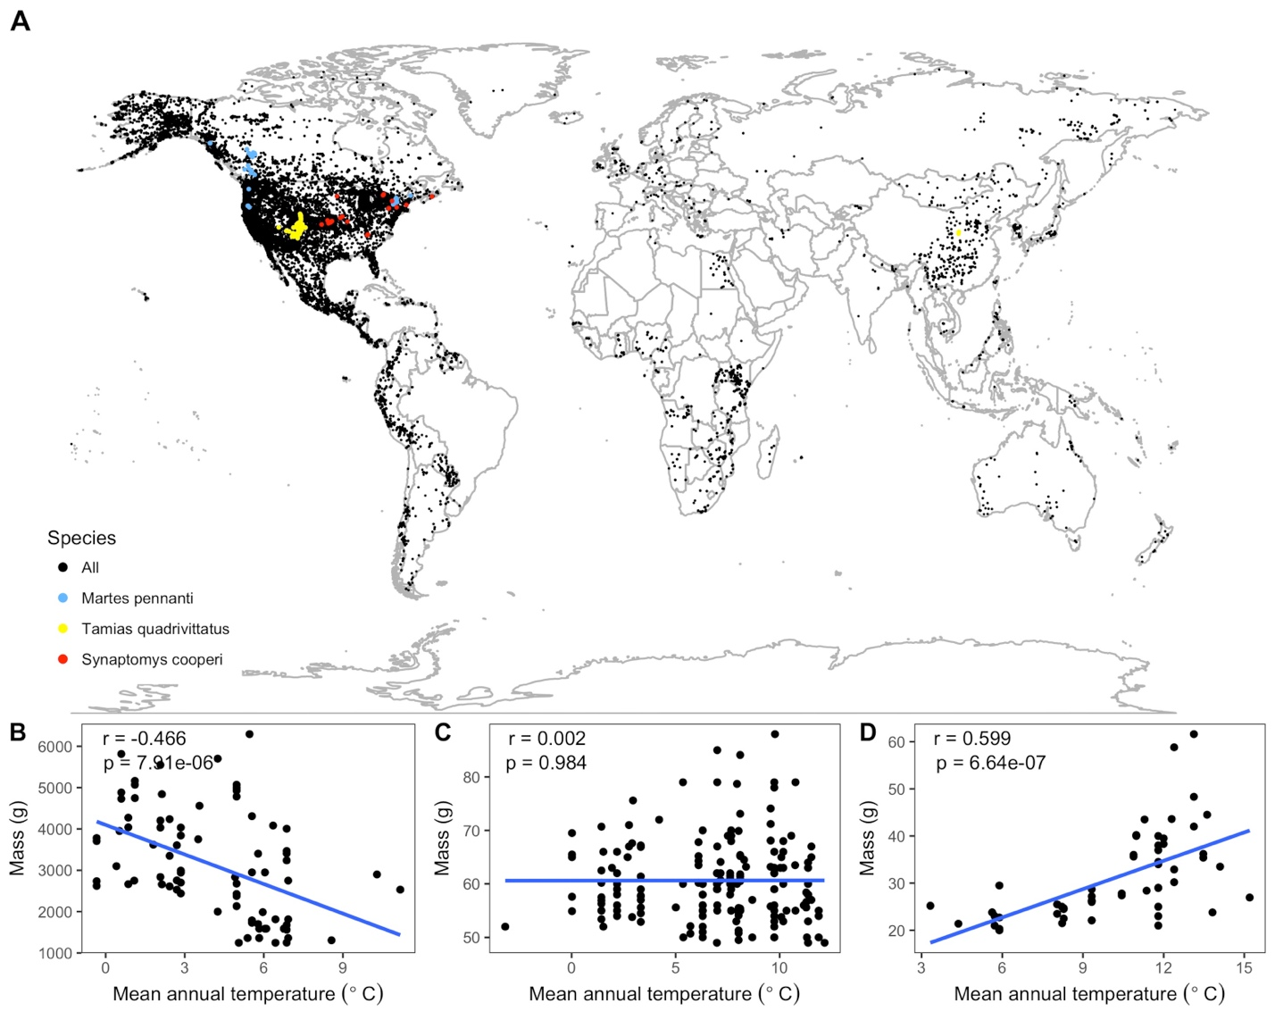

Figure 2-1. Species spatial distributions and selected temperature-mass relationships. (A) Spatial collection locations of all individual specimens. All species shown with black points except three species, whose relationships between mean annual temperature and mass are shown at bottom (B-D), are marked with colored points. These species were chosen as representative of the variability in relationship strength and direction exhibited by the 952 species from the study: *Martes pennanti* had a negative relationship with temperature explaining a substantial amount of variation in mass (B; blue points); *Tamias quadrivittatus* had no directional relationship between temperature and mass with temperature having little explanatory power (C; yellow points); *Synaptomys cooperi* had a strong positive temperature-mass relationship with a correlation coefficient (r) in the 99th percentile of all species' values (D; red points). Intraspecific temperature-mass relationships are shown with black circles for all individuals and ordinary least squares regression trends as blue lines. Linear regression correlation coefficients and p-values in upper left hand corner of figure for each species.

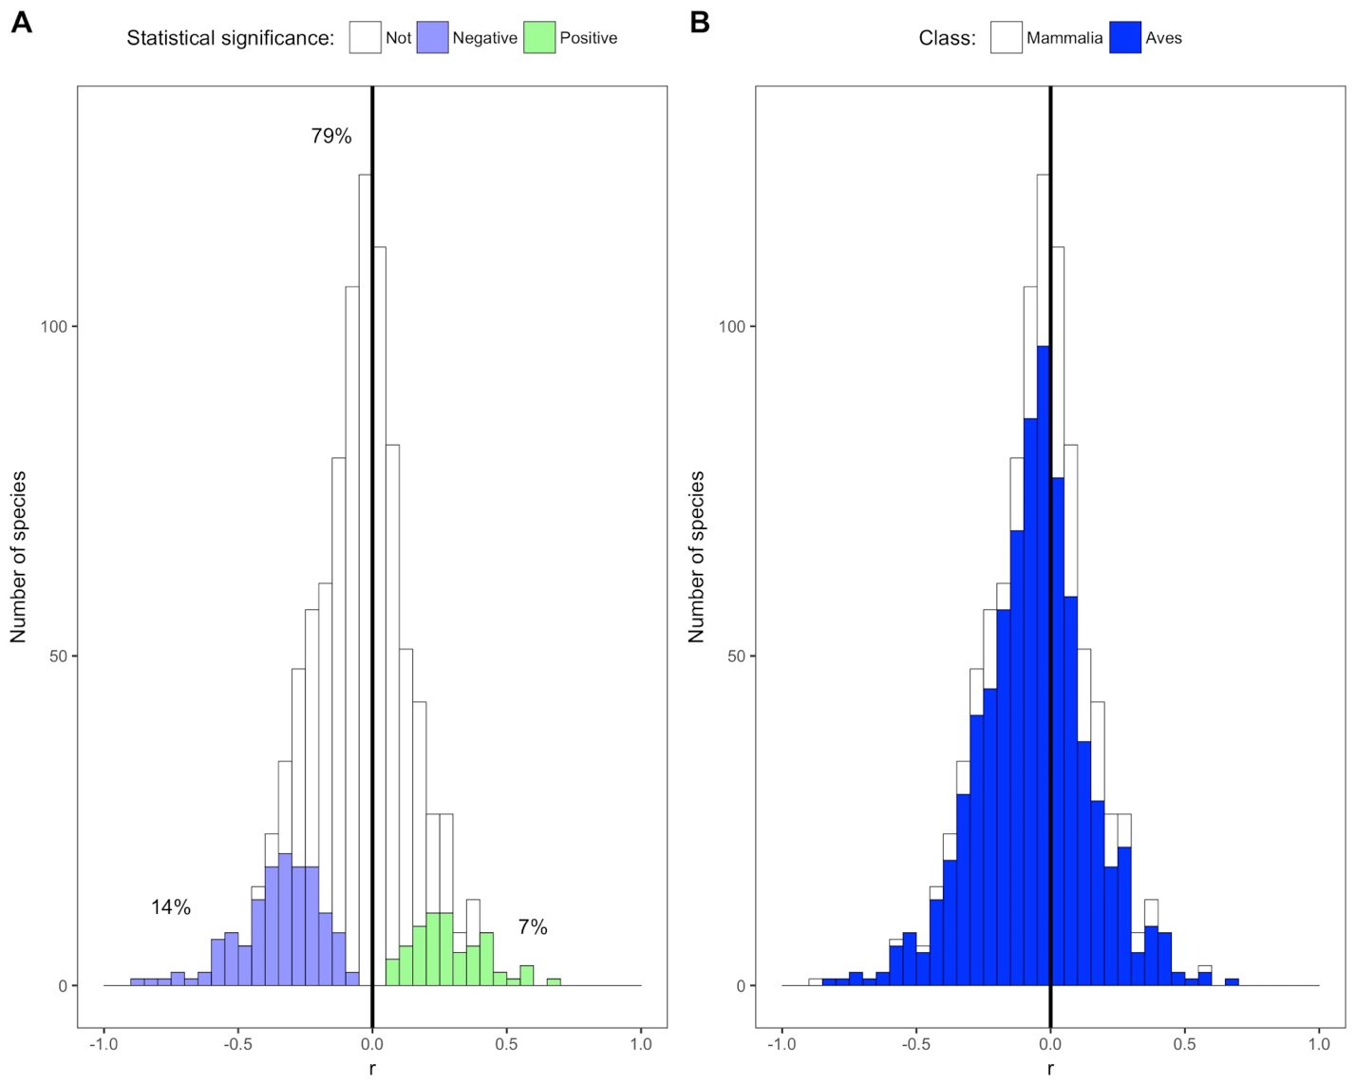

Figure 2-2. Species correlation coefficients by statistical significance and taxonomic class. (A) Stacked histogram of correlation coefficients (r) for all species' intraspecific temperature-mass relationships. Colored bars show species with statistically significant relationships, both negative (purple) and positive (green), while white bars indicate species with relationship slopes that are not significantly different from zero. Percentages shown are percentages of species in each group. (B) Stacked histogram of all species' correlation coefficients with bar color corresponding to taxonomic class. Dark vertical lines are correlation coefficients of zero.

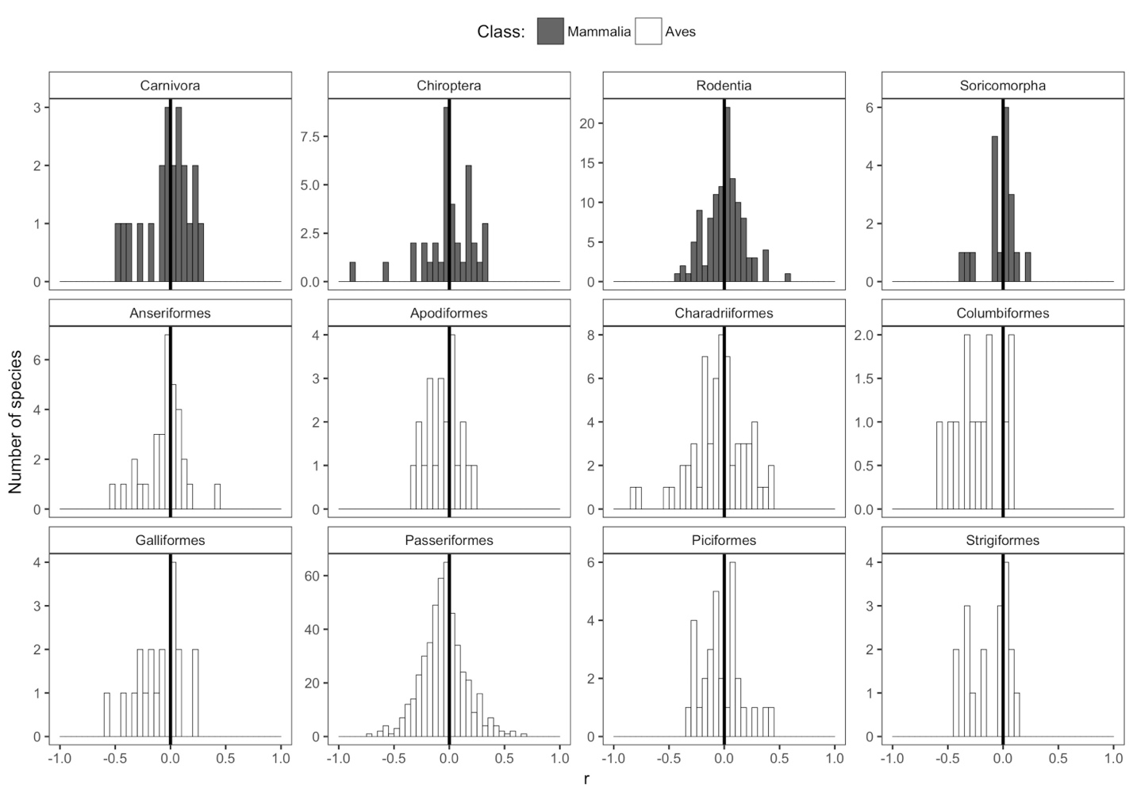

Figure 2-3. Species correlation coefficients for selected taxonomic orders.Histograms of correlation coefficients (r) from intraspecific temperature-mass relationships for each taxonomic order represented by more than ten species, with order shown above histogram. Height of y-axis varies depending on number of species. Bar color indicates taxonomic class. Dark vertical lines are correlation coefficients of zero. For remaining orders, see Figure A-2.

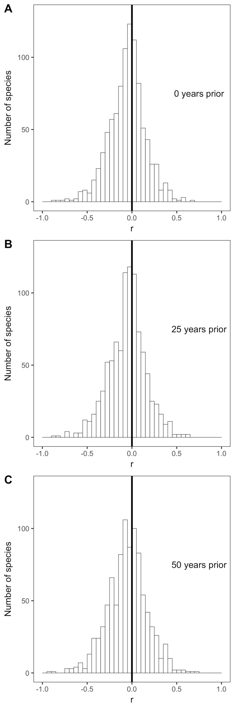

Figure 2-4. Species correlation coefficients with selected past year temperatures. Histograms of correlation coefficients (r) for all species' intraspecific temperature-mass relationships with mean annual temperature from (A) the year in which individuals were collected, (B) 25 years prior to collection year, and (C) 50 years prior to collection year. Dark vertical lines are correlation coefficients of zero. For all past year temperatures, see Figure A-4.

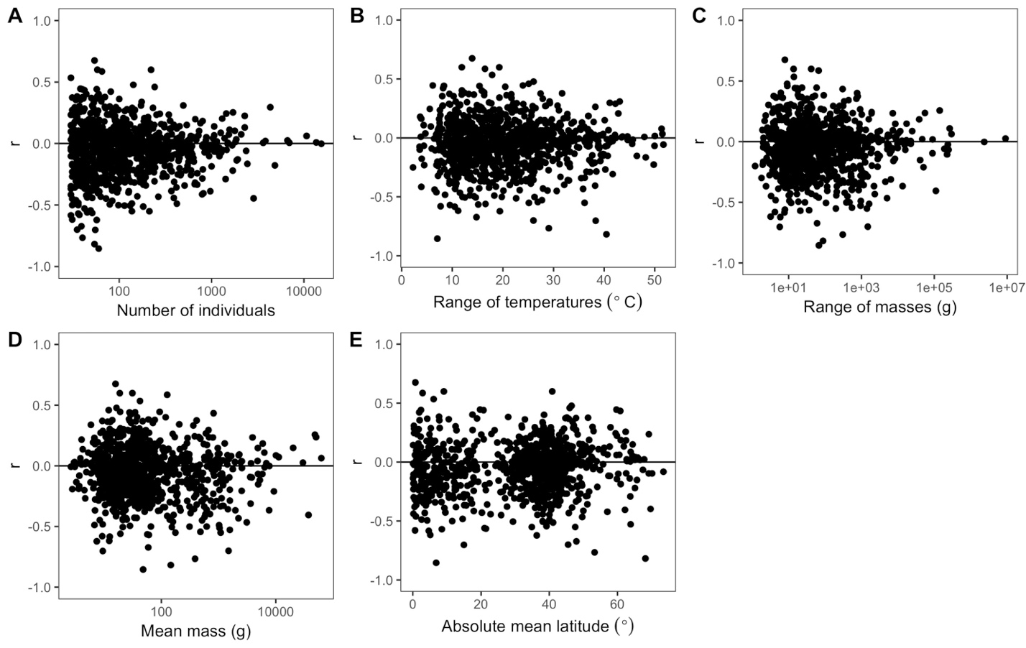

Figure 2-5. Variability of species correlation coefficients across several variables.Variation in all species' correlation coefficients (r) across the following variables for each species: (A) number of individuals, (B) difference between hottest and coldest collection year temperatures, (C) mass range, (D) mean mass, and (E) absolute mean latitude. Horizontal lines are correlation coefficients of zero. The x-axes of some plots (A, C, D) are on a log scale to better show spread of values.

CHAPTER 3

TEMPORAL RESPONSES OF MAMMAL BODY SIZE TO INCREASING TEMPERATURE

Introduction

Changes in climate can influence the traits of organisms, resulting in downstream effects on the functioning of natural systems. In particular, the potential for organisms to become smaller in response to increasing global temperatures has received growing attention as a potential universal response to climate change (Gardner et al., 2011; Sheridan and Bickford, 2011; Riemer et al., 2018a). The idea of warmer temperatures possibly resulting in decreased body size is based on Bergmann’s rule, a negative spatial relationship between the size of individuals of endotherm species and the temperature of the location at which they occur (Bergmann, 1847; Brown and Lee, 1969; Ashton, 2002; Freckleton et al., 2003; Meiri & Dayan, 2003). This rule has been extrapolated to predict that increasing temperatures from climate change should cause individuals of endotherm species to decrease in size as temperatures increase. This has been supported by syntheses of published studies, which suggest that endotherms have generally been decreasing in size over the last several decades (Gardner et al., 2011; Sheridan and Bickford, 2011; Yom-Tov and Geffen, 2011). Because organismal size is an important ecological characteristic that affects many aspects of ecosystems, including metabolic rates (Brown et al., 2004), food web structure (Woodward et al., 2005), and energy flux (Dickie et al., 2018), changes in size due to climate change are likely to influence ecosystem structure and function (Riemer et al., 2018a; Ohlberger et al., 2011; Yvon-Durocher and Allen, 2012).

In ectotherms, the mechanism that underlies the relationship between temperature and organismal size is well supported by empirical and theoretical work (van der Have and de Jong, 1996; Walters and Hassall, 2006; Forster et al., 2011). In contrast, most proposed mechanisms for endotherms have been called into question (Watt et al., 2010) and the generality of the empirical relationship has been cast in doubt by data-intensive analysis that evaluate Bergmann’s rule for man species simultaneously (McNab, 1971; Meiri et al., 2004; Riemer et al., 2018b). For example, when this relationship was recently examined for nearly 1,000 bird and mammal species using a century of global data, only 14% of species showed significant negative relationships (Riemer et al., 2018b). This calls into question how likely it is that endotherms will decrease in size in response to temperature shifts from climate change.

These data-intensive studies generally use museum collections and therefore usually have mixed spatial and temporal data as specimens are sampled across both space and time (McNab, 1971; Meiri et al., 2004; Riemer et al., 2018b). Therefore, while these analyses question Bergmann’s rule in general, they do not directly address whether organisms will tend to get small through time because responses of ecosystems across time do not necessarily match their responses across space (Fukami and Wardle, 2005). Recent studies that have suggested that species are getting smaller through time are limited by small numbers of species (Teplitsky et al., 2008; Husby et al., 2011; Canale et al., 2016), small numbers of sites (Van Buskirk et al., 2010; Salewski et al., 2010), and data that is collected over short time periods (Smith et al., 1998). Syntheses of these results (e.g., Millien et al., 2006) are potentially affected by both limitations of individual studies and potential publication bias due to negative results being less frequently published (Koricheva et al., 2013; Riemer et al., 2018b). Therefore, in order to determine how the size of species will respond to climate change, shifts in size and their relationship to increasing temperature needs to be examined in a data-intensive manner.

We directly assessed temporal shifts in body size and how these shifts related to changing temperature in a data-intensive manner by compiling long-term time series data on mammal communities and their associated temperatures from three geographic locations. This consisted of size measurements for 128,710 individuals, which were used to determine the average annual mass of 32 unique species-site combinations with observations for at least five individual years spread across a minimum timespan of a decade. This data-intensive approach addresses limitations of previous work on the temperature-mass relationship, which consisted of studies on single species and meta-analyses derived from those studies.

Methods

Datasets

Organismal size data was compiled from three long-term studies of small mammals, which all had individual-level body mass measurements. We only included datasets that had at least ten years of continuous data. Two of the sites, Portal and Fray Jorge, are long-term experimental studies of community dynamics in mammal communities. Portal is located in the United States in southeastern Arizona (Ernest et al., 2018). Fray Jorge is in the national park of the same name in Chile (Kelt et al., 2013). These two datasets were downloaded using the Data Retriever (Morris and White, 2013; Senyondo et al., 2017), with additional metadata taken from Ecological Archives. The Sevilleta dataset is from a Long Term Ecological Research project in the southwestern United States, which is collected because it is at the intersection of several major biomes. Data are collected at eight subsites that are in close proximity, which we chose to integrate due to similar patterns across the sites (Figure B-1). This time series dataset was downloaded, along with metadata, from the University of New Mexico digital repository (Newsome, 2016). The locations of the three sites are shown in Figure 3-1.

From each dataset, we retained only individual records that were identified as a rodent species, had an associated mass measurement, and were indicated as adults. For the two experimental sites, Portal and Fray Jorge, only individuals collected from control treatments were included. We kept all instances of the same individual being recaptured, which is common at these sites. We only included individuals of each species from years in which at least 15 individuals were collected, as it has been shown that a signal of temporal size change is noticeable with a minimum of 14 specimens per year for mammals (Yom-Tov & Geffen, 2011). After restricting each species data to include only those years that had data for at least 15 individuals, we kept only those species that had at least five years of data. Doubling these two thresholds did not change trends in temporal mass change or the relationship between temperature and mass (Figure B-2). The resulting dataset had 32 mass time series (i.e., unique combinations of species and sites; Table B-1) from 128,710 individual records and 25 species (Table 3-1). Trends in mass for species common to more than one site were compared.

For temperature data, we used a global dataset with monthly average temperature values from 1900 to 2014 on a 0.5 degrees latitude by 0.5 degrees longitude grid, which is created and maintained by the University of Delaware and National Oceanic and Atmospheric Administration (Willmott and Matsuura, 2001). The coordinates for each of the three sites were determined from metadata or related citations (Aguilera et al., 2016), and were used to extract all of the monthly temperatures for each site from the temperature dataset. Mean annual temperatures were calculated from the monthly temperatures, and then were combined with the mass dataset to provide a temperature for each species at each site in each year.

Analysis

We visually examined how temperature and mass varied through time at each site, and compared each species mean annual mass with corresponding average annual temperatures using linear regression. We calculated and compiled the r values from all regressions to evaluate the strength and direction of the temperature-mass relationship among all species at each site. To examine how mass and temperature concurrently changed over time, we compared the percent change in each species mass to the absolute change in temperature over the years with sufficient data.

We additionally used a dynamic regression model of the mass time series for each species to determine the effect of temperature while controlling for temporal autocorrelation. We used an ARIMA model with an automatically chosen order, after confirming that this order was appropriate. Mean annual temperature was included as an external variable and the resulting model residuals were reviewed. All model diagnostics are in Figure B-3. To determine the effect of temperature on mass, we calculated the p-value for each species, which were adjusted to take into account for multiple comparisons (Benajmini & Hochberg, 1995), and chose an alpha cut-off of 0.05. We additionally determined the trend in each species mass time series using a dynamic regression model including drift. All cleaning and analysis was completed using R (R Core Team, 2016), with code and data downloads provided reproducibly on GitHub (https://github.com/KristinaRiemer/temporal_MRT) and archived on Zenodo (citation).

Results

Temperatures increased at all sites (Figure 3-2A, B, C) in accordance with broader scale climate change. Most species time series (one time series per species per site) had positive slopes (66%; Figure 3-2D, E, F), indicating that increases in size were most common, in opposition to the expected trend. Most of these trends were weak, with only 6% being statistically significant (Figure 3-2G, H, I; Figure B-4). Most time series also showed no significant relationship between temperature and mass over time (66%; Figure 3-3D, E, F; Figure B-5). Of the relationships that were significant, almost all of them (10 out of 11) had positive relationships between mean annual mass and mean annual temperature, instead of the expected negative relationship (1 out of 11: Figure 3-3; Figure B-6). There was no relationship between the absolute change in temperature over the time series and the percent change in species mass (Figure 3-4). Most relationships are in the upper right quadrant (increase in temperature and increase in size), instead of the lower right or upper left which would indicate the expected negative temperature-mass relationships (Figure 3-4). There were seven species that occurred at both the Portal and Sevilleta sites, of which four had opposite relationships between temperature and mass at the two sites (Figure B-7).

Discussion

Our results do not support a general decrease in size through time for endotherm species or a general negative relationship between body size and temperature at a single site time series. Instead, species, showed idiosyncratic changes through time and relationships with temperature at each site, with some species increasing in size, some remaining unchanged, and others decreasing in size. This variability occurred even within a single species, as three of the seven species that occurred at more than one site had different size responses at different sites (Figure B-7). Additionally, most species had weak or non-significant relationships between temperature and mass. That these relationships were weak and variable in direction indicates that changes in temperature are unlikely to be a dominant driver of shifts in mammal body size, which further suggests that declining body size is not likely to be a third universal response to climate change in endotherms (Gardner et al., 2011; Sheridan and Bickford, 2011).

While temperature does not seem to dominate dynamic changes in size, this does not mean that it has no influence on size. Body size is affected by a wide variety of biotic and abiotic factors, including resource availability (McNab, 2010), anthropogenic fragmentation (Lomolino & Perault, 2007), island size (Lomolino, 2005), and competition from other species (Menge, 1972). Variation in the response of body size across time has been previously documented and ascribed to other environmental changes (Gardner et al., 2011; Yom-Tov & Geffen, 2011; Sheridan & Bickford, 2011). For example, one mammal species was shown to have increased in size due to plants developing later in the year (Canale et al., 2016) and declining polar bear size was linked to the availability of sea ice (Stirling and Derocher, 2012). Therefore, even if temperature directly influences size across time, this influence may be overpowered by the other factors influencing size, resulting in there not being general trends in size.

While temperature could influence size in endotherms, the mechanism underlying this remains unclear. While empirical evidence of a negative temperature-mass relationship in endotherms has been documented for over a century, there is no agreed upon mechanistic explanation though many have been proposed. The initial and most commonly referenced hypothesis is that it is beneficial for individuals to be smaller in warmer environments because they have an increasing surface area to volume ratio and therefore lose heat relatively more quickly (Bergmann, 1847). However, there is no direct evidence for this mechanism (McNab, 2010) and it has been shown that morphological changes in fur characteristics are more effective than heat regulation for some mammals (Steudel et al., 1994). Other proposed mechanisms include starvation resistance, dispersal, predator-prey interactions, and productivity pulses but none of these mechanisms have been directly supported (Blackburn et al., 1999; Watt et al., 2010).

Our results suggest that the response of mammal body size to changes in climate are likely to be highly variable. However, while our data include over 100,000 individual size measurements, it is still too limited in scope to draw general conclusions about how endotherm size will change in the future. Doing so will require increasing the number of locations and species sampled. Having more data for the same species in multiple geographic locations will also be important for assessing the observed variability of temperature-mass relationships within species observed in this study. The taxonomic breadth of this analysis should also be expanded to include larger and non-nocturnal mammals, and to bird species. An analysis of birds in this context is particularly important because there are some smaller recent studies suggesting decreasing size in bird size (Van Buskirk et al., 2010; Husby et al., 2011; Teplitsky et al., 2008). Sites with more diverse environments, including constant or decreasing temperatures and greater precipitation, should also be included to determine the generality of the temporal size response and how it is influenced by climate factors besides temperature. Finally, mean annual temperature may not be the most important aspect of temperature to measure. Minimum or maximum temperatures may have more directly influences on species sizes (e.g., Smith et al., 1995).

The variable size response to temperature across time for the mammal species in this study calls into question the idea that decreases in size will represent a third universal response to global warming as has been proposed (Gardner et al., 2011; Sheridan and Bickford, 2011). Body sizes are likely responding to many factors that interact in potentially complex and non-linear ways. Understanding the key factors influencing size and how they will interact to determine size response to climate change should be a priority due to the importance of size in ecological systems.

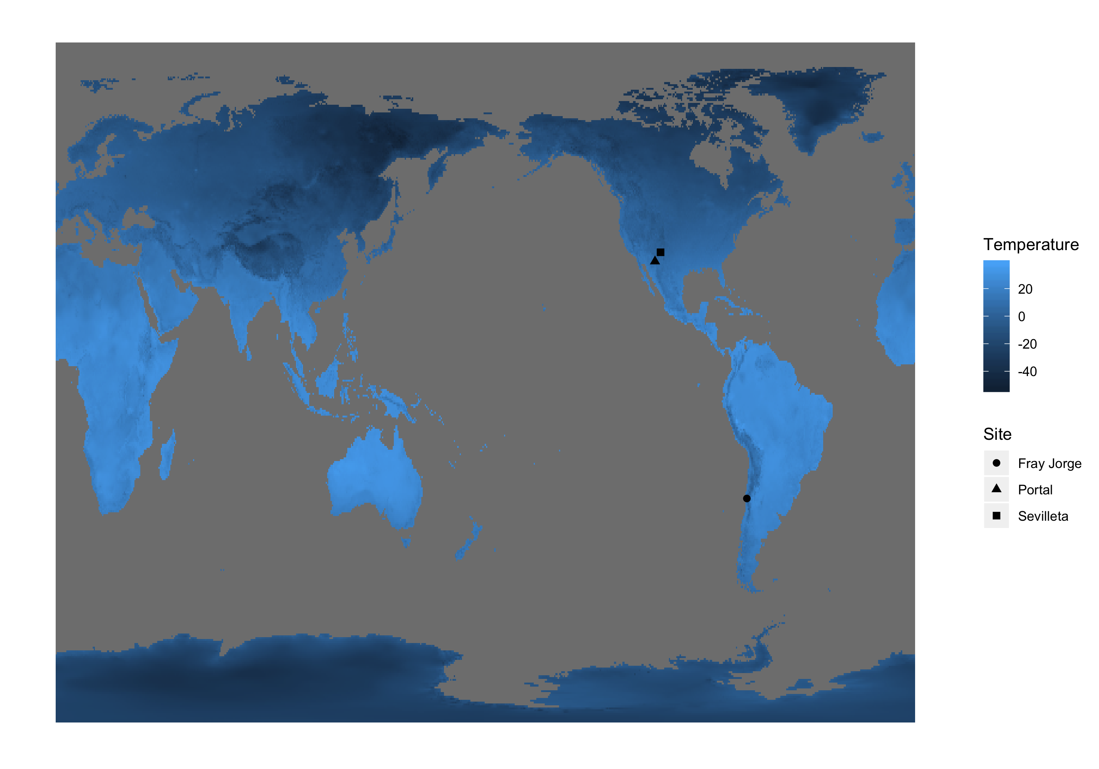

Figure 3-1. Map of global terrestrial temperatures for December 2014 showing spatial locations of three sites.

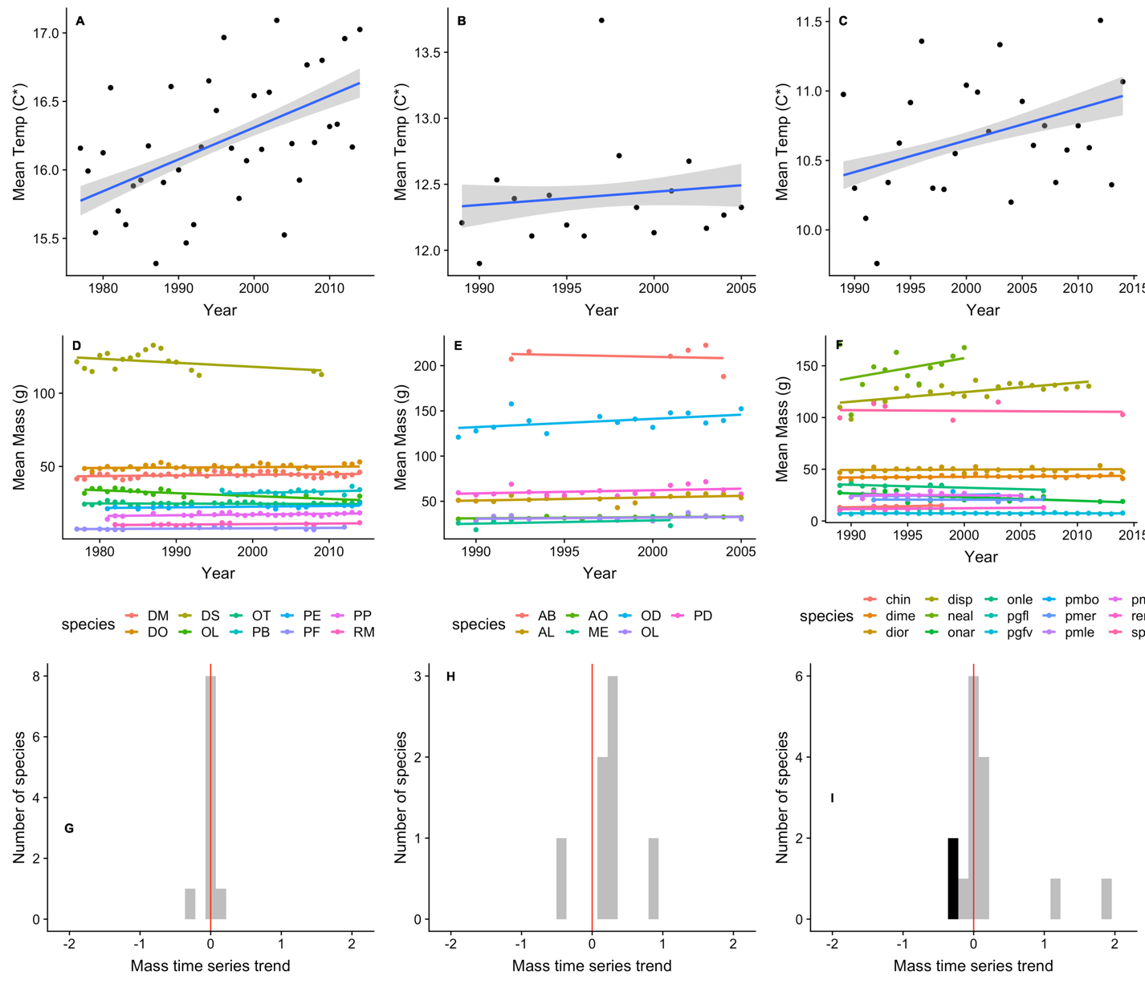

Figure 3-2. Trends in temperature and mass at each site. Mean annual temperatures at Portal (A), Fray Jorge (B), and Sevilleta (C) are black points, with linear regression trend for temperature as blue line and confidence intervals as grey shading. (D-F) Species mean annual masses shown as points of different colors, with linear regression line of corresponding color for trend in mass, by site. (G-I) Distribution of mean annual mass slope from mass time series dynamic regression model for all species by site, with statistically significant values shown in black and not statistically significant in grey. Vertical red line at slope of zero.

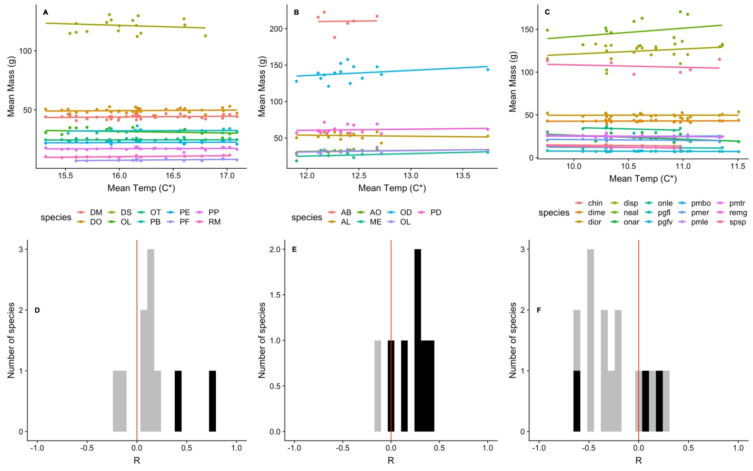

Figure 3-3. Each species relationship between mean annual temperature and mean annual mass shown as points, with one color per species, for Portal (A), Fray Jorge (B), and Sevilleta (C). Liner regression trend for each species temperature-mass relationship shown in corresponding color. (D-F) Distribution of r values from linear regression for each species temperature-mass relationship by site, with statistically significant values shown in black and not statistically significant in grey. Vertical red line at slope of zero.

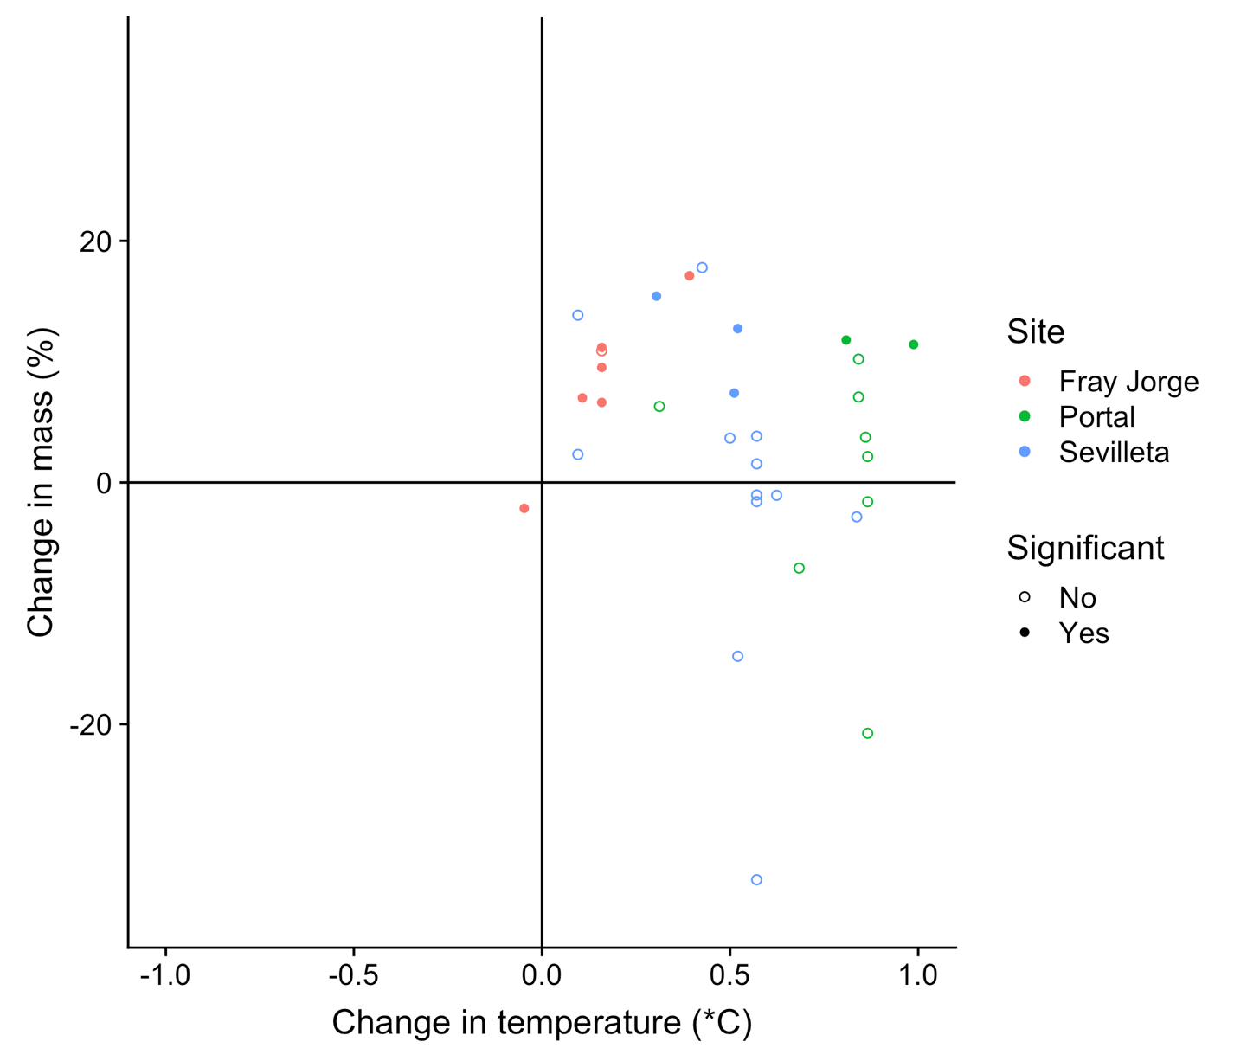

Figure 3-4. Absolute change in temperature experienced by each species, from linear regression of mean annual temperatures, compared to the percent change in each species mass, from linear regression of mean annual masses. Points for species with statistically significant temperature-mass relationships are filled, while open points show not statistically significant relationships. Sites are indicated by color of points.

Table 3-1. Summary statistics for all individual records and by site.

| Individuals | Species |
| --- | --- |
| 128710 | 32 |

| Site | Individuals | Species | Years | Individuals (min) | Individuals (max) | Years (min) | Years (max) |
| --- | --- | --- | --- | --- | --- | --- | --- |
| Fray Jorge | 83670 | 7 | 17 | 15 | 9613 | 6 | 17 |
| Portal | 28293 | 10 | 38 | 15 | 635 | 13 | 38 |
| Sevilleta | 16747 | 15 | 26 | 15 | 706 | 5 | 26 |

CHAPTER 4

BODY SIZE SHIFTS INFLUENCE EFFECTS OF INCREASING TEMPERATURES ON ECTOTHERM METABOLISM

Introduction

Environmental temperature influences organisms in many ways; it can increase or decrease rates of physiological processes (Brown et al., 2012), determine timing of reproduction (Olive, 1995), or even directly affect mortality (Pauly, 1980)[2]*. Because of the far-reaching influence of temperature, projected increases due to climate change are expected to substantially alter diverse species characteristics. Increased temperatures have already been implicated in shifts in species geographic distributions (e.g., Buckley et al., 2010; Parmesan & Yohe, 2003) and in the phenology of species' life history and development (e.g., Wolkovich et al., 2012).

Rising global temperatures may increase the metabolic rates of ectotherms (Seebacher et al., 2015; Dillon et al., 2010). Metabolic rate is a key physiological process reflecting the energy required for the maintenance, growth, and reproduction of organisms. In ectotherms, environmental temperature directly influences metabolic rates through its influence on the rate of biological reactions that underlie metabolism. Because the relationship between temperature and metabolic rate is positive and exponential until an upper temperature threshold, small changes in temperature can have substantial impacts on metabolic rate (Gillooly et al., 2001). Changes in metabolic rate affect many aspects of organismal biology and ecology, including individual fitness (Burton et al., 2011), population dynamics (Buckley et al., 2014), community composition (Marquet et al., 2004), and ecosystem processes such as ecosystem respiration and nutrient cycling (McIntyre et al., 2008; Rall et al., 2010; O'Connor et al., 2011; Anderson-Teixeira et al., 2012; Lemoine & Burkepile, 2012; Gilbert et al., 2014). Therefore, understanding the impact of temperature increases on metabolic rates is critical to determining how ectotherms, and the ecological communities in which they perform key roles, will respond to climate change.

Beyond its well-characterized direct effect on ectotherm metabolic rates, temperature also has indirect effects mediated by other aspects of organismal biology, including body size. The influence of temperature on body size is referred to as the size-temperature rule: when reared at higher temperatures, ectotherms are often smaller as adults (Forster et al., 2011a; Angilletta, 2004; Atkinson, 1994). This is because the thermal environment impacts the biological reactions controlling growth and development that ultimately determine adult body size (Walter & Hassall, 2006). As temperature shifts, theoretical models indicate that differences in the temperature dependence of biomass accumulation and ontogenetic differentiation can alter the size at which an individual finishes their development, thus generating the size-temperature relationship (Zuo et al., 2012). These shifts can occur quickly, with individual body size often responding to temperature change after a single generation (e.g., fruit flies in Partridge et al., 1994). Smaller ectotherms then have decreased whole-body metabolic rate due to the positive allometric relationship between body size and metabolic rate (Kleiber, 1932; West et al., 1997; Brown et al., 2004).

Studies of the ectothermic metabolic response to warming temperatures have focused solely on the direct effect of temperature on metabolic rate while overlooking potential indirect effects arising from changes in body size (e.g., Dillon et al., 2010). Indirect effects often emerge in ecology because ecological systems are complex systems composed of multiple, and sometimes antagonistic, interactions, which can be strong enough to modify outcomes. Indirect effects can arise when the same causal mechanism influences a response value through another pathway. In the case of adult metabolic rates, the influence of temperature not only directly increases the rates of metabolic reactions but also affects metabolic rates indirectly via body size shifts. Because previous studies did not incorporate the indirect effect of temperature on metabolic rate through its impact on body size, it is currently unclear whether the expected increase in metabolic rates could actually be offset by size changes.

Here we examine how ectothermic metabolism may respond to temperature shifts due to climate change. In addition to examining the direct influence of warming temperature on metabolism, we include the indirect effect on body size. While higher temperatures cause metabolic rates to increase when size is constant (i.e., direct effect), this increase could be dampened when size is allowed to vary (i.e., indirect effect) consistent with empirical data, if not result in an overall decreased metabolic rate. To estimate how much size changes in response to temperature, we collect experimental data on observed ectothermic size shifts in response to temperature changes. These empirically observed size shifts are compared to hypothetical masses required to maintain the same metabolic rates under increased temperatures, as estimated using a previously established relationship describing the effects of size and temperature on metabolic rate. We further estimate metabolic rates with increased temperature when size is constant and when size varies. We compare these metabolic rates to explore how changes in body size may alter ectotherm metabolic rates relative to the changes that would be expected based on the direct effects of temperature alone.

Methods

Data

We used data from published experimental studies that raised individuals of ectotherm species at constant temperatures. From these studies, we obtained average adult size of all individuals grown at each temperature treatment. Criteria for inclusion were that (1) in each study individuals were raised at a minimum of two experimental temperatures, (2) individuals were either lab-bred or collected at an early life stage, and (3) sufficient food was provided so that resource limitation did not influence ontogenetic growth. These criteria were laid out by Forster et al. (2011a), which was also the source of most of our data, and we collected some additional data from the literature that also conformed to these criteria (Baker, 1969; Berven, 1982; Brust, 1967; Burges & Cammell, 1964; Coker, 1933; Dixon et al., 1982; Kitching et al., 1999; Lamb & Gerber, 1985; Lock & McLaren, 1970; Marti & Carpenter, 2008; McKie & Cranston, 2005; Oetken et al., 2009; Stacey & Fellowes, 2002; Vannote & Sweeney, 1980). Some studies had multiple trials to compare responses of individuals from different latitudes or elevations; we retained data for all trials and treated them independently for the analysis. If length was the only size metric provided, we used it to estimate mass based on allometric relationships (Figure C-1).

Studies examined body size response to temperature across a range of temperatures (2°C to 36°C) that differed from each other by various temperature increments (1°C to 29°C difference in temperature between experiments within studies). For each study, and trial if applicable, we paired the lowest experimental temperature with each of the remaining higher temperatures. Some studies therefore had multiple pairs. This filtered subset of the data had temperature ranges of 2°C to 25°C for the lower temperature and 4°C to 36°C for the higher temperature. For each experimental pair, we considered the mass value associated with this lowest temperature to represent that species' mass before temperature increase while mass value reported for the higher temperature represented size response to an increase in temperature (Figure 4-1).

The final dataset contained 639 pairs of average adult masses for 109 species across 97 studies. This dataset includes species from nine taxonomic classes, ranging from Insecta to Amphibia, and terrestrial species from every continent except Antarctica and aquatic species from every ocean and many large bodies of water. Most species are very small (<100 mg) invertebrates because experiments raising larger ectotherms to adulthood are less common. Mass values span six orders of magnitude, from 1 µg to 5 g. Data and code have been deposited in the online Dryad Data Repository (<https://doi.org/10.5061/dryad.hg5473q>).

Metabolic Rate Calculations

Size-temperature studies do not typically measure metabolic rate. Therefore, we used an established relationship to calculate metabolic rates for all pairs from the experimental temperature-mass dataset. This relationship, which is central to the metabolic theory of ecology (MTE) (Brown et al., 2004), combines both mass and temperature effects on metabolic rates:

|  |  |
| --- | --- |
| *R = r0Mbe-E/kT* | (4-1) |

Here, *R* = metabolic rate, *r0* = scaling constant, *M* = mass (g), *b* = unitless scaling exponent, *E* = activation energy of respiration (eV), *k* = Boltzmann's constant (8.617 x 10-5 eV/K), and *T* = temperature (K). Though the mechanism underlying the MTE equation has been questioned (O'Connor et al., 2007), there is theoretical support based on the scaling of organismal transport systems (West et al., 1997) and it provides a reasonable empirical approximation across a wide range of taxa (Gillooly et al., 2001) and has been used previously to estimate metabolic rates response to temperature change (e.g., Dillon et al., 2010). An advantage of this equation for our study is that it allows us to incorporate both the direct effect of temperature on metabolic rate (*e-E/kT*) and the indirect effect through organismal size (*Mb*).

We used values of *b* and *E* specific to each taxonomic class to allow for taxon-specific responses of metabolism to temperature. Because availability of class-specific *b* and *E* values varied widely among the classes, we used different approaches for determining these values. When data on organismal metabolic rate available for a class also contained size and temperature information (Branchiopoda, Amphibia, Malacostraca, Maxillopoda; Makarieva et al., 2008; White et al., 2012), we used a multiple regression method (White et al., 2012) to calculate *b* and *E*. Values for Actinopterygii were estimated using fish species from several classes (Gillooly et al., 2001) and values for Insecta were acquired from literature sources (Chown et al., 2007; Irlich et al., 2009), while the average values of *b* = 0.75 and *E* = 0.63 eV (Brown et al., 2004) were used for Entognatha, Eurotatoria, and Gastropoda, the most data-limited taxonomic classes. Data used to calculate *b* and *E* were non-overlapping with our experimental temperature-mass dataset. While values of *b* and *E* may be affected by temperature (Figure C-2), data of this resolution are not available for most of the 109 species in our dataset.

Compensation Mass

We assessed the magnitude of size response to temperature needed to offset the direct effect of temperature on metabolic rate, and how close each pair’s observed size response to temperature came to reaching this predicted value. To calculate the predicted size necessary to offset the increase in temperature for an experimental pair (*MN*), we rearranged Equation 4-1 to solve for size (Figure C-3):

|  |  |
| --- | --- |
| *MN = (R / e-E/kT)1/b* | (4-2) |

where *R* is the starting metabolic rate and *T* is the observed temperature from the higher temperature experiment for each pair. Thus, needed mass (*MN*) is the mass a species would have to be under higher temperature conditions in order for metabolic rate to not change (Figure 4-1b).

We calculated the observed change in size for each pair of temperatures, (“observed mass change” = percent change from initial mass to actual mass), and the theoretical change in size needed to maintain metabolic rate with increased temperature (“compensation mass change” = percent change from initial mass to needed mass) (Figure 4-1b). A paired t-test was used to compare log-transformed actual and needed mass values.

Metabolic Rates Comparisons

To examine how metabolic rate responses to temperature is modified by size changes, we used Equation 4-1 to calculate three metabolic rates for each experimental pair in the temperature-size dataset (Figure 4-1a):

1. “Starting metabolic rate” represents the metabolic rate prior to temperature increase, and was calculated using size and temperature data from the lower temperature experiment of each pair.
2. “Constant size metabolic rate” is the hypothetical metabolic rate including only the direct effect of temperature increase. It was calculated with the size from the lower temperature of each experimental pair, and temperature from the higher temperature of each pair (i.e., the assumption that size at the lower temperature does not change as temperature increases).
3. “Varying size metabolic rate” represents the empirical metabolic rate that includes both the direct and indirect effects of temperature increase. It was calculated using both size and temperature data from the higher temperature of each pair.

Comparisons between starting and constant size metabolic rates quantify how much metabolic rate increases with just temperature, while comparisons between starting and varying size metabolic rates quantify how much metabolic rate increases with temperature when the size response to temperature change is also accounted for. Making these comparisons across many experiments is more complicated than for a single experiment because the dataset consists of a variety of temperatures, temperature differences, and body sizes across organisms. We used Equation 4-1 to devise theoretical expectations that would allow us to plot and analyze this disparate data in a unified way. For each experimental pair, we are comparing one of our metabolic rates calculated at the warmer temperature (constant size or varying size metabolic rates; *R2*) to its starting metabolic rate (*R1*):

|  |  |
| --- | --- |
| *R2* *r0M2be-E/kT2*  -- = --------------  *R1* *r0M1be-E/kT1* | (4-3) |

Using logarithms, the equation can be rearranged into the form of a line (Figure C-7):

|  |  |
| --- | --- |
| ln *R2* – ln *R1* = *b*(ln *M2* - ln *M1*) + *E* / *K* ((-*T1* - *T2*) / (*T1T2*)) | (4-4) |

where y = ln *R2* – ln *R1*, slope = *E*/*K*, x = (-*T1 - T2 / T1T2*), and the intercept = *b*(ln *M2* - ln *M1*). We then calculated our response variable for each experiment pair as the log ratio between metabolic rates: i) “metabolic rate change with constant size”: the log ratio between constant size and starting metabolic rates and ii) “metabolic rate change with varying size”: the log ratio between varying size and starting metabolic rates (Figure 4-1a). The difference between these two metabolic rates changes were assessed by determining how they varied from a 1:1 line; if size does not change with temperature, metabolic rate change with constant size will be equal to metabolic rate change with varying size. This is therefore a measure of the impact of size change on the metabolic response to temperature increases. We then calculated the proportion of variance in metabolic rate change with varying size that could be explained by the constant size metabolic rate change (R2).

Linear Mixed Model

We used a mixed model to determine if other factors, besides the body size response, impacted the difference between constant size and varying size metabolic rates. Using Equation 4-4 for the two ratios of metabolic change (metabolic rate change with varying size and metabolic rate change with constant size), we calculated the residual between the predicted metabolic response with no change in size and the metabolic change using the observed mass change with temperature (see Figure C-7 for how this difference was calculated). The residual was used as the response variable for the model and indicates discrepancies from the theoretical metabolic rate change with constant size (Figure 4-4). Likelihood ratio tests were used to determine the significance of all fixed and random effects, using maximum likelihood for the former and restricted maximum likelihood for the latter. We included temperature difference, as represented by the temperature axis (Figure 4-4), as a fixed effect because greater increases in temperature for experimental pairs are expected to have an impact on the difference between constant size and varying size metabolic rates. The random effects in the model were the taxonomic classifications of species and class, as metabolic rate varies amongst these groupings due to biology and ecology, and also study and trial, to take into account differences in experimental setups. The random effect species was nested in taxonomic class, and trial nested in study. We initially included the logarithm of mass from the lower temperature of each pair as a fixed effect, because metabolic rate depends on the relative size of organisms, and the lower temperature of each pair as a fixed effect, as this may affect how different the two higher temperature metabolic rates are. These were not included in the final model because neither initial mass nor initial temperature have substantial impacts on metabolic rate change (χ2 = 0.522, df = 1, p = 0.47; χ2 = 0.0799, df = 1, p = 0.777; Figure C-4). The final model was fit using restricted maximum likelihood and random intercepts, and assumptions for linearity, homoscedasticity, and normality were fulfilled (Figure C-5). We ran the linear mixed model using the R package lme4 version 1.1.9 (Bates et al., 2015; Winter, 2013).All analyses were completed using R version 3.3.1 (R Core Team, 2016).

Results

Compensation Mass

In very few of the experimental pairs did mass decrease enough for metabolic rate to remain constant regardless of temperature increase. To maintain constant metabolic rates, all pairs would need to get smaller as temperature increased (x-axis, Figure 4-2). Most pairs did decrease in size (y-axis, Figure 4-2; observed mass change mean ± standard deviation: -14% ± 25%), with 75% of all pairs not decreasing enough to avoid increased metabolic rate, while 4% decreased in size more than needed. In contrast, 21% of pairs increased in size. On average, actual mass (i.e., empirical mass in response to temperature increase) was significantly smaller than needed mass (i.e., theoretical mass required in order for metabolic rate to not change due to temperature increase; t638 = 37.787; p < 2.2x10-16; CI = 0.86 – 0.95).

Metabolic Rates Comparison

Metabolic rates differed when the indirect effect of size change from temperature increase was included with the direct effect. Under the constant size assumption, metabolic rates increased with higher temperature for all experimental pairs (Figure 4-3). Including the indirect effect of varying size resulted in three types of metabolic rate changes, which follow from the trends in mass (Figure 4-2). Metabolic rates for most (75%) pairs did not increase as much from temperature increase, with the remaining pairs either having lower metabolic rates (4%) or higher metabolic rates with empirical size change accounted for (Figure 4-3). Overall, a 1:1 line between the two metabolic rate changes explained 73% of the variance in metabolic rate change including size response to temperature (Figure 4-3).

As temperature difference increased, pairs in most classes had smaller increases in metabolic rates due to relatively greater decreases in size (Figure 4-4; see trend lines in Figure C-6). There was also variability in metabolic rate change across taxonomic classes; for example, many pairs in the Amphibia class had greatly decreased mass, and therefore decreased metabolic rates in response to increased temperatures (Figures 4-3 and 4-4). Across classes, most pairs decreased by up to half their mass, as shown by the lower two grey lines (Figure 4-4).

Linear Mixed Model

The included effects had moderate to strong impact on metabolic rate response to temperature increase including varying size. These effects included temperature difference between experimental pairs, taxonomic class and species, and experimental study and trial. As expected due to the exponential relationship between temperature and metabolic rate, the amount of temperature increase was important (χ2 = 399.15, df = 1, p < 2.2 x 10-16), with a greater temperature difference resulting in relatively less of an increase in metabolic rate (slope = -0.018 ± 0.0007; Figure 4-4). The random effects of taxonomic class, species, study, and trial had statistically significant impacts and explained 37%, 7%, 49%, and 4% of variance, relatively.

Discussion

Consistent with expectations, predictions of the changes in most species' metabolic rates were lower when the indirect effect of temperature (i.e., body size change) was included along with the direct effect. While all metabolic rates increased with increased temperatures when the indirect effect was not included, incorporating the body size response to temperature moderately dampened the increase in metabolic rate for most species (Figure 4-3). Though there is no accepted quantitative description of the relationship between temperature and size for ectotherms (Forster et al., 2011b), 79% of the pairs in this study had decreased size with higher temperatures. In a small proportion of the species, mostly amphibians, size decreased enough to not only offset the impact of increased temperature on metabolic rate, but to result in an overall decrease in metabolic rates.

A substantial minority of species increased in size in response to increased temperature, instead of decreasing as expected from the size-temperature rule. Of more than 600 pairs, 134 increased in size (Figure 4-2) and therefore had a greater increase in metabolic rate when the indirect effect of temperature was included (Figure 4-3). This increase in metabolic rates does not appear to be driven by taxonomy, as these species represented seven of the nine taxonomic classes, and the distribution of pairs within each class was similar to that of the entire dataset. While it is unknown why some species exhibit this opposing response, many explanations have been proposed based on growth rates (Angilletta & Dunham, 2003; Walters & Hassall, 2006), abiotic conditions (Atkinson, 1994), extreme temperatures (Kingsolver & Huey, 2008), and life history characteristics (Walters & Hassall, 2006; Forster et al., 2012). It has been shown theoretically that increases in size with increasing temperature can arise when growth rates are more sensitive to temperature than development rates (Zuo et al., 2012). Regardless of the mechanism, these anomalous species will have relatively greater metabolic rates and body sizes from increased temperatures, with the accompanying higher energy requirements. Their greater use of space, food, and other resources could result in disproportionately greater ecological impacts and ecological mismatches, such as substantial changes in prey abundances due to increased consumption by predators (Rall et al., 2010).

Previous work examining global patterns of predicted metabolic rate increases under global change found that tropical species would experience a larger increase in metabolic rates than temperate ones (Dillon et al., 2010). This latitudinal gradient of metabolic responses to temperature emerges because the exponential relationship between temperature and metabolic rate causes small temperature changes in the tropics to translate into large changes in metabolism due to the warmer baseline temperatures in the tropics (Dillon et al., 2010). For body size shifts to alter the Dillon et al. (2010) findings would require a latitudinal pattern in body size responses to temperature – either larger decreases in size in tropical areas or a higher fraction of species increase in size with temperature in temperate areas. However, Klok and Harrison (2013) found no signal of latitude in their meta-analysis of the size-temperature rule. Thus our results likely mean that while the predicted magnitude of metabolic rate increases may be less overall than reported in Dillon et al. (2010), the global pattern of a higher impact on the tropical zones is likely robust to size changes.

While our results do not impact our understanding of metabolic rate responses to global warming across latitudes, our results may have implications for dynamics within individual ecosystems. Understanding the likely magnitudes of shifts in metabolic rates from particular temperature changes is important because, as metabolic demands of organisms increase, individuals require more resources to support themselves (Schmidt-Nielsen, 1984; Anderson-Teixeira et al., 2012). These changes in organismal metabolic rates are then more likely to have substantial consequences for every aspect of ecological systems, from population- to ecosystem-level (Anderson-Teixeira et al., 2012). Even the small magnitude shifts shown here have the potential to be important because the responses of populations and communities to changes in both resource and temperature are complex (Vasseur & McCann, 2005). For example, metabolic rate shifts from increasing temperatures resulted in decreased resource density and greater intraspecific competition in a fish population (Ohlberger et al., 2011). Even small changes in fluxes can have significant impacts depending on context. Under certain circumstances, small changes in the balance between rates of resource production and the rates that consumers acquire and allocate resources can result in large and unpredictable fluctuations in food web stability (Gilbert et al., 2014). Since all of our species play one or both of those roles, even our small differences in sizes and metabolic rates could have unexpected consequences, depending on the role the species plays and the productivity of the environment. These consequences could be less severe because metabolic rates increased less than predicted.

While our study highlights the role of size shifts on metabolic rates, size shifts are themselves an important response to global change (Gardner et al., 2011). Size impacts many aspects of population, community, and ecosystem ecology independently of its impact through metabolic rate (Peters, 1983; Calder, 1984; Schmidt-Nielsen, 1984). When organisms change size, it can influence their foraging decisions and competitive ability (Smith et al., 1998), thus impacting space use, population sizes, and community composition. Additionally, because predator-prey relationships are often constrained by body size (Brose et al., 2006), changes in body size may alter which prey a predator can physically capture and consume, thereby altering the number and identity of predators that feed on a particular prey species. In addition to its impacts on metabolic rates, temperature-mediated shifts in body size might have their own important impacts on the ecology of organisms. Incorporating the effects of temperature change on ectotherm metabolic rates through its coordinated impacts on metabolism and size will be challenging, but previous work on changing body size (Woodward et al., 2005; Ohlberger, 2013) is a potential guide.

While using the MTE equation to estimate metabolic rates allowed us to assess the direct and indirect effects of temperature across a range of taxa, there are some limitations with this approach. Though measured metabolic rates would be ideal, studies measuring metabolic rates and sizes of individuals raised at constant temperatures are rare. Because of organismal variation in *b* and *E* (Price et al., 2012), estimated metabolic rates may differ if values more specific to a finer taxonomic level than class are used. Similarly, these values may depend on environmental context. For example, the scaling exponent *b* can vary among closely related species and within species (Ohlberger et al., 2012). Amongst teleost fish species, the scaling exponent *b* is also dependent on temperature (Killen et al., 2010). While we only had one species of teleost fish in our dataset, using the Killen et al. (2010) version of the metabolic equation did reduce the magnitude of the metabolic response to increased temperature (Figure C-2). The MTE equation also does not incorporate any effects of phenotypic plasticity and acclimation on metabolic rates (Seebacher et al., 2015; Whitely & Faulkner, 2005), which could also influence how an organism’s metabolic rate responds to increasing temperature. Metabolic rate estimates depend on accurate body size and temperature measurements, which may have varied among experimental setups and resulted in the impact of study on metabolic rate changes.

Lastly, we focused on the metabolic rate of adult ectotherms, but increasing temperatures will also influence metabolic rate and size at the juvenile stage via growth and development rates (Dabrowski, 1986) which likely would have a variety of important implications for the ecology of these organisms as well. In fact, theoretical models provide evidence that the size-temperature rule occurs due to growth and development rates being impacted differently by temperature. Our results, in combination with Zuo et al. (2012), indicate that we cannot rely upon single relationships to understand how organismal processes respond to temperature. These responses are complex due to the interaction of multiple processes that respond differentially to temperature. Better prediction of organismal response to temperature will require the development of theoretical models that integrate multiple processes and their specific temperature responses. Given these limitations, our results should be viewed as an estimate of the effects on adult metabolism of shifts in adult size, if these could be isolated from all other biological adjustments that organisms may make when their environment changes. To move this area of research forward will require a broad-scale attempt to directly measure metabolic rates and sizes of organisms under a variety of temperature shifts.

Understanding how climate change will impact species and ecosystems is difficult because ecological systems are complex. Temperature influences the dynamics of ecological systems at almost every level, from the physiology of organisms to the rates of ecosystem fluxes. We often reduce this complexity by studying the direct effects of temperature change on some particular component of ecology (e.g., metabolic rate) and then sometimes additionally the direct effect of the changed ecological component on some other ecological process. Our results highlight the need to consider the coordinated impact of multiple pathways of effects when making predictions about how species will respond to climate change. While we focused here on the body size response of ectotherms to temperature as an indirect effect on metabolic rate, this is by no means the only pathway by which temperature can impact metabolic rate. Temperature can impact size through a variety of other environmental pathways besides the size-temperature response, including through resource availability, which could then consequently affect body size in various ways (McNab, 2010; Bickford et al., 2011). Designing studies to assess the relative importance of direct and indirect effects of temperature on species, communities, and ecosystem properties of interest is an important next step for our ability to predict the impacts of climate change.



Figure 4-1. Diagrams showing how the experimental data from the pairs were used to calculate constant size and varying size metabolic rate changes for each species (**a**), and how the data were used to calculate observed and compensation mass change for each species (**b**). The example data is from the species *Drosophila melanogaster*.



Figure 4-2. Comparison between compensation mass change and observed mass change for each unique combination of species, trial, and temperature difference. Compensation mass change is the percent change from initial mass to needed mass (i.e., mass change needed to maintain metabolic rate with increased temperature), while observed mass change is the percent change from initial mass to actual mass (i.e., observed mass change of individuals of each species raised experimentally). No change in mass and no change needed in mass are indicated by grey lines. Equivalence between needed mass and actual mass shown by black line.



Figure 4-3. Comparison between log difference of metabolic rates with size held constant and with size varying empirically in response to temperature increase. Black diagonal line indicates constant size and varying size metabolic rates are equal (i.e., mass does not vary), where points above line are pairs with higher varying size metabolic rate than constant size metabolic rate. Points below grey line are pairs where varying size metabolic rate is smaller than starting metabolic rate (i.e., actual mass smaller than compensation mass). Orange points are pairs from taxonomic class Amphibia and remainder are blue.



Figure 4-4. Metabolic rate change by taxonomic class. The black line shows the metabolic rate response expected if size is held constant. The points show the metabolic rate change calculated from experiments when size is allowed to response to temperature. To put variation around the black line in perspective, the grey lines correspond to how metabolic rate should change for different scenarios of mass response to that temperature increase: top to bottom, mass increase by 2x, mass increase by 1.5x, mass decrease by 0.75x, and mass decrease by 0.5x. The grey and black lines, and the format of the x-axis, are derived from the MTE equation (Figure C-7). We interpret the x-axis as temperature difference because the values of the x-axis are largely determined by the temperature difference between two experiments (i.e., T1 – T2) (Figure C-8).

CHAPTER 5

CONCLUSIONS

The purpose of this research is to determine how shifting temperatures due to climate change impact two species traits, body size and metabolic rate. Because these traits are fundamental to the structure and function of ecosystems, being able to predict how they will change in animal species is crucial for understanding climate change impacts on these systems.

It is commonly held that animal species will get smaller as global temperatures warm. For endothermic species, this is based on Bergmann’s rule, which states that the relationship between temperature and intraspecific mass is generally negative. I addressed how generally applicable this is in Chapter 2 by documenting this relationship for a large number of endothermic species using museum records. I found that the majority of nearly 1,000 bird and mammal species had no relationship between temperature and mass, indicating that Bergmann’s rule does not seem to apply to most endothermic species. While these data were spread across both time and space, the applicability of this rule needs to be determined temporally to be most relevant in the context of climate change. In Chapter 3, I examined how mass changed over the course of a decade in 32 time series in locations where temperatures got warmer. In accordance with the results from Chapter 2, most species had no relationship between temperature change over time and mass change over time, and those species that had a relationship tended to have a positive one instead of the expected negative temperature-mass relationship.

While a negative relationship between temperature and mass is not broadly common among endothermic species, this negative relationship is well supported with both empirical evidence and mechanistic theory for ectothermic species. It is expected that ectothermic species will get smaller in size as temperatures warm, resulting in these species having lower metabolic rates. This is in contrast with the direct effect of temperature, with individuals having higher metabolic rates due to warmer temperatures. I explored these opposing effects in Chapter 4 to predict metabolic rates for more than 100 ectothermic species. I found that decreasing body sizes do mitigate the impact of temperature on metabolic rates, ectotherm metabolic rates will likely increase overall due to the direct effect of warming temperatures.

In this research, I used data-intensive approaches to identify general patterns in the response of species traits to temperature change in order to assess the implications of climate change for natural systems. While species traits may respond simply and directionally to changing environmental conditions, especially when isolated, these responses are much more complicated in natural systems. In order to predict how environmental changes will affect ecosystems, the importance and interconnected effects of shifts in abiotic variables for specific traits in many species has to be determined, as was done with this research. Changes in species traits will have immense impact on how ecological systems function.

APPENDIX A

SUPPLEMENTAL FIGURES FOR CHAPTER 2

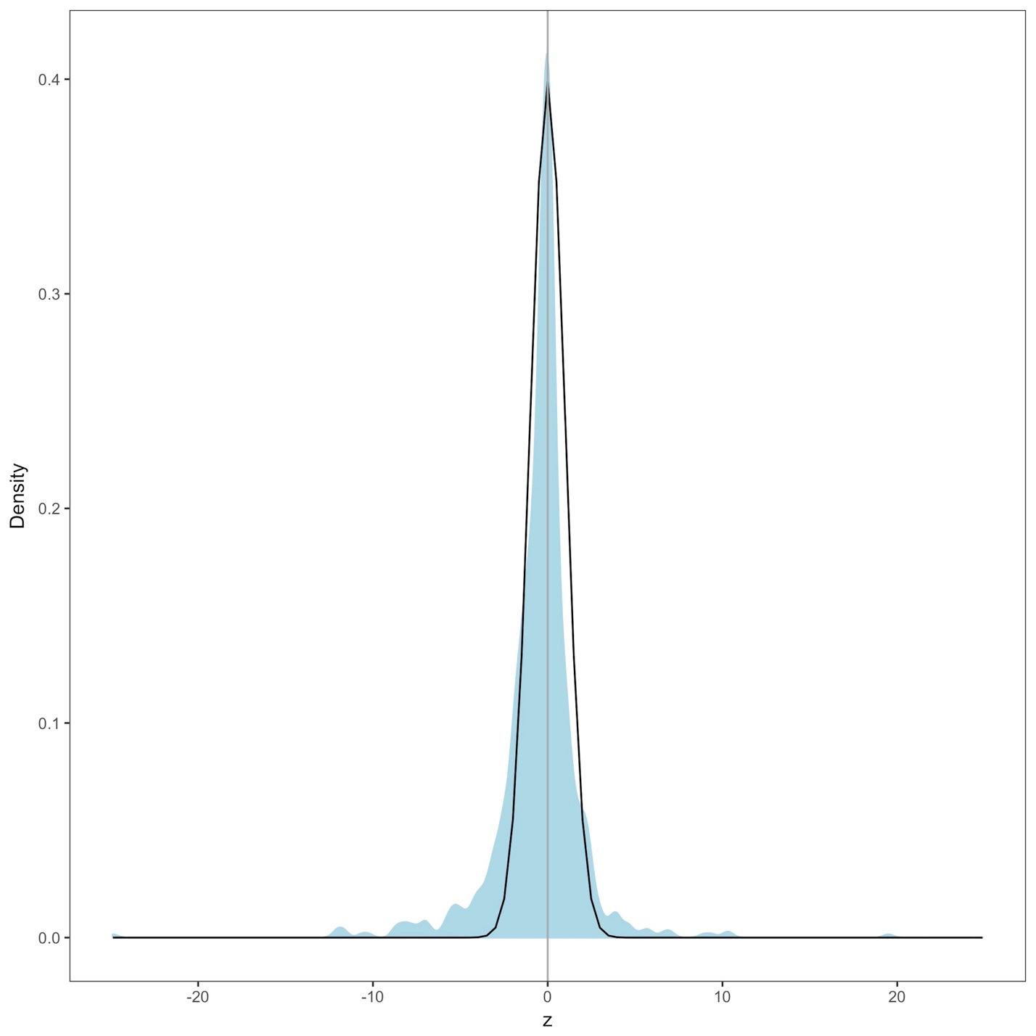

Figure A-1. Species z scores and z distribution.Density plot of z scores for all species’ intraspecific temperature-mass relationships in blue, with standard normal z distribution shown with black line. Z scores were calculated from p-values corrected with false discovery rate control. Grey vertical line is z score of zero.

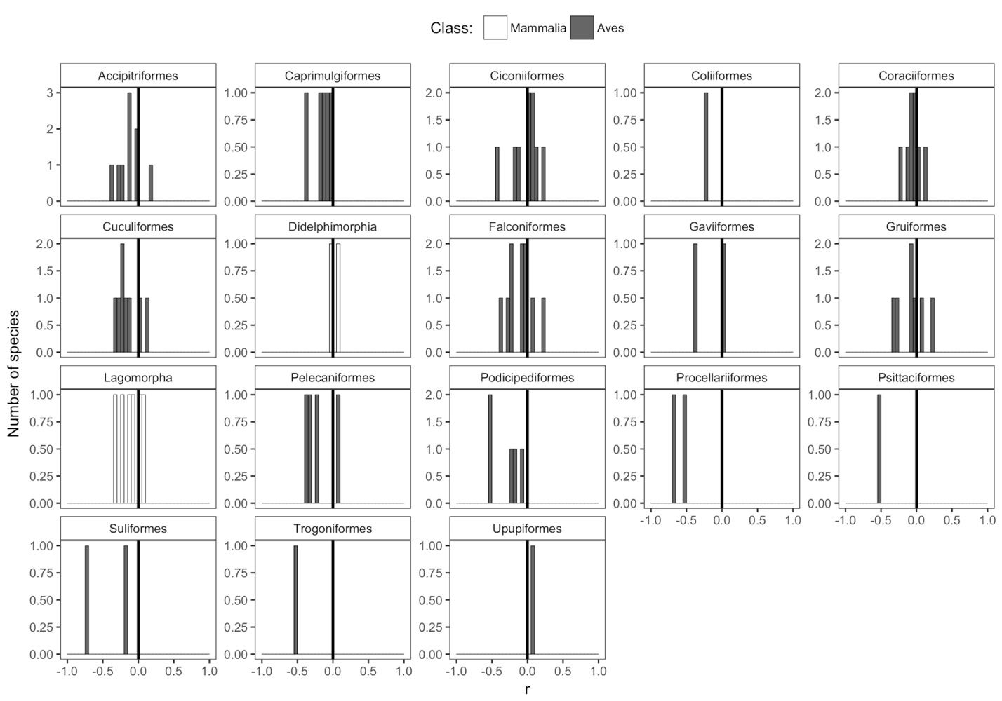

Figure A-2. Species correlation coefficients for remaining taxonomic orders. Histograms of correlation coefficients (r) from intraspecific temperature-mass relationships for each taxonomic order represented by ten or fewer species, with order shown above histogram. Height of y-axis varies depending on number of species. Bar color indicates taxonomic class. Dark vertical lines are correlation coefficients of zero.

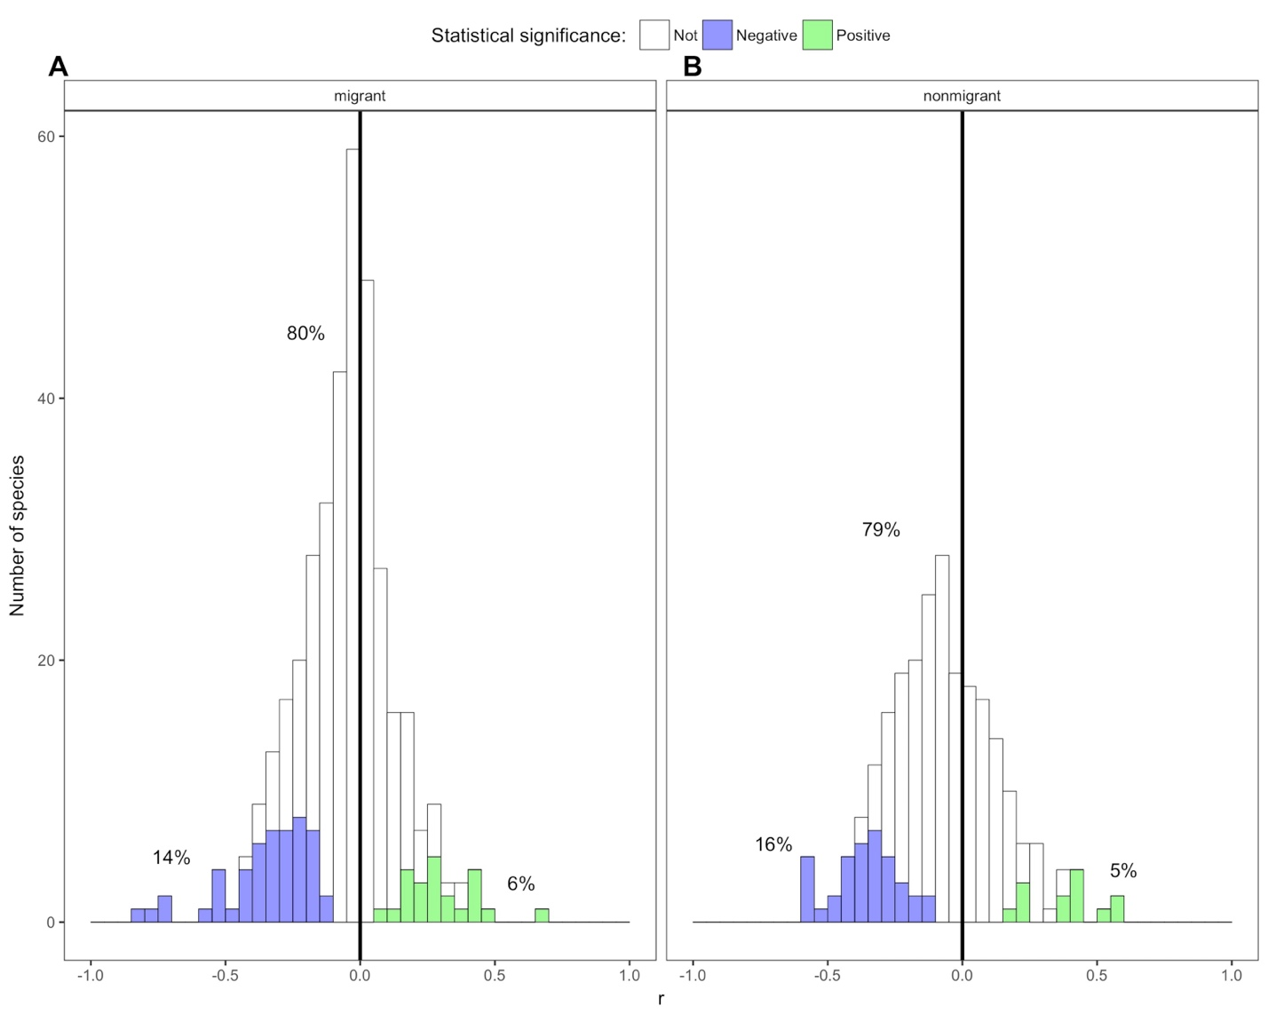

Figure A-3. Species correlation coefficients by bird migratory status.Stacked histograms of correlation coefficients (r) from intraspecific temperature-mass relationships for (A) migrant and (B) nonmigrant bird species. Of 750 bird species, 371 migrant species and 243 nonmigrant species were identified from data requested from BirdLife International (Birdlife International, 2017); species with migratory status codes of “Altitudinal Migrant”, “Full Migrant”, and “Nomadic” were reclassified as migrants and “Not a Migrant” as nonmigrants. Colored bars show species with statistically significant relationships, both negative (purple) and positive (green), while white bars indicate species with relationship slopes that are not significantly different from zero. Percentages shown are percentages of species in each group. Dark vertical lines are correlation coefficients of zero.

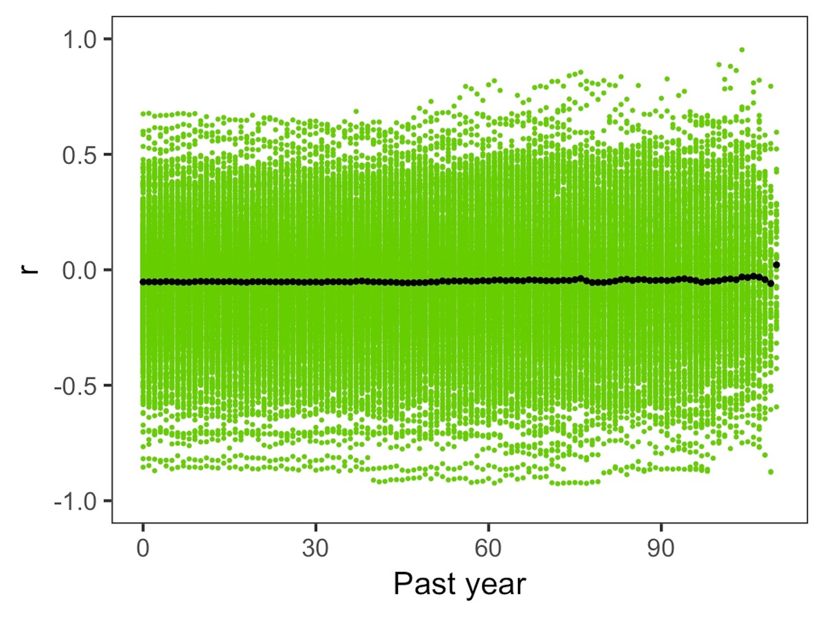

Figure A-4. Species correlation coefficients for all past year temperatures.Distributions of correlation coefficients (r) for all species' intraspecific temperature-mass relationships with mean annual temperature for collection year to 110 years prior to collection year. Black points show mean correlation coefficient across species for each past year of temperature.

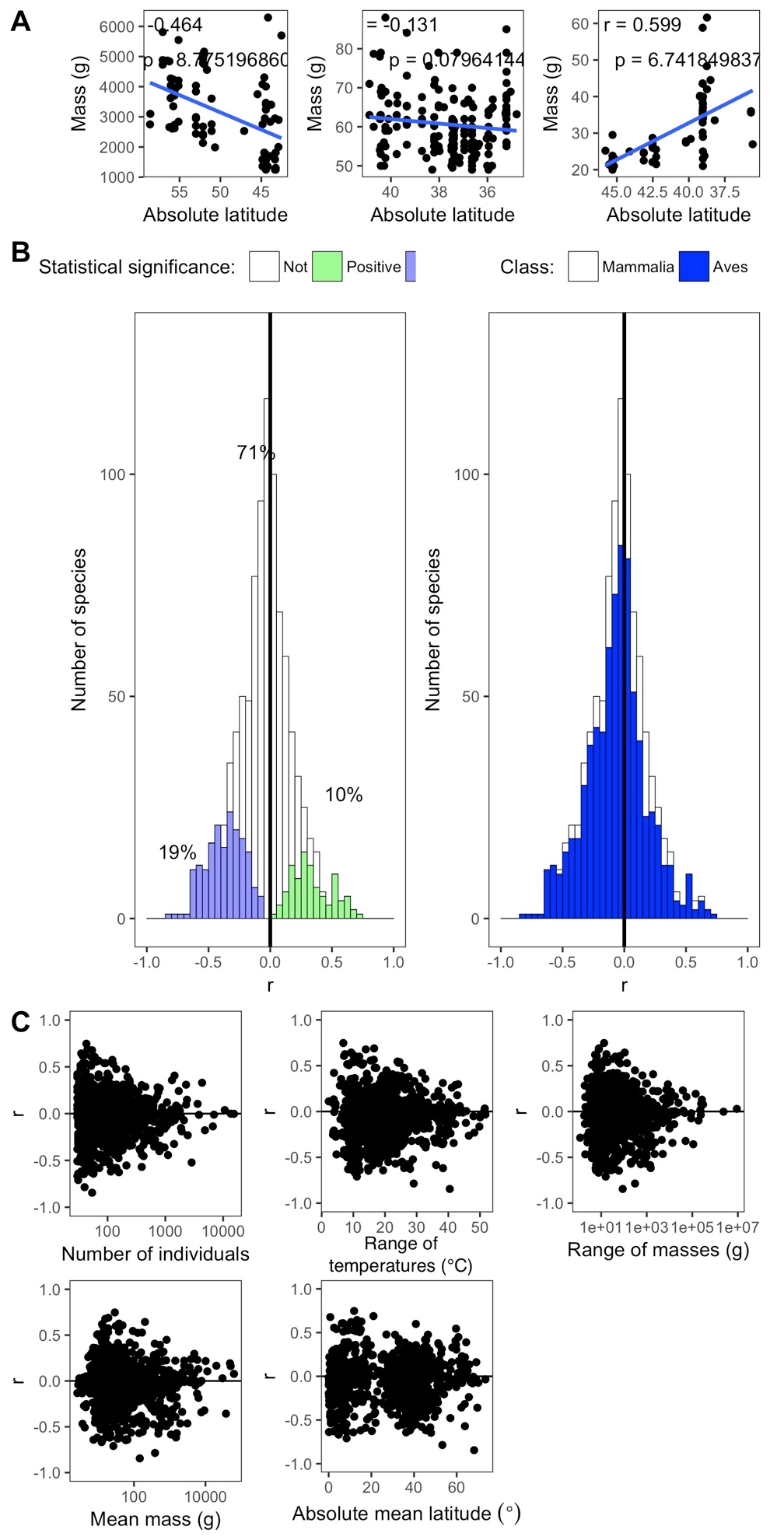

Figure A-5. Species correlation coefficients for latitude-mass relationships.Results for all species' latitude-mass relationships including (A) linear regression for latitude-temperature relationships for three example species, *Martes pennanti*, *Tamias quadrivittatus*, and *Synaptomys cooperi*, (B) stacked histograms of all species' correlation coefficients (r) showing statistical significance of relationships and relationships by taxonomic class, and (C) variation in all species' correlation coefficients across number of individuals, collection year temperature range, mass range, mean mass, and absolute mean latitude. The latitude axes in (A) are reversed (i.e., higher latitudes to left) to correspond with temperature axes (Figures 1 and 2).

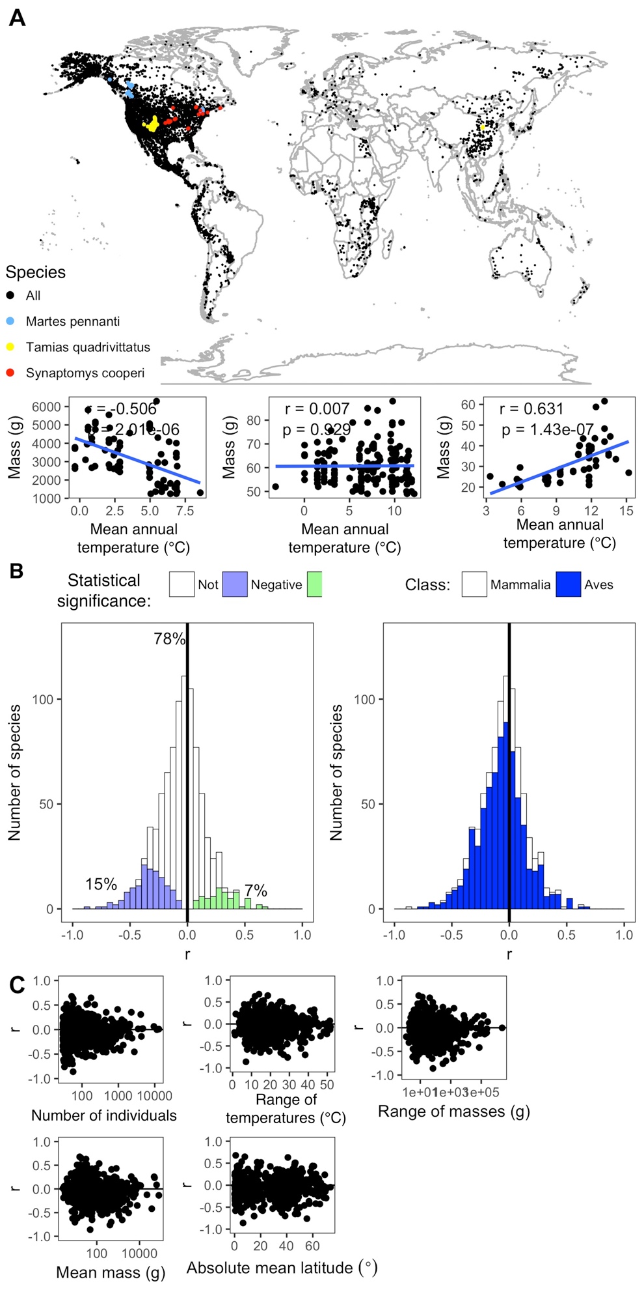

Figure A-6. Species correlation coefficients for temperature-mass relationships with lifestage sensitivity analysis.Results for all species' temperature-mass relationships with additional filtering of specimens based on lifestage. The final dataset (Figure 2A) contained a column with lifestage information for each individual, if it had been recorded. To remove all individuals explicitly identified as non-adults, we filtered that dataset to include only those individuals which had their lifestage recorded as adult, or if no lifestage information was provided. These include (A) spatial collection locations of all individual specimens and linear regression for temperature-mass relationships for three example species, *Martes pennanti*, *Tamias quadrivittatus*, and *Synaptomys cooperi*, (B) stacked histograms of all species' correlation coefficients (r) showing statistical significance of relationships and relationships by taxonomic class, and (C) variation in all species' correlation coefficients across number of individuals, collection year temperature range, mass range, mean mass, and absolute mean latitude.

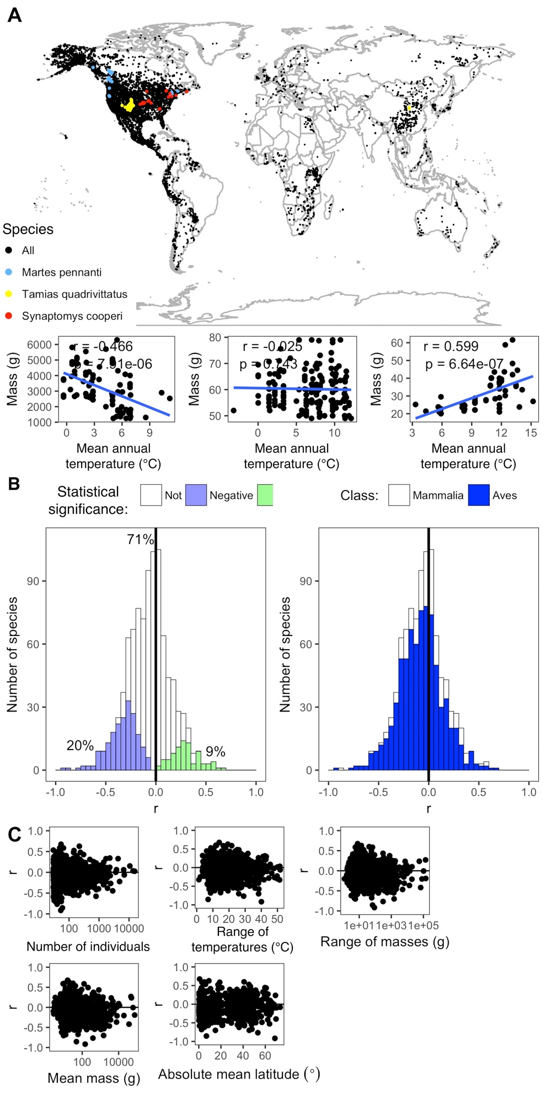

Figure A-7. Species correlation coefficients for temperature-mass relationships with outlier sensitivity analysis.Results for all species' temperature-mass relationships with outliers removed. Outliers were considered any individual mass value that was more than three standard deviations away from the fitted relationship value. These include (A) spatial collection locations for all individual specimens and linear regression for temperature-mass relationships for three example species, *Martes pennanti*, *Tamias quadrivittatus*, and *Synaptomys cooperi*, (B) stacked histograms of all species' correlation coefficients (r) showing statistical significance of relationships and relationships by taxonomic class, and (C) variation in all species' correlation coefficients across number of individuals, collection year temperature range, mass range, mean mass, and absolute mean latitude.

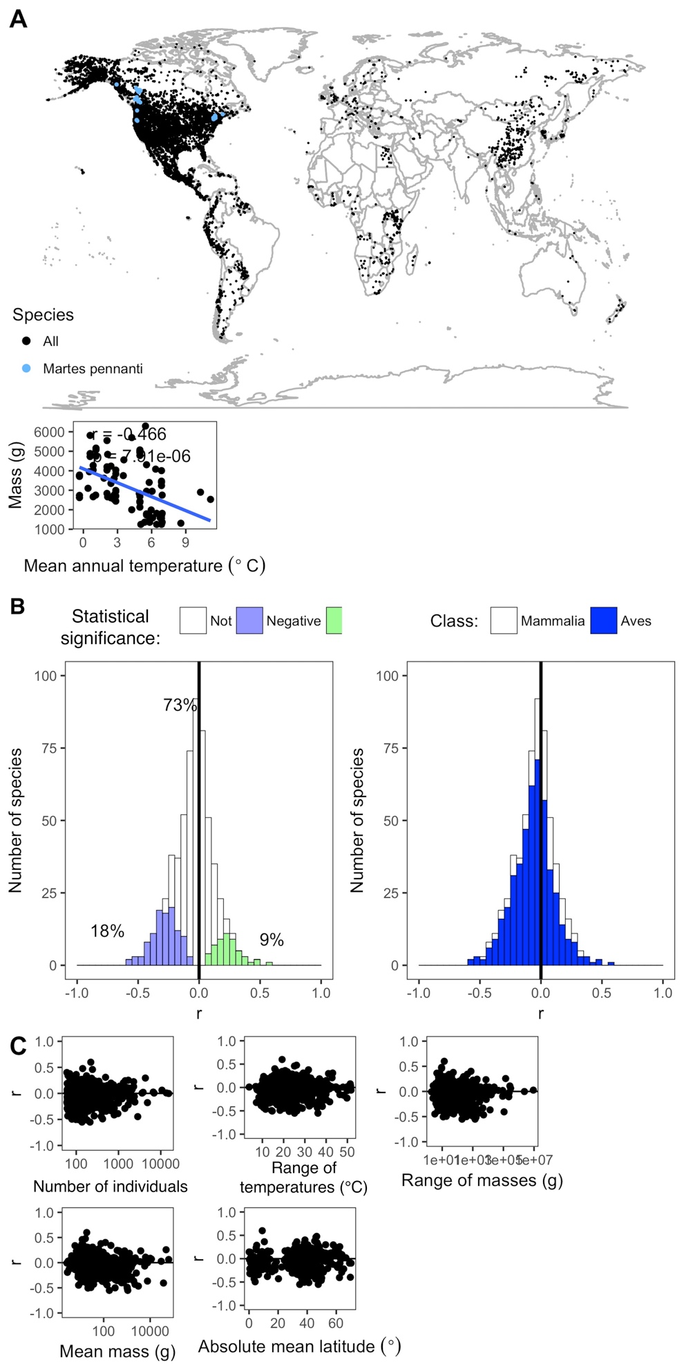

Figure A-8. Species correlation coefficients for temperature-mass relationships with species thresholds increased.Results for all species’ temperature-mass relationships for species with at least 60 individuals, range in collection years of at least 40, and range in latitudinal degrees of at least 10 (n = 591). These include (A) spatial collection locations for all individual specimens and linear regression for temperature-mass relationship for an example species, *Martes pennant*, (B) stacked histograms of all species’ correlation coefficients (r) showing statistical significance of relationships and relationships by taxonomic class, and (C) variation in all species’ correlation coefficients across number of individuals, collection year temperature range, mass range, mean mass, and absolute mean latitude.

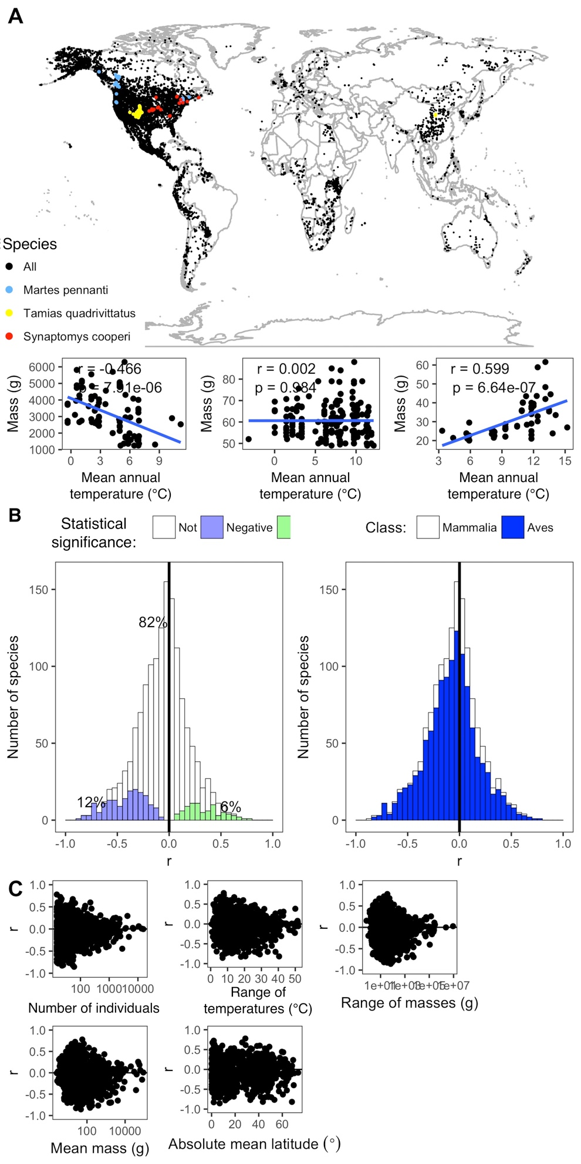

Figure A-9. Species correlation coefficients for temperature-mass relationships with species thresholds decreased.Results for all species’ temperature-mass relationships for species with at least 15 individuals, range in collection years of at least 10, and range in latitudinal degrees of at least 2.5 (n = 1,455). These include (A) spatial collection locations for all individual specimens and linear regression for temperature-mass relationships for three example species, *Martes pennant*, *Tamias quadrivittatus*, and *Synaptomys cooperi*, (B) stacked histograms of all species’ correlation coefficients (r) showing statistical significance of relationships and relationships by taxonomic class, and (C) variation in all species’ correlation coefficients across number of individuals, collection year temperature range, mass range, mean mass, and absolute mean latitude.

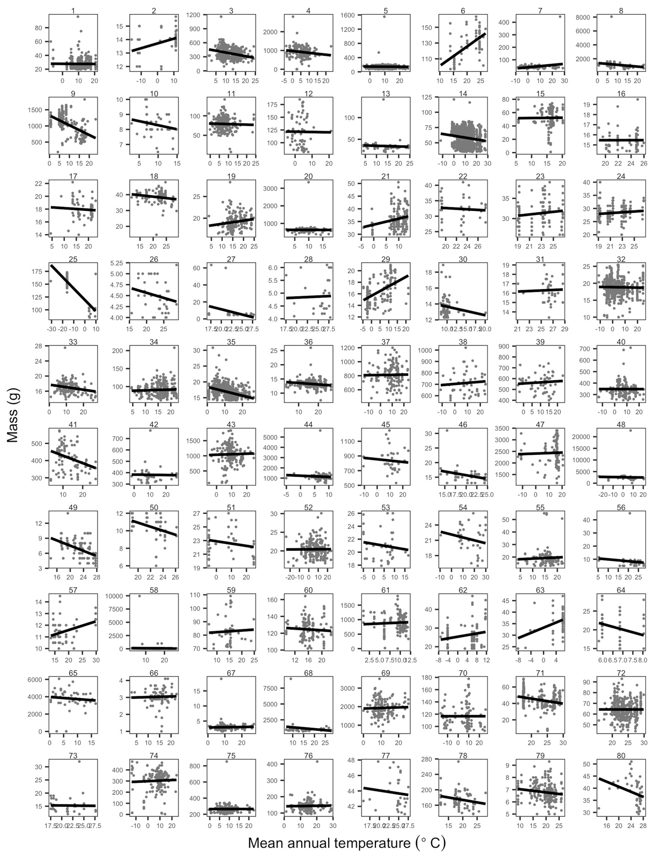

Figure A-10. Species’ temperature-mass relationships. Plots of temperature-mass relationships for 80 of the 952 species. Grey points are individuals and black lines show ordinary least squares linear regression of relationships. Ranges of both mass and temperature axes vary depending on species. Species names with corresponding plot numbers: *(1) Abrothrix olivaceus, (2) Acanthis flammea, (3) Accipiter cooperii, (4) Accipiter gentilis, (5) Accipiter striatus, (6) Acridotheres tristis, (7) Actitis macularia, (8) Aechmophorus clarkii, (9) Aechmophorus occidentalis, (10) Aegithalos caudatus, (11) Aegolius acadicus, (12) Aegolius funereus, (13) Aeronautes saxatalis, (14) Agelaius phoeniceus, (15) Agelaius tricolor, (16) Aimophila carpalis, (17) Aimophila cassinii, (18) Aimophila rufescens, (19) Aimophila ruficeps, (20) Aix sponsa, (21) Alauda arvensis, (22) Alcedo quadribrachys, (23) Alethe diademata, (24) Alethe poliocephala, (25) Alle alle, (26) Amazilia beryllina, (27) Amazilia cyanocephala, (28) Amazilia rutila, (29) Ammodramus caudacutus, (30) Ammodramus henslowii, (31) Ammodramus humeralis, (32) Ammodramus sandwichensis, (33) Ammodramus savannarum, (34) Ammospermophilus leucurus, (35) Amphispiza belli, (36) Amphispiza bilineata, (37) Anas acuta, (38) Anas americana, (39) Anas clypeata, (40) Anas crecca, (41) Anas cyanoptera, (42) Anas discors, (43) Anas platyrhynchos, (44) Anas rubripes, (45) Anas strepera, (46) Anoura geoffroyi, (47) Anser albifrons, (48) Anser caerulescens, (49) Anthreptes collaris, (50) Anthreptes rectirostris, (51) Anthus hodgsoni, (52) Anthus rubescens, (53) Anthus spinoletta, (54) Anthus trivialis, (55) Antrozous pallidus, (56) Apalis flavida, (57) Apalis thoracica, (58) Aphelocoma californica, (59) Aphelocoma coerulescens, (60) Aphelocoma ultramarina, (61) Aplodontia rufa, (62) Apodemus agrarius, (63) Apodemus peninsulae, (64) Apodemus uralensis, (65) Aquila chrysaetos, (66) Archilochus alexandri, (67) Archilochus colubris, (68) Ardea alba, (69) Ardea herodias, (70) Arenaria interpres, (71) Artibeus jamaicensis, (72) Artibeus lituratus, (73) Artibeus toltecus, (74) Asio flammeus, (75) Asio otus, (76) Athene cunicularia, (77) Attila spadiceus, (78) Aulacorhynchus prasinus, (79) Auriparus flaviceps, (80) Automolus ochrolaemus.*

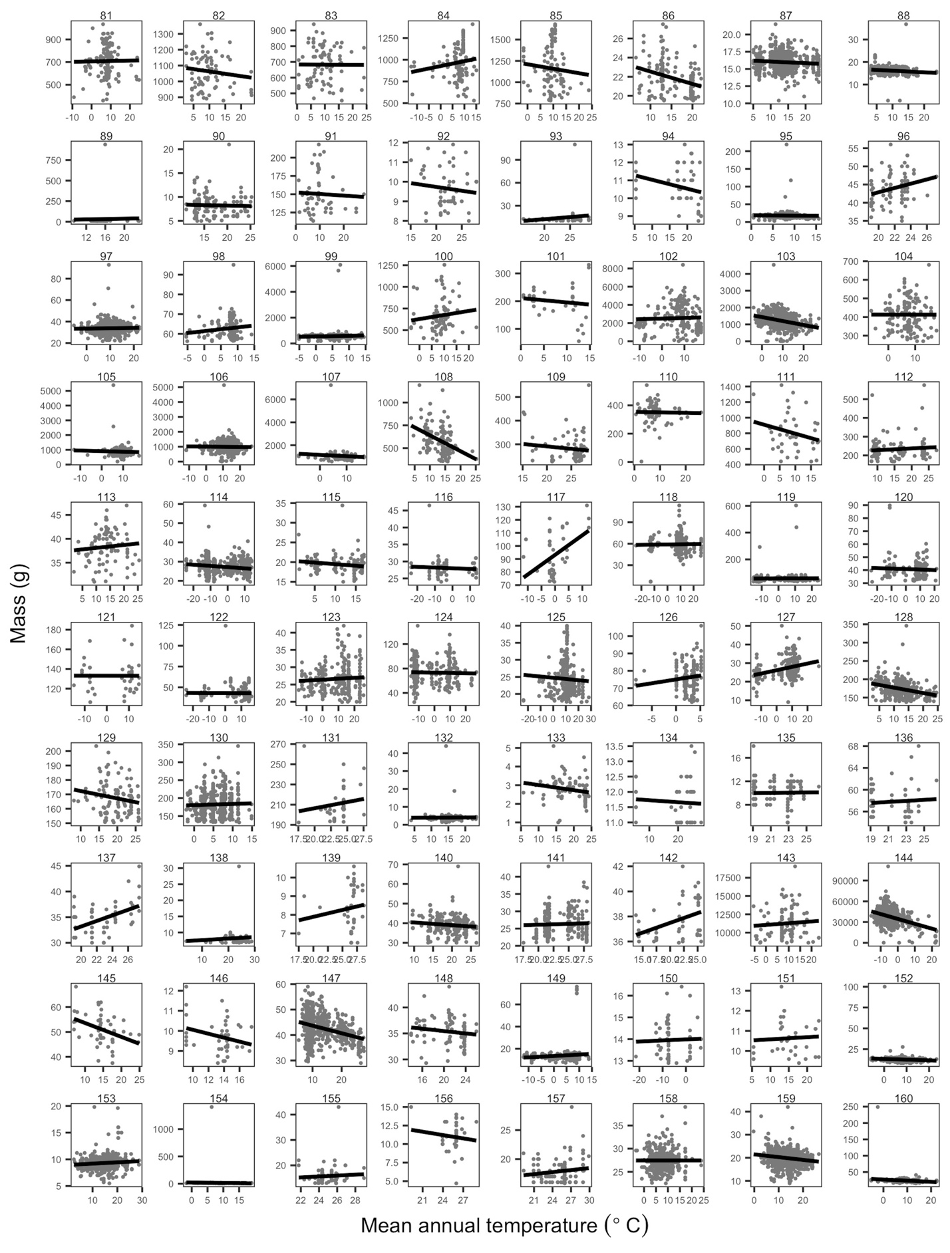

Figure A-11. Species’ temperature-mass relationships. Plots of temperature-mass relationships for 80 of the 952 species. Grey points are individuals and black lines show ordinary least squares linear regression of relationships. Ranges of both mass and temperature axes vary depending on species. Species names with corresponding plot numbers: *(81) Aythya affinis, (82) Aythya americana, (83) Aythya collaris, (84) Aythya marila, (85) Aythya valisineria, (86) Baeolophus bicolor, (87) Baeolophus inornatus, (88) Baeolophus ridgwayi, (89) Baeolophus wollweberi, (90) Baiomys taylori, (91) Bartramia longicauda, (92) Basileuterus culicivorus, (93) Basileuterus rufifrons, (94) Batis molitor, (95) Blarina brevicauda, (96) Bleda syndactyla, (97) Bombycilla cedrorum, (98) Bombycilla garrulus, (99) Bonasa umbellus, (100) Botaurus lentiginosus, (101) Brachyramphus marmoratus, (102) Branta canadensis, (103) Bubo virginianus, (104) Bucephala albeola, (105) Bucephala clangula, (106) Buteo jamaicensis, (107) Buteo lagopus, (108) Buteo lineatus, (109) Buteo magnirostris, (110) Buteo platypterus, (111) Buteo swainsoni, (112) Butorides virescens, (113) Calamospiza melanocorys, (114) Calcarius lapponicus, (115) Calcarius ornatus, (116) Calcarius pictus, (117) Calidris acuminata, (118) Calidris alba, (119) Calidris alpina, (120) Calidris bairdii, (121) Calidris canutus, (122) Calidris fuscicollis, (123) Calidris mauri, (124) Calidris melanotos, (125) Calidris minutilla, (126) Calidris ptilocnemis, (127) Calidris pusilla, (128) Callipepla californica, (129) Callipepla gambelii, (130) Callospermophilus lateralis, (131) Calocitta formosa, (132) Calypte anna, (133) Calypte costae, (134) Camaroptera brachyura, (135) Camaroptera chloronota, (136) Campethera caroli, (137) Campethera nivosa, (138) Camptostoma obsoletum, (139) Campylopterus largipennis, (140) Campylorhynchus brunneicapillus, (141) Campylorhynchus rufinucha, (142) Campylorhynchus zonatus, (143) Canis latrans, (144) Canis lupus, (145) Caprimulgus vociferus, (146) Cardellina rubrifrons, (147) Cardinalis cardinalis, (148) Cardinalis sinuatus, (149) Carduelis flammea, (150) Carduelis hornemanni, (151) Carduelis lawrencei, (152) Carduelis pinus, (153) Carduelis psaltria, (154) Carduelis tristis, (155) Carollia brevicauda, (156) Carollia castanea, (157) Carollia perspicillata, (158) Carpodacus cassinii, (159) Carpodacus mexicanus, (160) Carpodacus purpureus.*

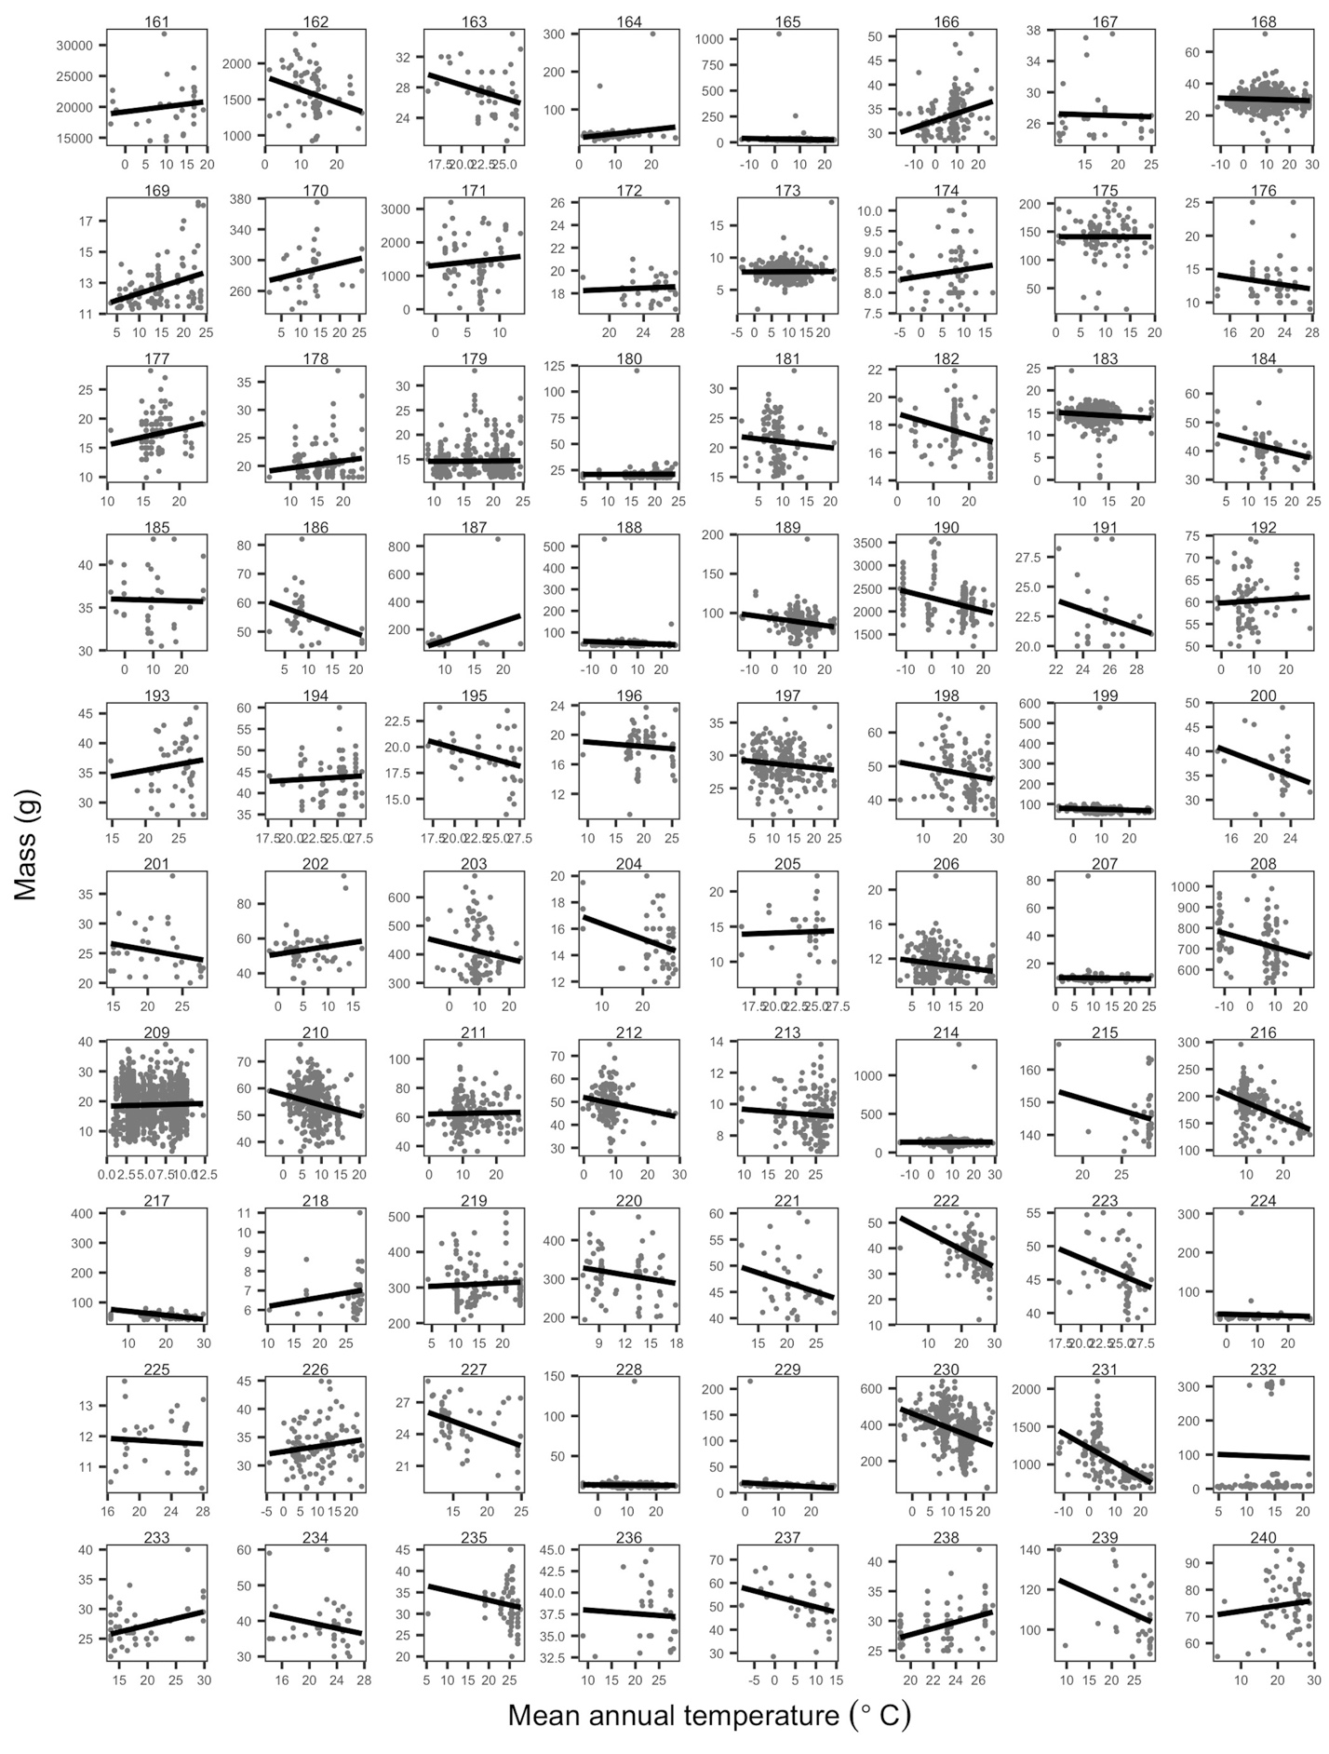

Figure A-12. Species’ temperature-mass relationships. Plots of temperature-mass relationships for 80 of the 952 species. Grey points are individuals and black lines show ordinary least squares linear regression of relationships. Ranges of both mass and temperature axes vary depending on species. Species names with corresponding plot numbers: *(161) Castor canadensis, (162) Cathartes aura, (163) Catharus aurantiirostris, (164) Catharus fuscescens, (165) Catharus guttatus, (166) Catharus minimus, (167) Catharus occidentalis, (168) Catharus ustulatus, (169) Catherpes mexicanus, (170) Catoptrophorus semipalmatus, (171) Centrocercus urophasianus, (172) Cercomacra tyrannina, (173) Certhia americana, (174) Certhia familiaris, (175) Ceryle alcyon, (176) Ceyx picta, (177) Chaetodipus fallax, (178) Chaetodipus formosus, (179) Chaetodipus intermedius, (180) Chaetodipus penicillatus, (181) Chaetura pelagica, (182) Chaetura vauxi, (183) Chamaea fasciata, (184) Charadrius alexandrinus, (185) Charadrius dubius, (186) Charadrius melodus, (187) Charadrius montanus, (188) Charadrius semipalmatus, (189) Charadrius vociferus, (190) Chen caerulescens, (191) Chiroderma villosum, (192) Chlidonias niger, (193) Chloroceryle americana, (194) Chlorocichla flaviventris, (195) Chlorophanes spiza, (196) Chlorospingus ophthalmicus, (197) Chondestes grammacus, (198) Chordeiles acutipennis, (199) Chordeiles minor, (200) Chrysococcyx cupreus, (201) Chrysococcyx klaas, (202) Cinclus mexicanus, (203) Circus cyaneus, (204) Cisticola erythrops, (205) Cisticola galactotes, (206) Cistothorus palustris, (207) Cistothorus platensis, (208) Clangula hyemalis, (209) Clethrionomys gapperi, (210) Coccothraustes vespertinus, (211) Coccyzus americanus, (212) Coccyzus erythropthalmus, (213) Coereba flaveola, (214) Colaptes auratus, (215) Colinus cristatus, (216) Colinus virginianus, (217) Colius striatus, (218) Collocalia esculenta, (219) Columba fasciata, (220) Columba livia, (221) Columbina inca, (222) Columbina passerina, (223) Columbina talpacoti, (224) Contopus borealis, (225) Contopus cinereus, (226) Contopus cooperi, (227) Contopus pertinax, (228) Contopus sordidulus, (229) Contopus virens, (230) Corvus brachyrhynchos, (231) Corvus corax, (232) Corynorhinus townsendii, (233) Cossypha caffra, (234) Cossypha heuglini, (235) Cossypha natalensis, (236) Cossypha niveicapilla, (237) Coturnicops noveboracensis, (238) Criniger calurus, (239) Crotophaga ani, (240) Crotophaga sulcirostris.*

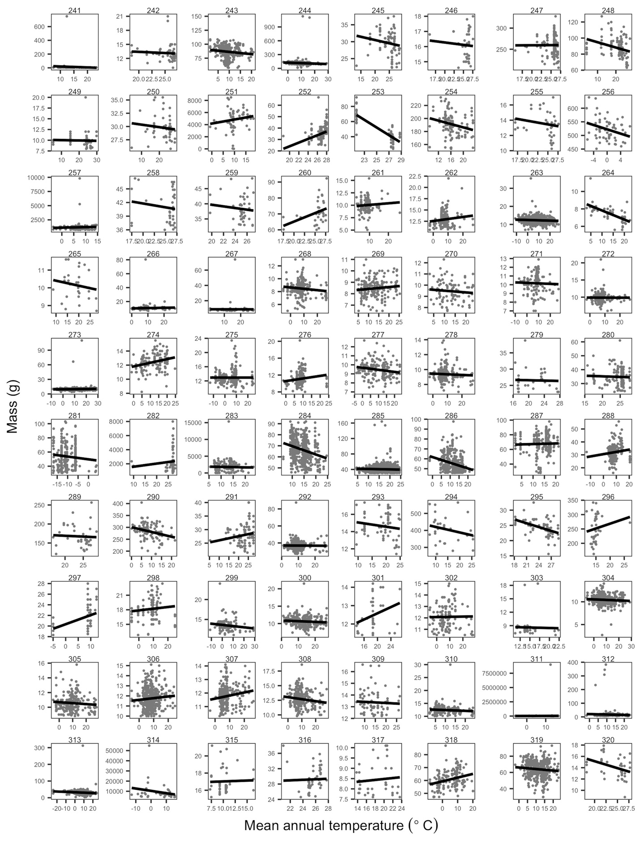

Figure A-13. Species’ temperature-mass relationships. Plots of temperature-mass relationships for 80 of the 952 species. Grey points are individuals and black lines show ordinary least squares linear regression of relationships. Ranges of both mass and temperature axes vary depending on species. Species names with corresponding plot numbers: *(241) Cryptotis parva, (242) Cyanerpes cyaneus, (243) Cyanocitta cristata, (244) Cyanocitta stelleri, (245) Cyanocompsa cyanoides, (246) Cyanocompsa parellina, (247) Cyanocorax morio, (248) Cyanocorax yncas, (249) Cyanomitra olivacea, (250) Cyclarhis gujanensis, (251) Cygnus columbianus, (252) Cynopterus brachyotis, (253) Cynopterus sphinx, (254) Cyrtonyx montezumae, (255) Dacnis cayana, (256) Dendragapus canadensis, (257) Dendragapus obscurus, (258) Dendrocincla fuliginosa, (259) Dendrocincla homochroa, (260) Dendrocolaptes certhia, (261) Dendroica caerulescens, (262) Dendroica castanea, (263) Dendroica coronata, (264) Dendroica discolor, (265) Dendroica dominica, (266) Dendroica fusca, (267) Dendroica graciae, (268) Dendroica magnolia, (269) Dendroica nigrescens, (270) Dendroica occidentalis, (271) Dendroica palmarum, (272) Dendroica pensylvanica, (273) Dendroica petechia, (274) Dendroica pinus, (275) Dendroica striata, (276) Dendroica tigrina, (277) Dendroica townsendi, (278) Dendroica virens, (279) Dendropicos fuscescens, (280) Desmodus rotundus, (281) Dicrostonyx groenlandicus, (282) Didelphis marsupialis, (283) Didelphis virginiana, (284) Dipodomys agilis, (285) Dipodomys merriami, (286) Dipodomys ordii, (287) Dipodomys panamintinus, (288) Dolichonyx oryzivorus, (289) Dryocopus lineatus, (290) Dryocopus pileatus, (291) Dryoscopus cubla, (292) Dumetella carolinensis, (293) Dysithamnus mentalis, (294) Egretta thula, (295) Elaenia flavogaster, (296) Elanus leucurus, (297) Emberiza aureola, (298) Emberiza spodocephala, (299) Empidonax alnorum, (300) Empidonax difficilis, (301) Empidonax flavescens, (302) Empidonax flaviventris, (303) Empidonax fulvifrons, (304) Empidonax hammondii, (305) Empidonax minimus, (306) Empidonax oberholseri, (307) Empidonax occidentalis, (308) Empidonax traillii, (309) Empidonax virescens, (310) Empidonax wrightii, (311) Enhydra lutris, (312) Eptesicus fuscus, (313) Eremophila alpestris, (314) Erethizon dorsatum, (315) Erithacus rubecula, (316) Eucometis penicillata, (317) Eugenes fulgens, (318) Euphagus carolinus, (319) Euphagus cyanocephalus, (320) Euphonia hirundinacea.*

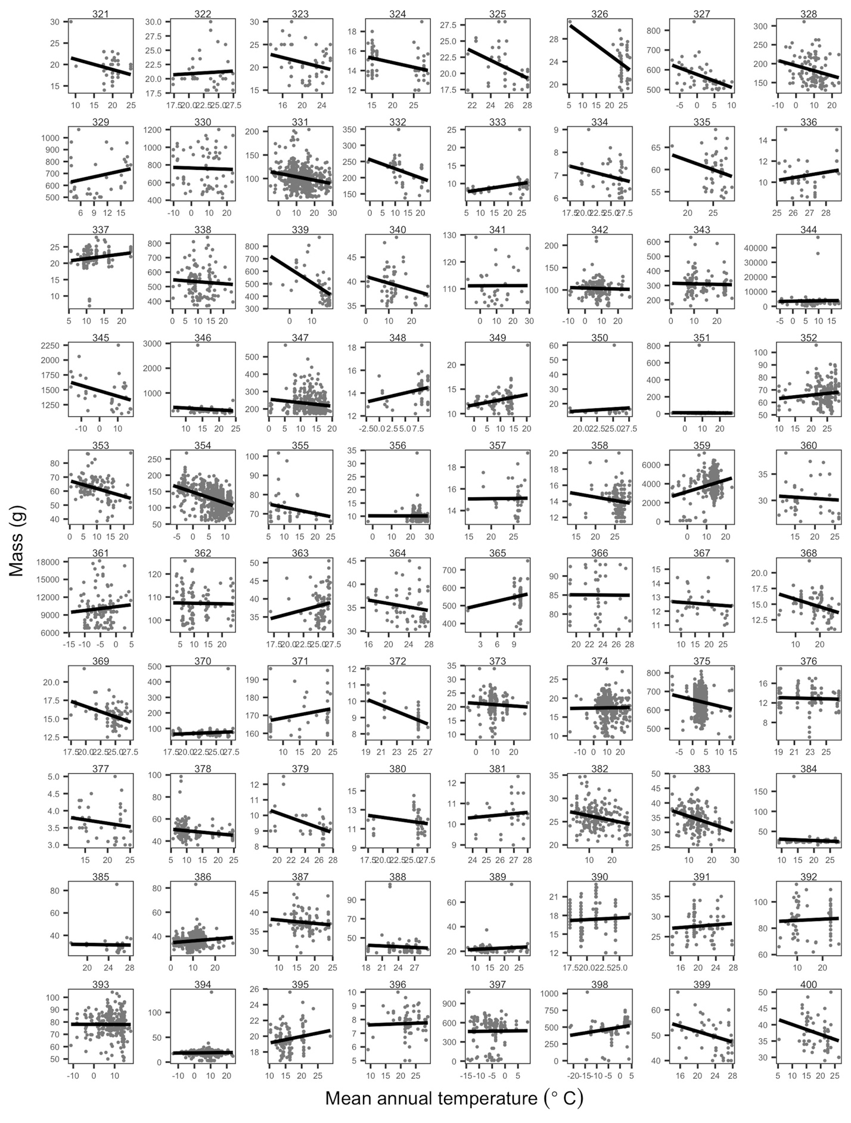

Figure A-14. Species’ temperature-mass relationships. Plots of temperature-mass relationships for 80 of the 952 species. Grey points are individuals and black lines show ordinary least squares linear regression of relationships. Ranges of both mass and temperature axes vary depending on species. Species names with corresponding plot numbers: *(321) Euplectes albonotatus, (322) Euplectes ardens, (323) Euplectes capensis, (324) Euplectes franciscanus, (325) Euplectes hordeaceus, (326) Eurillas virens, (327) Falcipennis canadensis, (328) Falco columbarius, (329) Falco mexicanus, (330) Falco peregrinus, (331) Falco sparverius, (332) Falco tinnunculus, (333) Ficedula hyperythra, (334) Florisuga mellivora, (335) Formicarius analis, (336) Formicivora grisea, (337) Fringilla coelebs, (338) Fulica americana, (339) Fulmarus glacialis, (340) Galerida cristata, (341) Gallinago delicata, (342) Gallinago gallinago, (343) Gallinula chloropus, (344) Gavia immer, (345) Gavia stellata, (346) Geococcyx californianus, (347) Geomys bursarius, (348) Geothlypis agilis, (349) Geothlypis philadelphia, (350) Geothlypis poliocephala, (351) Geothlypis trichas, (352) Glaucidium brasilianum, (353) Glaucidium gnoma, (354) Glaucomys sabrinus, (355) Glaucomys volans, (356) Glossophaga soricina, (357) Glyphorhynchus spirurus, (358) Glyphorynchus spirurus, (359) Grus canadensis, (360) Guiraca caerulea, (361) Gulo gulo, (362) Gymnorhinus cyanocephalus, (363) Habia fuscicauda, (364) Habia rubica, (365) Haematopus ostralegus, (366) Halcyon malimbica, (367) Helmitheros vermivorus, (368) Henicorhina leucophrys, (369) Henicorhina leucosticta, (370) Heteromys desmarestianus, (371) Himantopus mexicanus, (372) Hipposideros ruber, (373) Hirundo pyrrhonota, (374) Hirundo rustica, (375) Histrionicus histrionicus, (376) Hylia prasina, (377) Hylocharis leucotis, (378) Hylocichla mustelina, (379) Hylophilus decurtatus, (380) Hypocnemis cantator, (381) Hypothymis azurea, (382) Icteria virens, (383) Icterus bullockii, (384) Icterus cucullatus, (385) Icterus dominicensis, (386) Icterus galbula, (387) Icterus parisorum, (388) Icterus pustulatus, (389) Icterus spurius, (390) Indicator exilis, (391) Indicator minor, (392) Ixobrychus exilis, (393) Ixoreus naevius, (394) Junco hyemalis, (395) Junco phaeonotus, (396) Lagonosticta senegala, (397) Lagopus lagopus, (398) Lagopus mutus, (399) Laniarius ferrugineus, (400) Lanius collaris.*

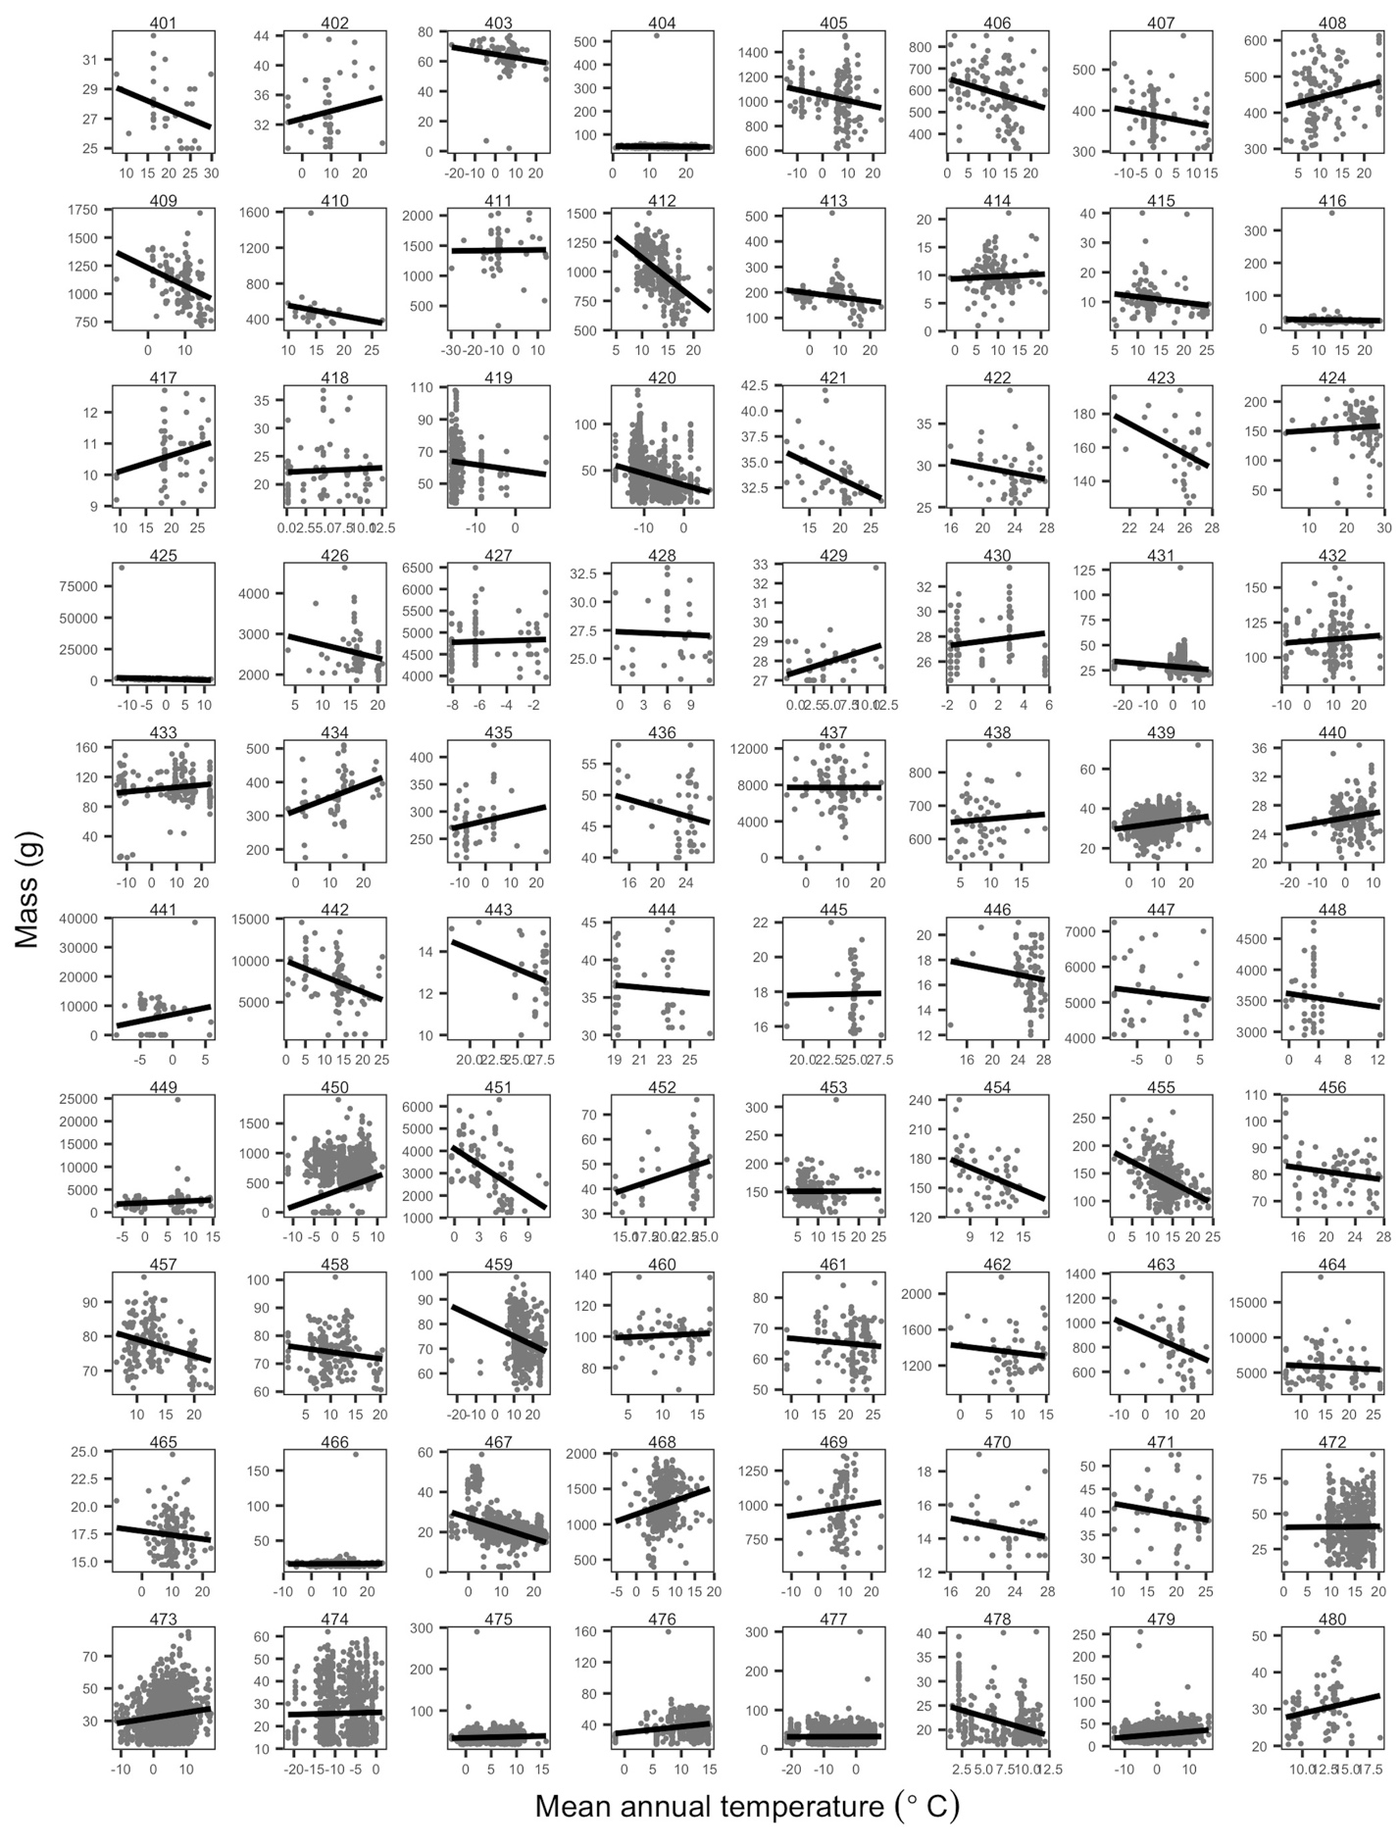

Figure A-15. Species’ temperature-mass relationships. Plots of temperature-mass relationships for 80 of the 952 species. Grey points are individuals and black lines show ordinary least squares linear regression of relationships. Ranges of both mass and temperature axes vary depending on species. Species names with corresponding plot numbers: *(401) Lanius collurio, (402) Lanius cristatus, (403) Lanius excubitor, (404) Lanius ludovicianus, (405) Larus argentatus, (406) Larus californicus, (407) Larus canus, (408) Larus delawarensis, (409) Larus glaucescens, (410) Larus heermanni, (411) Larus hyperboreus, (412) Larus occidentalis, (413) Larus philadelphia, (414) Lasionycteris noctivagans, (415) Lasiurus borealis, (416) Lasiurus cinereus, (417) Lathrotriccus euleri, (418) Lemmiscus curtatus, (419) Lemmus sibiricus, (420) Lemmus trimucronatus, (421) Lepidocolaptes affinis, (422) Lepidocolaptes souleyetii, (423) Leptotila rufaxilla, (424) Leptotila verreauxi, (425) Lepus americanus, (426) Lepus californicus, (427) Lepus othus, (428) Leucosticte arctoa, (429) Leucosticte atrata, (430) Leucosticte australis, (431) Leucosticte tephrocotis, (432) Limnodromus griseus, (433) Limnodromus scolopaceus, (434) Limosa fedoa, (435) Limosa lapponica, (436) Liomys pictus, (437) Lontra canadensis, (438) Lophodytes cucullatus, (439) Loxia curvirostra, (440) Loxia leucoptera, (441) Lynx canadensis, (442) Lynx rufus, (443) Macronous gularis, (444) Malimbus malimbicus, (445) Manacus candei, (446) Manacus manacus, (447) Marmota caligata, (448) Marmota flaviventris, (449) Marmota monax, (450) Martes americana, (451) Martes pennanti, (452) Mastomys natalensis, (453) Megaceryle alcyon, (454) Megascops asio, (455) Megascops kennicottii, (456) Melanerpes aurifrons, (457) Melanerpes carolinus, (458) Melanerpes erythrocephalus, (459) Melanerpes formicivorus, (460) Melanerpes lewis, (461) Melanerpes uropygialis, (462) Melanitta fusca, (463) Melanitta perspicillata, (464) Meleagris gallopavo, (465) Melospiza georgiana, (466) Melospiza lincolnii, (467) Melospiza melodia, (468) Mergus merganser, (469) Mergus serrator, (470) Merops pusillus, (471) Micrathene whitneyi, (472) Microtus californicus, (473) Microtus longicaudus, (474) Microtus miurus, (475) Microtus montanus, (476) Microtus ochrogaster, (477) Microtus oeconomus, (478) Microtus oregoni, (479) Microtus pennsylvanicus, (480) Microtus pinetorum.*

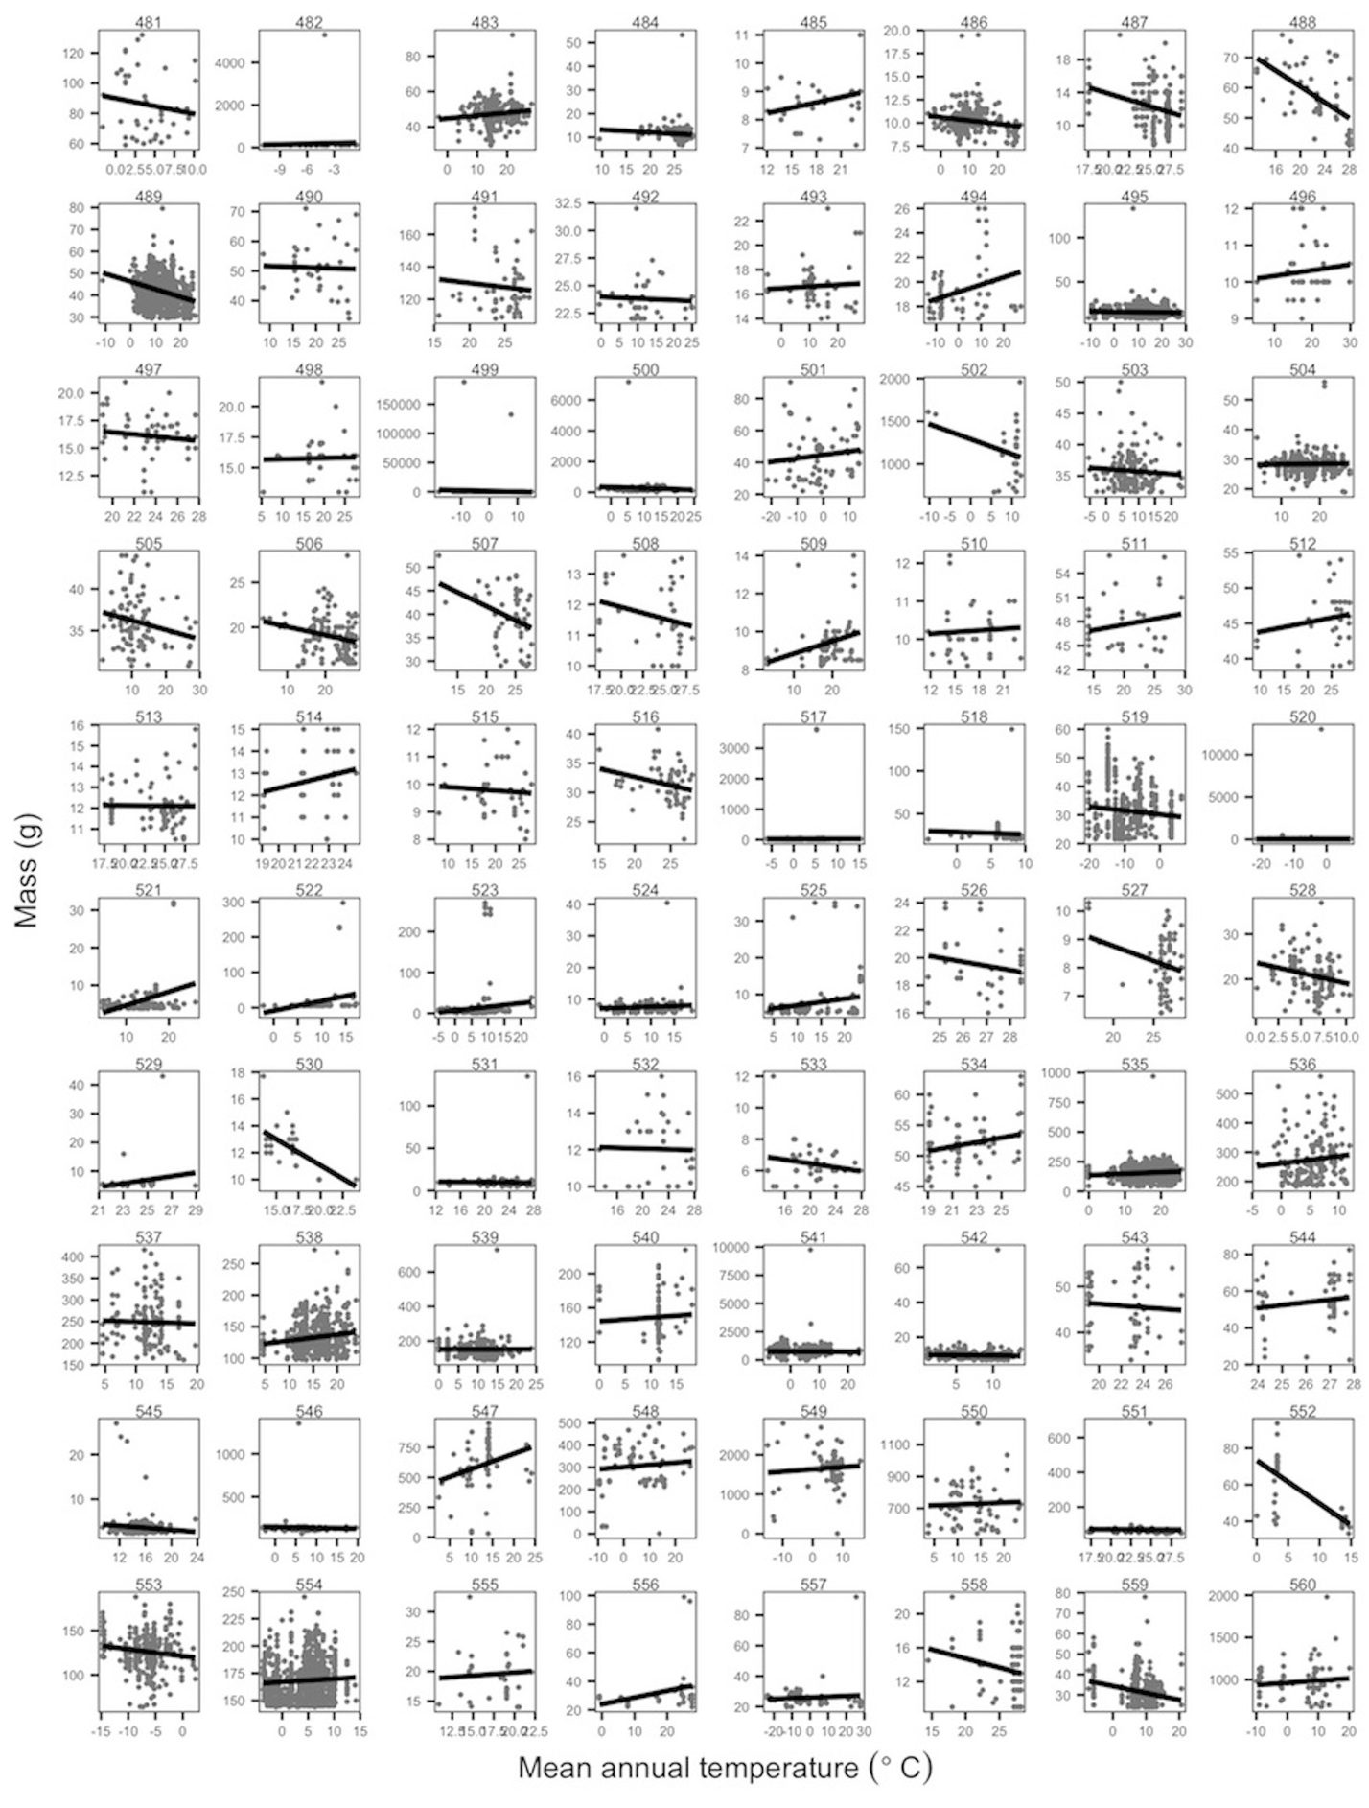

Figure A-16. Species’ temperature-mass relationships.**.** Plots of temperature-mass relationships for 80 of the 952 species. Grey points are individuals and black lines show ordinary least squares linear regression of relationships. Ranges of both mass and temperature axes vary depending on species. Species names with corresponding plot numbers: *(481) Microtus richardsoni, (482) Microtus xanthognathus, (483) Mimus polyglottos, (484) Mionectes oleagineus, (485) Mitrephanes phaeocercus, (486) Mniotilta varia, (487) Molossus molossus, (488) Molothrus aeneus, (489) Molothrus ater, (490) Molothrus bonariensis, (491) Momotus momota, (492) Motacilla alba, (493) Motacilla cinerea, (494) Motacilla flava, (495) Mus musculus, (496) Muscicapa adusta, (497) Muscicapa caerulescens, (498) Muscicapa striata, (499) Mustela erminea, (500) Mustela frenata, (501) Mustela nivalis, (502) Mustela vison, (503) Myadestes townsendi, (504) Myiarchus cinerascens, (505) Myiarchus crinitus, (506) Myiarchus tuberculifer, (507) Myiarchus tyrannulus, (508) Myiobius barbatus, (509) Myioborus miniatus, (510) Myioborus pictus, (511) Myiodynastes luteiventris, (512) Myiodynastes maculatus, (513) Myiopagis viridicata, (514) Myioparus griseigularis, (515) Myiophobus fasciatus, (516) Myiozetetes similis, (517) Myodes gapperi, (518) Myodes glareolus, (519) Myodes rufocanus, (520) Myodes rutilus, (521) Myotis californicus, (522) Myotis evotis, (523) Myotis lucifugus, (524) Myotis volans, (525) Myotis yumanensis, (526) Myrmoborus leucophrys, (527) Myrmotherula axillaris, (528) Napaeozapus insignis, (529) Natalus stramineus, (530) Nectarinia famosa, (531) Nectarinia olivacea, (532) Nectarinia senegalensis, (533) Nectarinia venusta, (534) Neocossyphus poensis, (535) Neotoma albigula, (536) Neotoma cinerea, (537) Neotoma fuscipes, (538) Neotoma lepida, (539) Neotoma mexicana, (540) Neotoma stephensi, (541) Neovison vison, (542) Neurotrichus gibbsii, (543) Nicator chloris, (544) Noctilio leporinus, (545) Notiosorex crawfordi, (546) Nucifraga columbiana, (547) Numenius americanus, (548) Numenius phaeopus, (549) Nyctea scandiaca, (550) Nycticorax nycticorax, (551) Nyctidromus albicollis, (552) Oceanodroma furcata, (553) Ochotona collaris, (554) Ochotona princeps, (555) Ochrotomys nuttalli, (556) Oenanthe isabellina, (557) Oenanthe oenanthe, (558) Oligoryzomys fulvescens, (559) Oligoryzomys longicaudatus, (560) Ondatra zibethicus.*

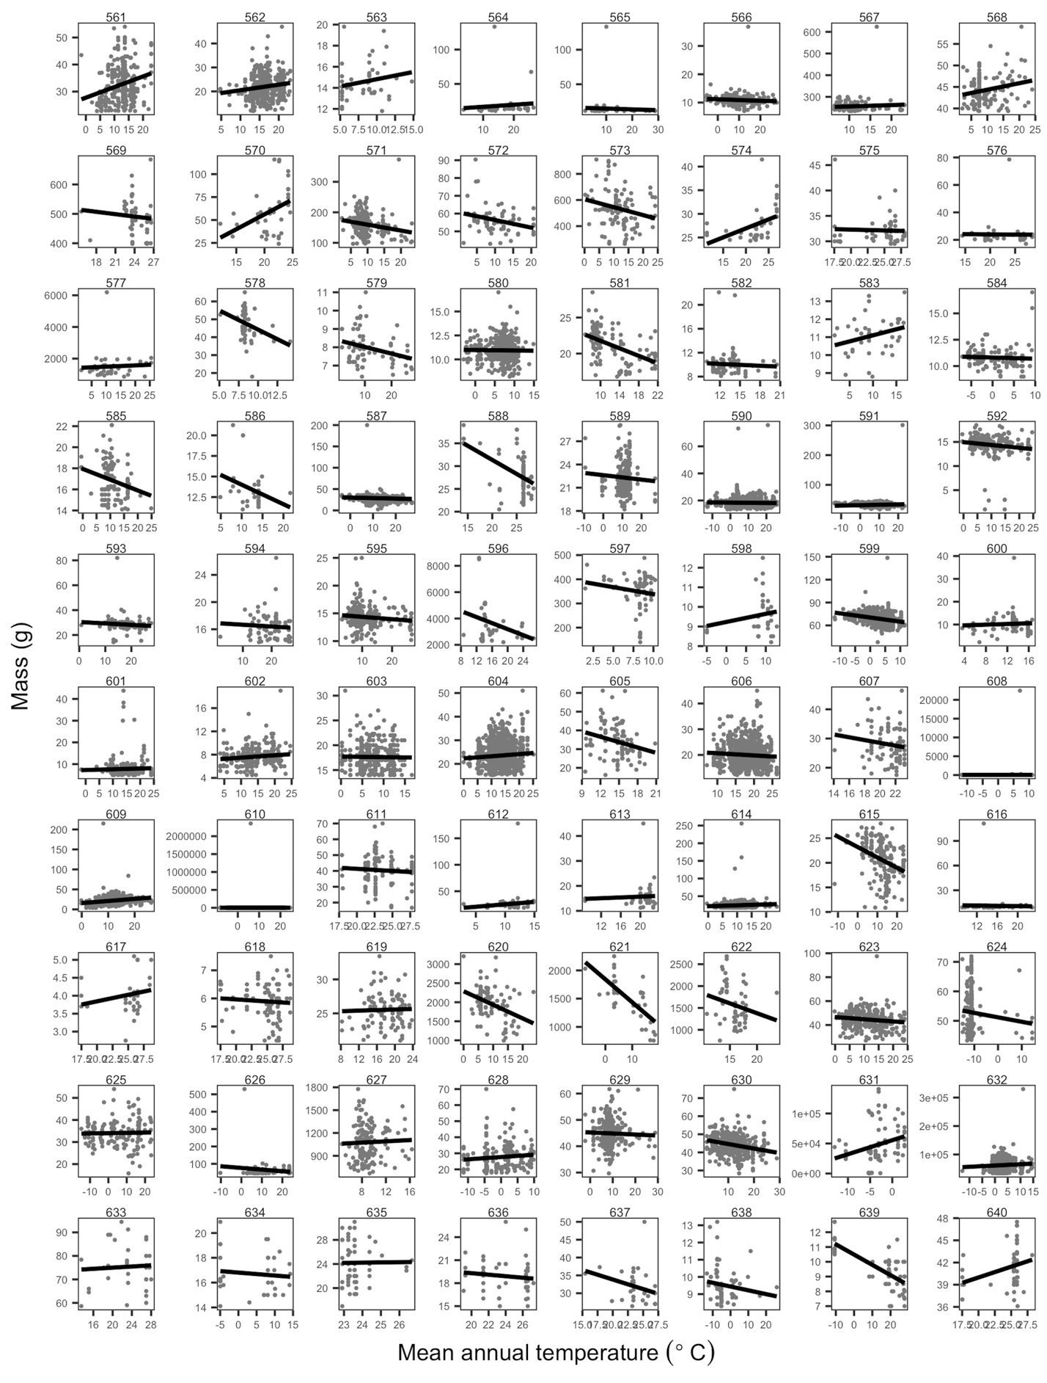

Figure A-17. Species’ temperature-mass relationships. Plots of temperature-mass relationships for 80 of the 952 species. Grey points are individuals and black lines show ordinary least squares linear regression of relationships. Ranges of both mass and temperature axes vary depending on species. Species names with corresponding plot numbers: *(561) Onychomys leucogaster, (562) Onychomys torridus, (563) Oporornis agilis, (564) Oporornis formosus, (565) Oporornis philadelphia, (566) Oporornis tolmiei, (567) Oreortyx pictus, (568) Oreoscoptes montanus, (569) Ortalis vetula, (570) Oryzomys palustris, (571) Otus asio, (572) Otus flammeolus, (573) Oxyura jamaicensis, (574) Pachycephala pectoralis, (575) Pachyramphus aglaiae, (576) Pachyramphus polychopterus, (577) Pandion haliaetus, (578) Parascalops breweri, (579) Parula americana, (580) Parus atricapillus, (581) Parus bicolor, (582) Parus carolinensis, (583) Parus gambeli, (584) Parus hudsonicus, (585) Parus major, (586) Parus monticolus, (587) Passer domesticus, (588) Passer griseus, (589) Passer montanus, (590) Passerculus sandwichensis, (591) Passerella iliaca, (592) Passerina amoena, (593) Passerina caerulea, (594) Passerina ciris, (595) Passerina cyanea, (596) Pelecanus occidentalis, (597) Perdix perdix, (598) Periparus ater, (599) Perisoreus canadensis, (600) Perognathus flavescens, (601) Perognathus flavus, (602) Perognathus longimembris, (603) Perognathus parvus, (604) Peromyscus boylii, (605) Peromyscus californicus, (606) Peromyscus eremicus, (607) Peromyscus gossypinus, (608) Peromyscus keeni, (609) Peromyscus leucopus, (610) Peromyscus maniculatus, (611) Peromyscus mexicanus, (612) Peromyscus nasutus, (613) Peromyscus polionotus, (614) Peromyscus truei, (615) Petrochelidon pyrrhonota, (616) Peucedramus taeniatus, (617) Phaethornis bourcieri, (618) Phaethornis superciliosus, (619) Phainopepla nitens, (620) Phalacrocorax auritus, (621) Phalacrocorax pelagicus, (622) Phalacrocorax penicillatus, (623) Phalaenoptilus nuttallii, (624) Phalaropus fulicarius, (625) Phalaropus lobatus, (626) Phalaropus tricolor, (627) Phasianus colchicus, (628) Phenacomys intermedius, (629) Pheucticus ludovicianus, (630) Pheucticus melanocephalus, (631) Phoca largha, (632) Phoca vitulina, (633) Phoeniculus purpureus, (634) Phoenicurus auroreus, (635) Phyllastrephus albigularis, (636) Phyllastrephus icterinus, (637) Phyllastrephus terrestris, (638) Phylloscopus borealis, (639) Phylloscopus trochilus, (640) Phyllostomus discolor.*

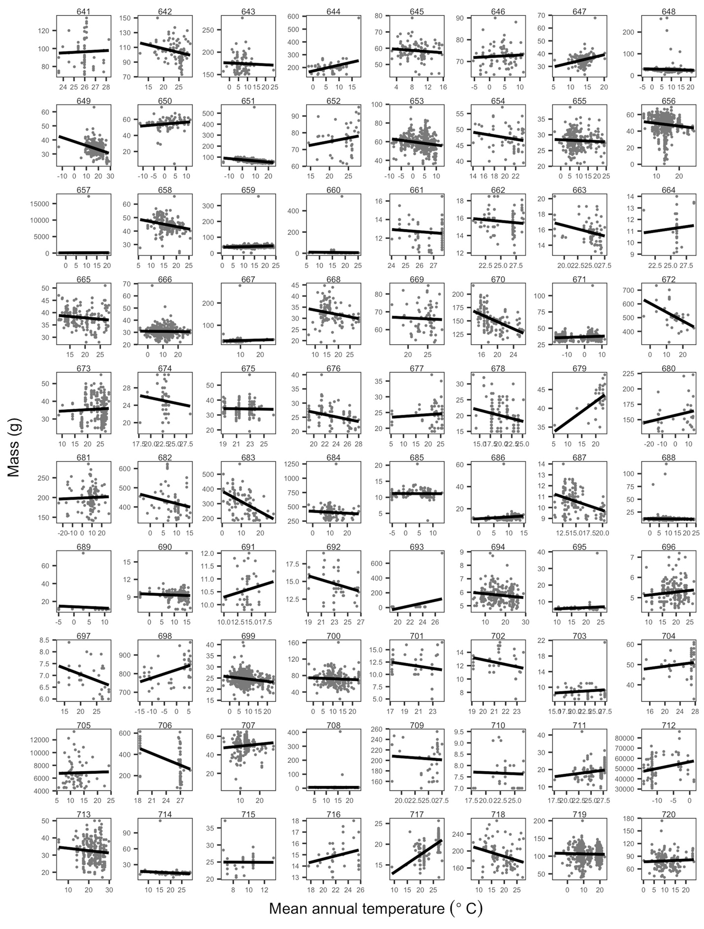

Figure A-18. Species’ temperature-mass relationships. Plots of temperature-mass relationships for 80 of the 952 species. Grey points are individuals and black lines show ordinary least squares linear regression of relationships. Ranges of both mass and temperature axes vary depending on species. Species names with corresponding plot numbers: *(641) Phyllostomus hastatus, (642) Piaya cayana, (643) Pica hudsonia, (644) Pica Pica, (645) Picoides albolarvatus, (646) Picoides arcticus, (647) Picoides nuttallii, (648) Picoides pubescens, (649) Picoides scalaris, (650) Picoides tridactylus, (651) Picoides villosus, (652) Piculus rubiginosus, (653) Pinicola enucleator, (654) Pipilo aberti, (655) Pipilo chlorurus, (656) Pipilo crissalis, (657) Pipilo erythrophthalmus, (658) Pipilo fuscus, (659) Pipilo maculatus, (660) Pipistrellus hesperus, (661) Pipra erythrocephala, (662) Pipra fasciicauda, (663) Pipra mentalis, (664) Pipra pipra, (665) Piranga flava, (666) Piranga ludoviciana, (667) Piranga olivacea, (668) Piranga rubra, (669) Pitangus sulphuratus, (670) Platycercus zonarius, (671) Plectrophenax nivalis, (672) Plegadis chihi, (673) Ploceus cucullatus, (674) Ploceus melanocephalus, (675) Ploceus nigerrimus, (676) Ploceus nigricollis, (677) Ploceus ocularis, (678) Ploceus velatus, (679) Ploceus xanthops, (680) Pluvialis dominica, (681) Pluvialis squatarola, (682) Podiceps auritus, (683) Podiceps nigricollis, (684) Podilymbus podiceps, (685) Poecile atricapilla, (686) Poecile atricapillus, (687) Poecile carolinensis, (688) Poecile gambeli, (689) Poecile palustris, (690) Poecile rufescens, (691) Poecile sclateri, (692) Pogoniulus scolopaceus, (693) Pogoniulus subsulphureus, (694) Polioptila caerulea, (695) Polioptila californica, (696) Polioptila melanura, (697) Polioptila plumbea, (698) Polysticta stelleri, (699) Pooecetes gramineus, (700) Porzana carolina, (701) Prinia bairdii, (702) Prinia leucopogon, (703) Prinia subflava, (704) Prionops retzii, (705) Procyon lotor, (706) Proechimys semispinosus, (707) Progne subis, (708) Psaltriparus minimus, (709) Pteroglossus torquatus, (710) Pteronotus davyi, (711) Pteronotus parnellii, (712) Pusa hispida, (713) Pycnonotus barbatus, (714) Pyrocephalus rubinus, (715) Pyrrhula pyrrhula, (716) Pytilia melba, (717) Quelea quelea, (718) Quiscalus mexicanus, (719) Quiscalus quiscula, (720) Rallus limicola.*

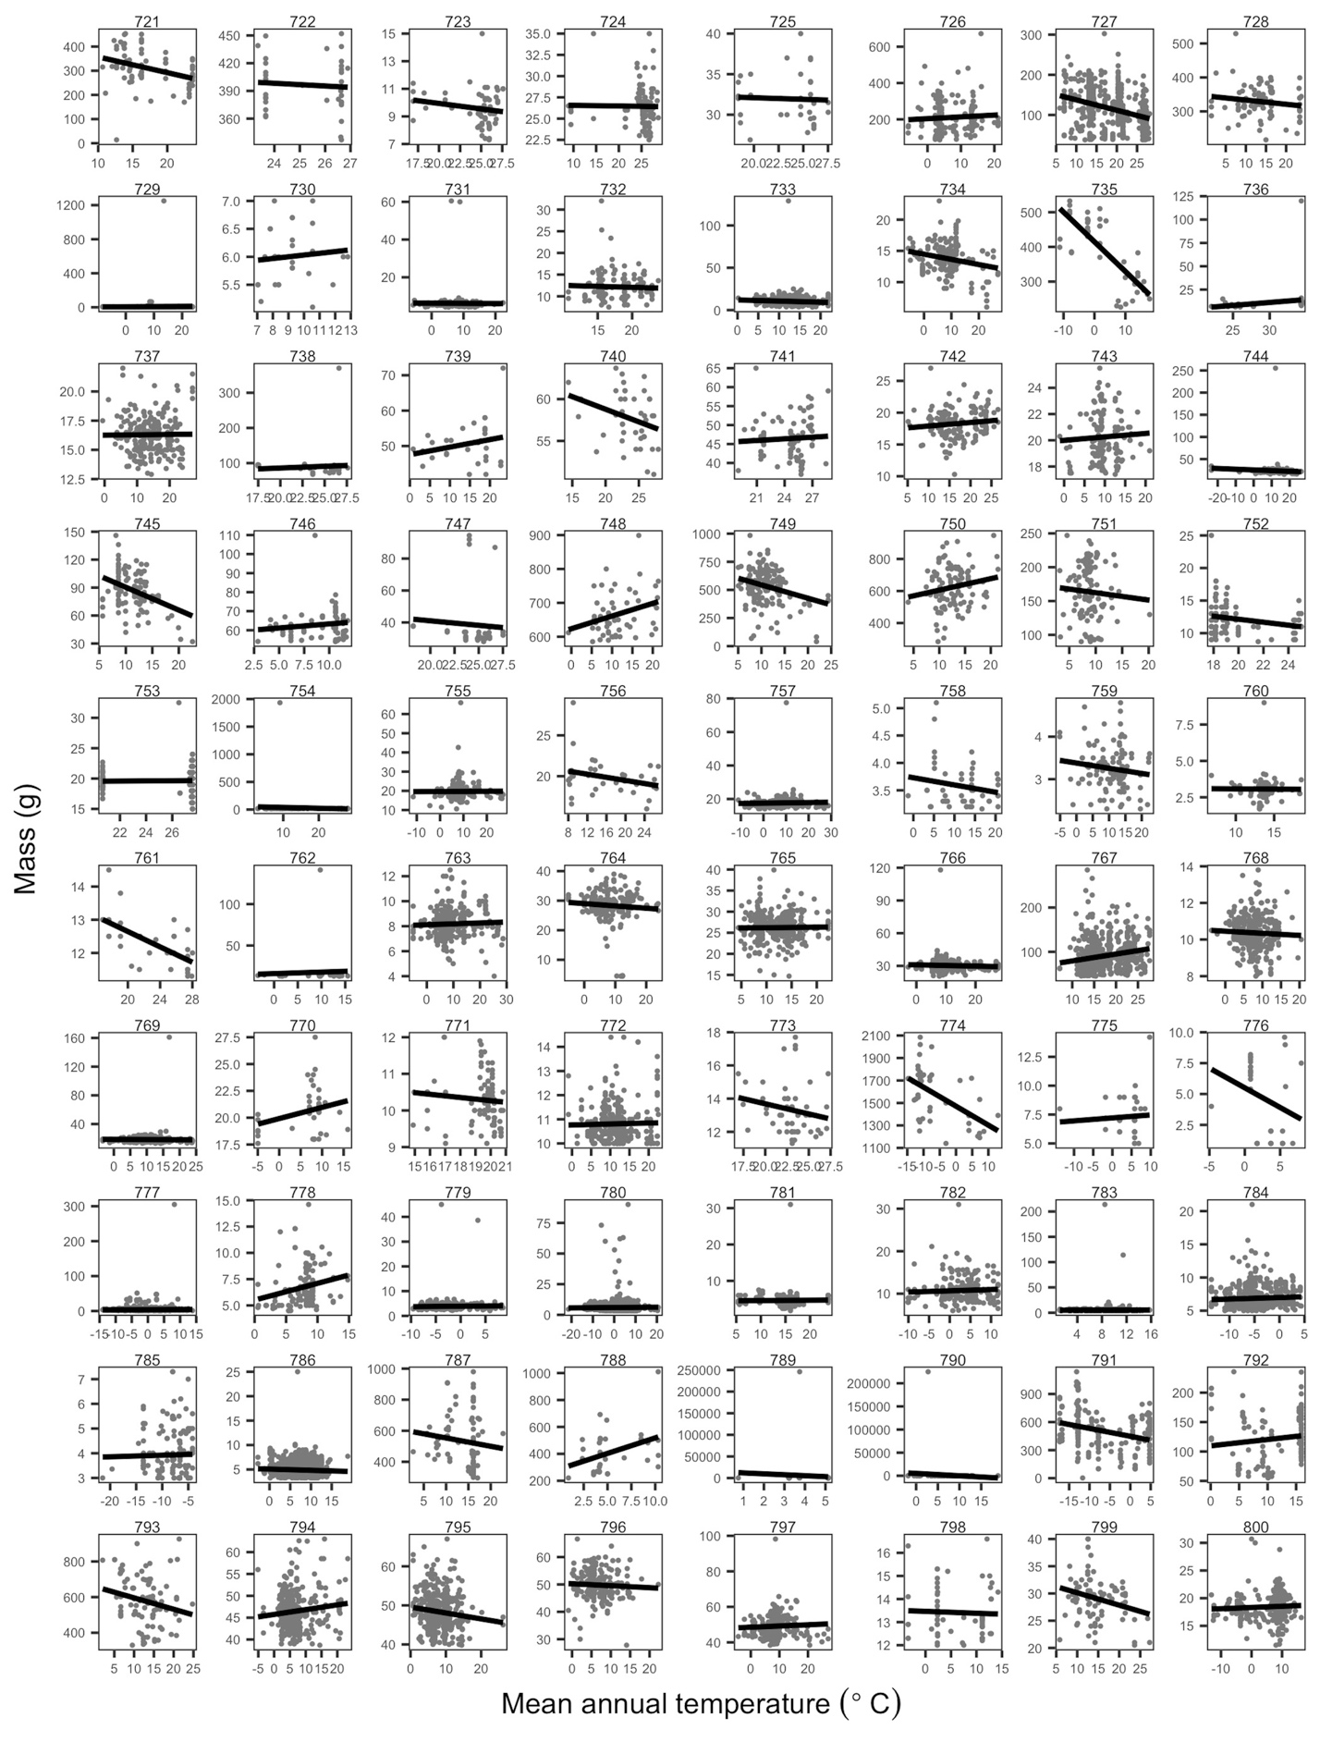

Figure A-19. Species’ temperature-mass relationships. Plots of temperature-mass relationships for 80 of the 952 species. Grey points are individuals and black lines show ordinary least squares linear regression of relationships. Ranges of both mass and temperature axes vary depending on species. Species names with corresponding plot numbers: *(721) Rallus longirostris, (722) Ramphastos sulfuratus, (723) Ramphocaenus melanurus, (724) Ramphocelus carbo, (725) Ramphocelus passerinii, (726) Rattus norvegicus, (727) Rattus rattus, (728) Recurvirostra americana, (729) Regulus calendula, (730) Regulus regulus, (731) Regulus satrapa, (732) Reithrodontomys fulvescens, (733) Reithrodontomys megalotis, (734) Riparia riparia, (735) Rissa tridactyla, (736) Saccopteryx bilineata, (737) Salpinctes obsoletus, (738) Saltator atriceps, (739) Saltator aurantiirostris, (740) Saltator coerulescens, (741) Saltator maximus, (742) Sayornis nigricans, (743) Sayornis phoebe, (744) Sayornis saya, (745) Scalopus aquaticus, (746) Scapanus orarius, (747) Schiffornis turdinus, (748) Sciurus aberti, (749) Sciurus carolinensis, (750) Sciurus niger, (751) Scolopax minor, (752) Scotinomys teguina, (753) Scotophilus kuhlii, (754) Seiurus aurocapilla, (755) Seiurus aurocapillus, (756) Seiurus motacilla, (757) Seiurus noveboracensis, (758) Selasphorus platycercus, (759) Selasphorus rufus, (760) Selasphorus sasin, (761) Serinus mozambicus, (762) Setophaga coronata, (763) Setophaga ruticilla, (764) Sialia currucoides, (765) Sialia mexicana, (766) Sialia sialis, (767) Sigmodon hispidus, (768) Sitta canadensis, (769) Sitta carolinensis, (770) Sitta europaea, (771) Sitta pusilla, (772) Sitta pygmaea, (773) Sittasomus griseicapillus, (774) Somateria spectabilis, (775) Sorex araneus, (776) Sorex arcticus, (777) Sorex cinereus, (778) Sorex fumeus, (779) Sorex hoyi, (780) Sorex monticolus, (781) Sorex ornatus, (782) Sorex palustris, (783) Sorex trowbridgii, (784) Sorex tundrensis, (785) Sorex ugyunak, (786) Sorex vagrans, (787) Spermophilus beecheyi, (788) Spermophilus columbianus, (789) Spermophilus elegans, (790) Spermophilus lateralis, (791) Spermophilus parryii, (792) Spermophilus tridecemlineatus, (793) Spermophilus variegatus, (794) Sphyrapicus nuchalis, (795) Sphyrapicus ruber, (796) Sphyrapicus thyroideus, (797) Sphyrapicus varius, (798) Spinus pinus, (799) Spiza americana, (800) Spizella arborea.*

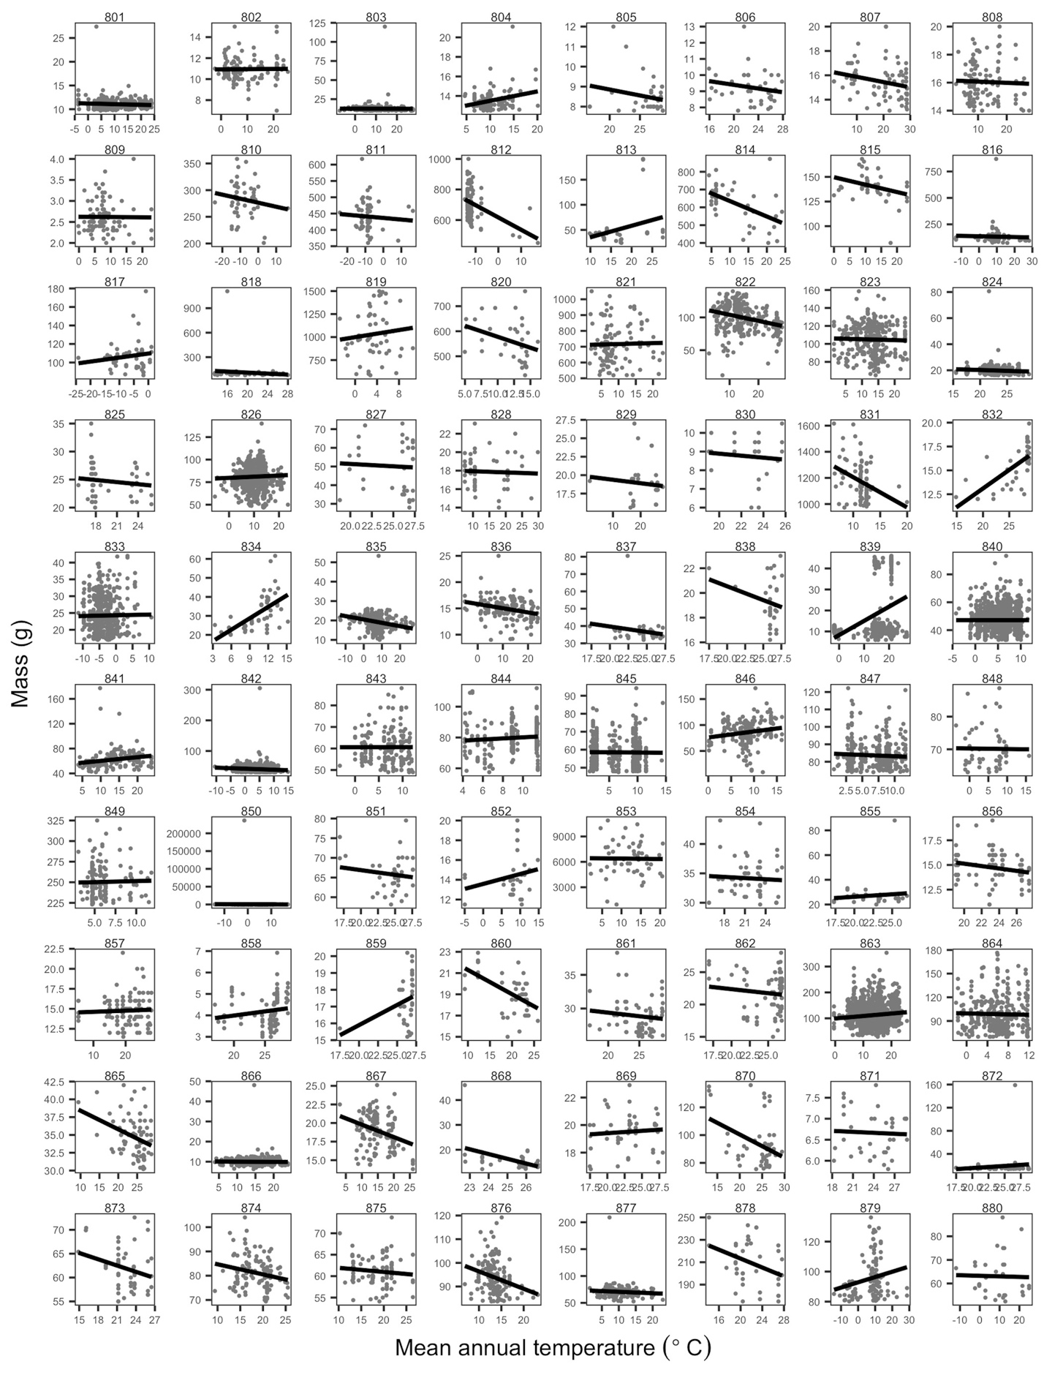

Figure A-20. Species’ temperature-mass relationships. Plots of temperature-mass relationships for 80 of the 952 species. Grey points are individuals and black lines show ordinary least squares linear regression of relationships. Ranges of both mass and temperature axes vary depending on species. Species names with corresponding plot numbers: *(801) Spizella breweri, (802) Spizella pallida, (803) Spizella passerina, (804) Spizella pusilla, (805) Sporophila minuta, (806) Sporophila torqueola, (807) Stelgidopteryx ruficollis, (808) Stelgidopteryx serripennis, (809) Stellula calliope, (810) Stercorarius longicaudus, (811) Stercorarius parasiticus, (812) Stercorarius pomarinus, (813) Sterna antillarum, (814) Sterna caspia, (815) Sterna forsteri, (816) Sterna hirundo, (817) Sterna paradisaea, (818) Streptopelia senegalensis, (819) Strix nebulosa, (820) Strix occidentalis, (821) Strix varia, (822) Sturnella magna, (823) Sturnella neglecta, (824) Sturnira lilium, (825) Sturnira ludovici, (826) Sturnus vulgaris, (827) Suncus murinus, (828) Sylvia atricapilla, (829) Sylvia borin, (830) Sylvietta virens, (831) Sylvilagus floridanus, (832) Synallaxis albescens, (833) Synaptomys borealis, (834) Synaptomys cooperi, (835) Tachycineta bicolor, (836) Tachycineta thalassina, (837) Tachyphonus rufus, (838) Tachyphonus surinamus, (839) Tadarida brasiliensis, (840) Tamias amoenus, (841) Tamias dorsalis, (842) Tamias minimus, (843) Tamias quadrivittatus, (844) Tamias senex, (845) Tamias speciosus, (846) Tamias striatus, (847) Tamias townsendii, (848) Tamias umbrinus, (849) Tamiasciurus douglasii, (850) Tamiasciurus hudsonicus, (851) Taraba major, (852) Tarsiger cyanurus, (853) Taxidea taxus, (854) Tchagra australis, (855) Telophorus sulfureopectus, (856) Terpsiphone rufiventer, (857) Terpsiphone viridis, (858) Thalurania furcata, (859) Thamnomanes caesius, (860) Thamnophilus caerulescens, (861) Thamnophilus doliatus, (862) Thamnophilus punctatus, (863) Thomomys bottae, (864) Thomomys talpoides, (865) Thraupis episcopus, (866) Thryomanes bewickii, (867) Thryothorus ludovicianus, (868) Thryothorus maculipectus, (869) Thryothorus pleurostictus, (870) Tityra semifasciata, (871) Todirostrum cinereum, (872) Tolmomyias sulphurescens, (873) Toxostoma cinereum, (874) Toxostoma curvirostre, (875) Toxostoma lecontei, (876) Toxostoma redivivum, (877) Toxostoma rufum, (878) Treron calva, (879) Tringa flavipes, (880) Tringa glareola.*

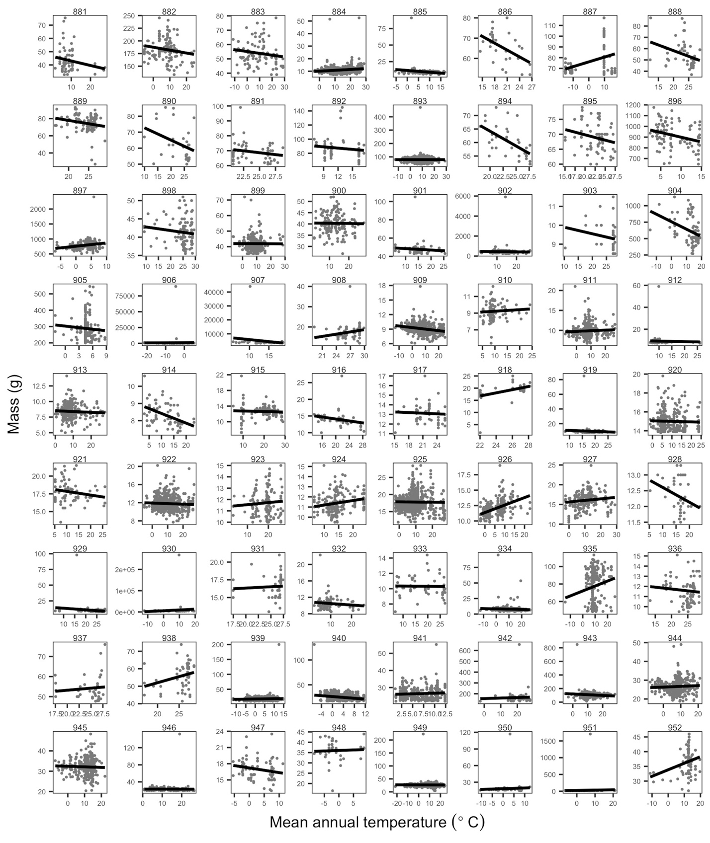

Figure A-21. Species’ temperature-mass relationships. Plots of temperature-mass relationships for 72 of the 952 species. Grey points are individuals and black lines show ordinary least squares linear regression of relationships. Ranges of both mass and temperature axes vary depending on species. Species names with corresponding plot numbers: *(881) Tringa macularia, (882) Tringa melanoleuca, (883) Tringa solitaria, (884) Troglodytes aedon, (885) Troglodytes troglodytes, (886) Trogon collaris, (887) Tryngites subruficollis, (888) Turdus albicollis, (889) Turdus grayi, (890) Turdus ignobilis, (891) Turdus leucomelas, (892) Turdus merula, (893) Turdus migratorius, (894) Turtur chalcospilos, (895) Turtur tympanistria, (896) Tympanuchus cupido, (897) Tympanuchus phasianellus, (898) Tyrannus melancholicus, (899) Tyrannus tyrannus, (900) Tyrannus verticalis, (901) Tyrannus vociferans, (902) Tyto alba, (903) Uraeginthus bengalus, (904) Uria aalge, (905) Urocitellus elegans, (906) Urocitellus parryii, (907) Urocyon cinereoargenteus, (908) Uroderma bilobatum, (909) Vermivora celata, (910) Vermivora chrysoptera, (911) Vermivora peregrina, (912) Vermivora pinus, (913) Vermivora ruficapilla, (914) Vermivora virginiae, (915) Vidua chalybeata, (916) Vidua macroura, (917) Vidua purpurascens, (918) Vireo altiloquus, (919) Vireo bellii, (920) Vireo cassinii, (921) Vireo flavifrons, (922) Vireo gilvus, (923) Vireo griseus, (924) Vireo huttoni, (925) Vireo olivaceus, (926) Vireo philadelphicus, (927) Vireo solitarius, (928) Vireo vicinior, (929) Volatinia jacarina, (930) Vulpes vulpes, (931) Willisornis poecilinotus, (932) Wilsonia canadensis, (933) Wilsonia citrina, (934) Wilsonia pusilla, (935) Xanthocephalus xanthocephalus, (936) Xenops minutus, (937) Xiphorhynchus flavigaster, (938) Xiphorhynchus guttatus, (939) Zapus hudsonius, (940) Zapus princeps, (941) Zapus trinotatus, (942) Zenaida asiatica, (943) Zenaida macroura, (944) Zonotrichia albicollis, (945) Zonotrichia atricapilla, (946) Zonotrichia capensis, (947) Zonotrichia georgiana, (948) Zonotrichia iliaca, (949) Zonotrichia leucophrys, (950) Zonotrichia lincolnii, (951) Zonotrichia melodia, (952) Zonotrichia querula.*

APPENDIX B

SUPPLEMENTAL TABLES AND FIGURES FOR CHAPTER 3

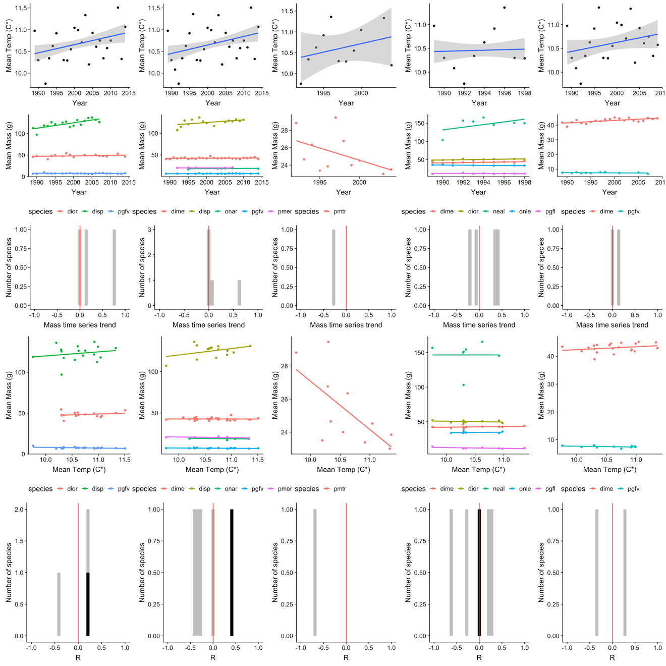

Figure B-1. Trends in mean annual temperature, mean annual mass, and temperature-mass relationships for all species by five Sevilleta subsites.

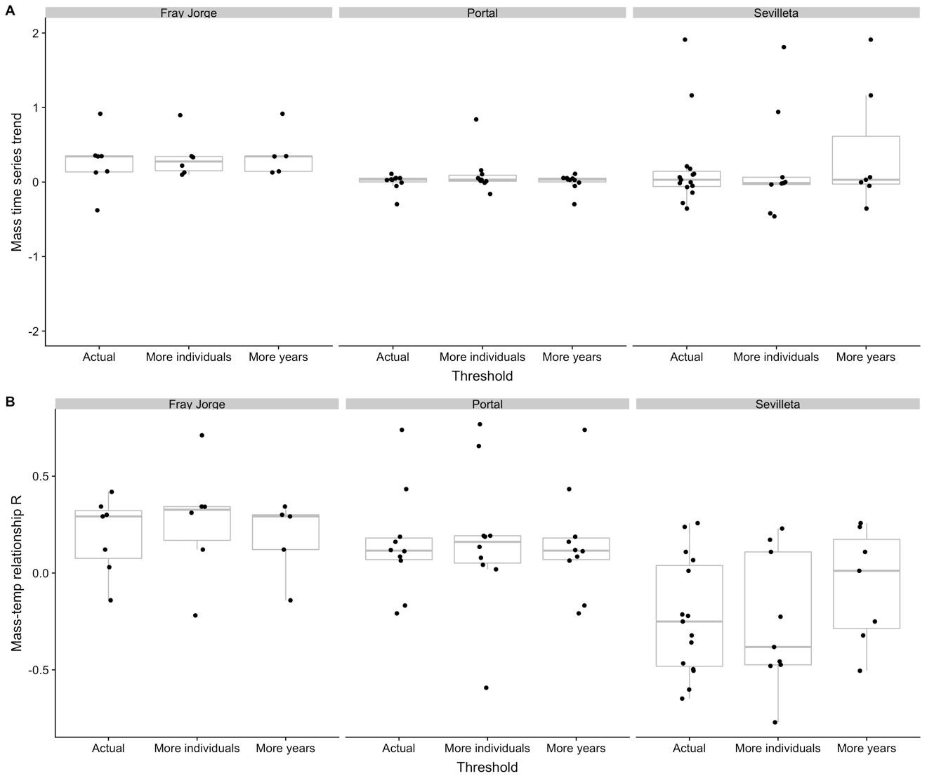

Figure B-2. Trend for mass time series and r value for temperature-mass relationship for each species at each site with actual thresholds for individual records datasets (15 individuals per species per year, 5 years per species) compared to using more individuals (30 individuals per species per year) and more years (10 years per species).

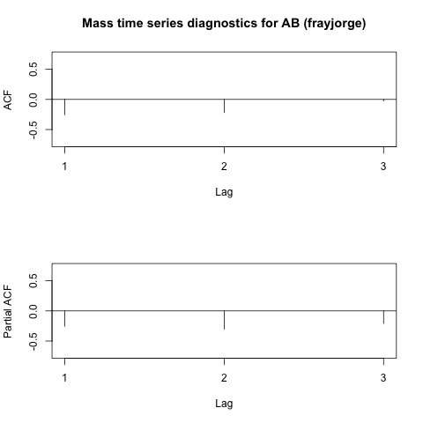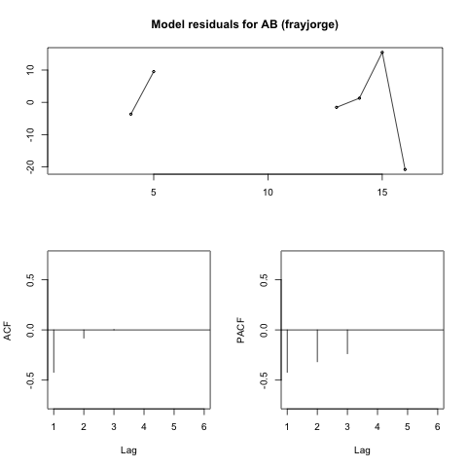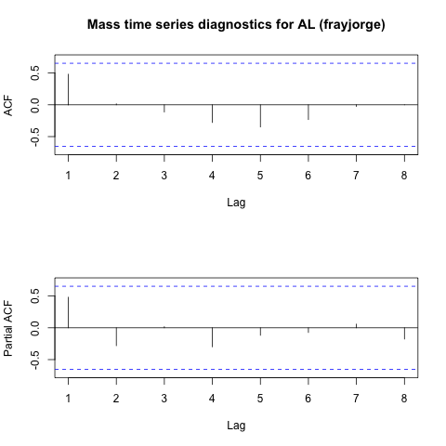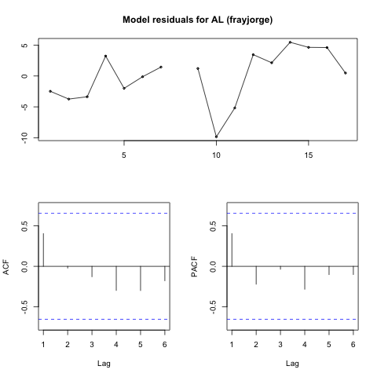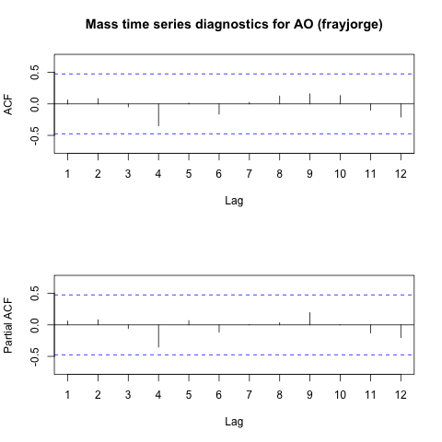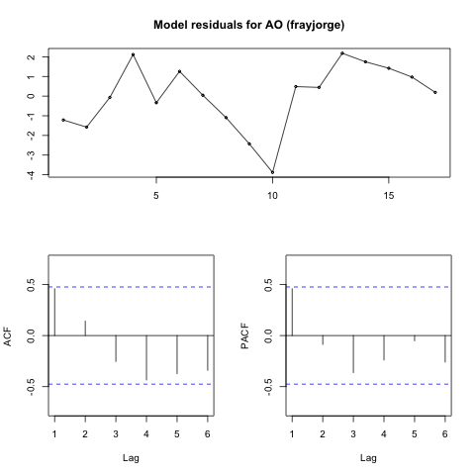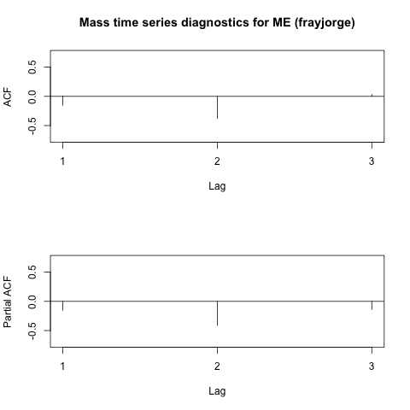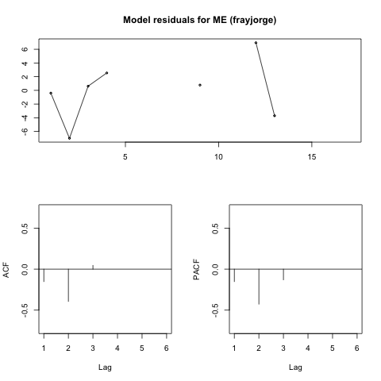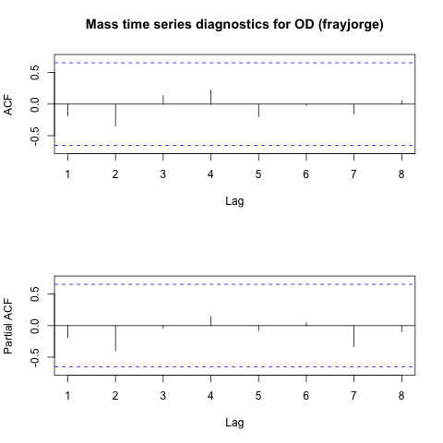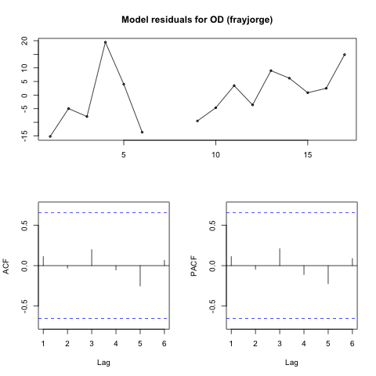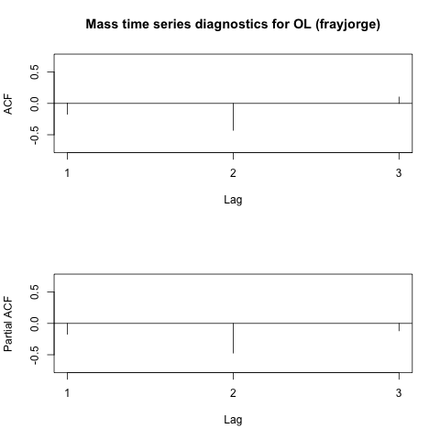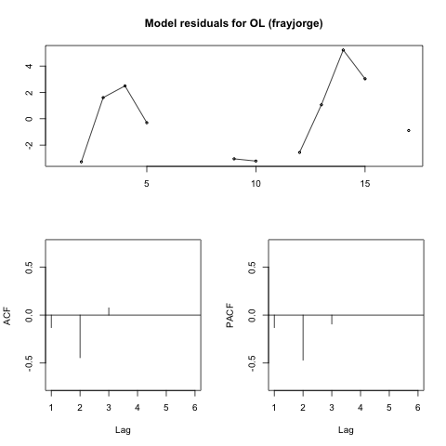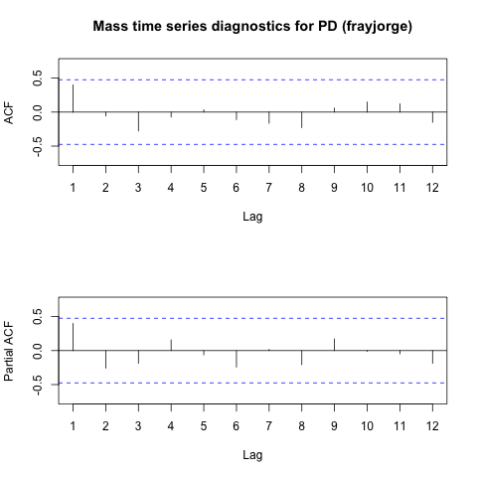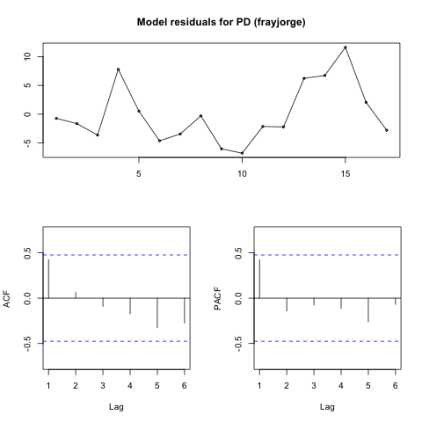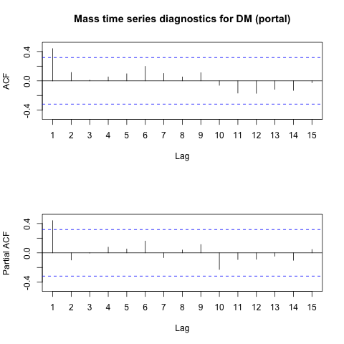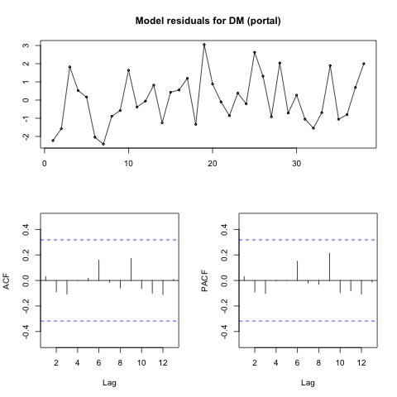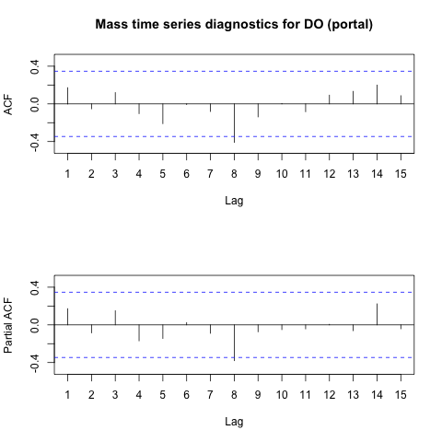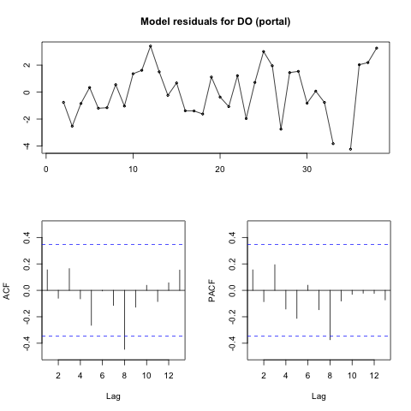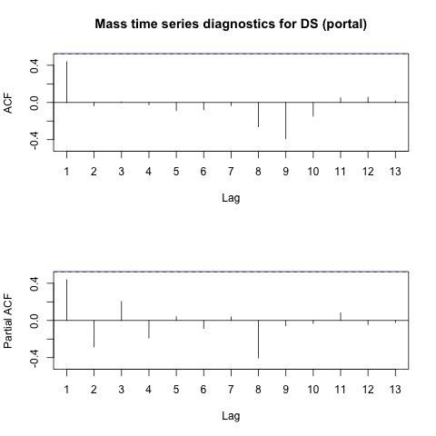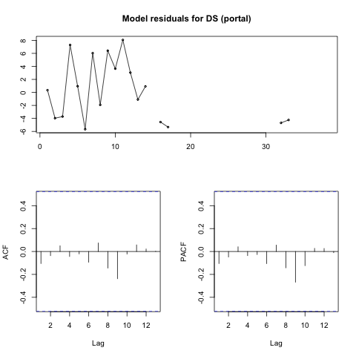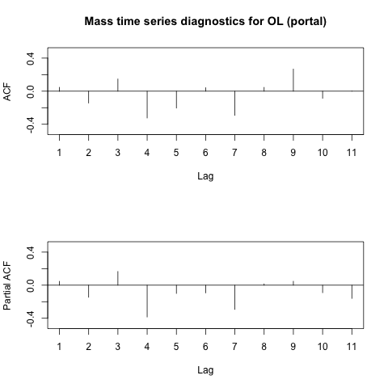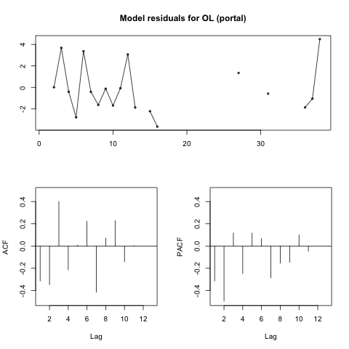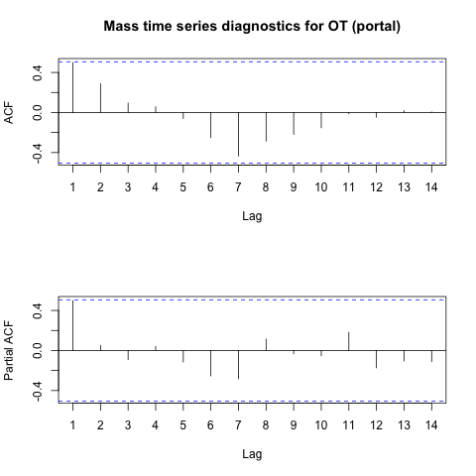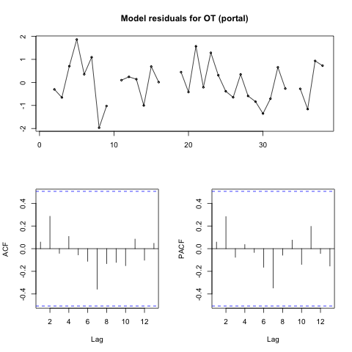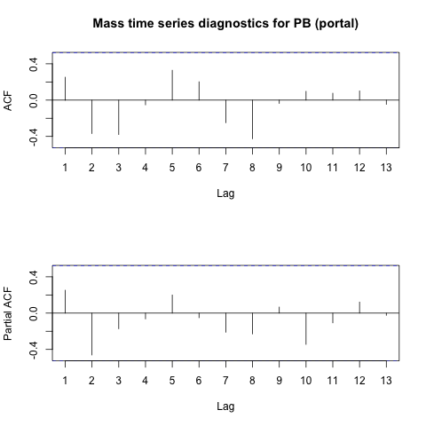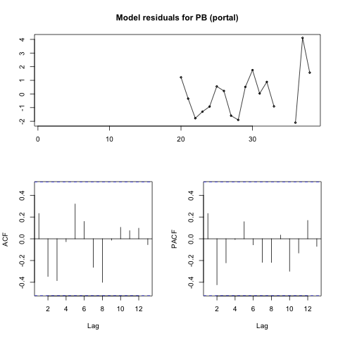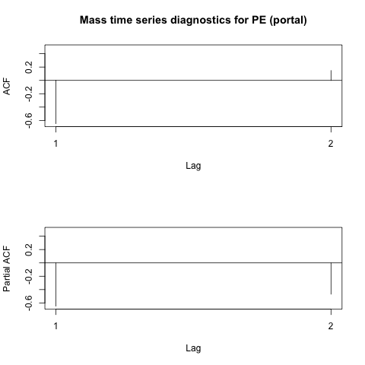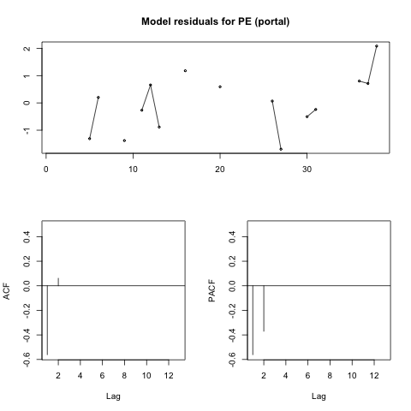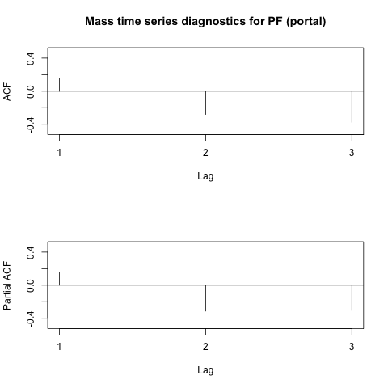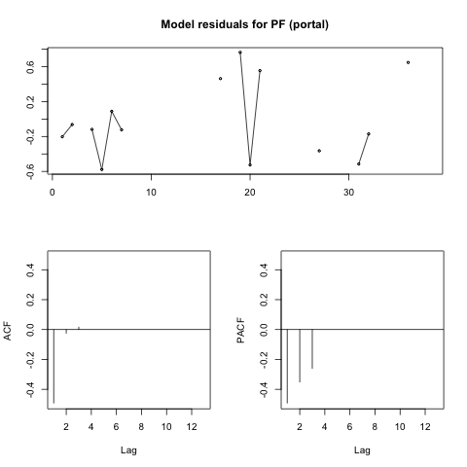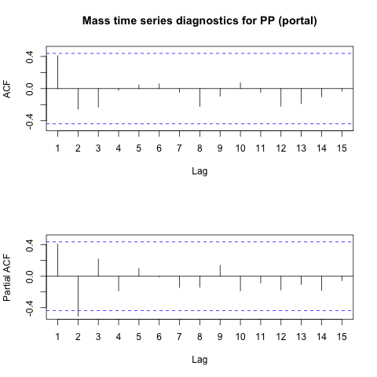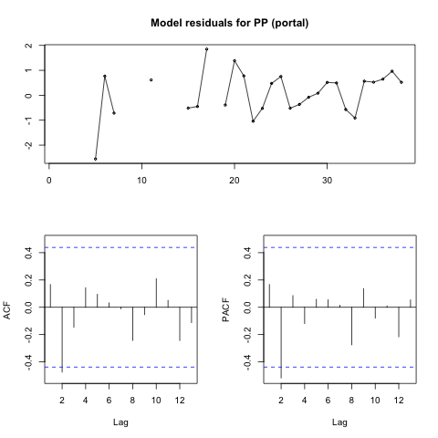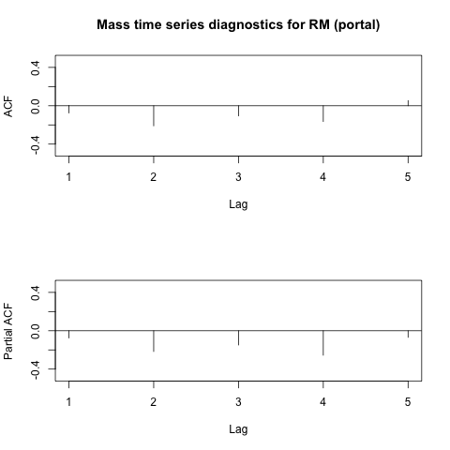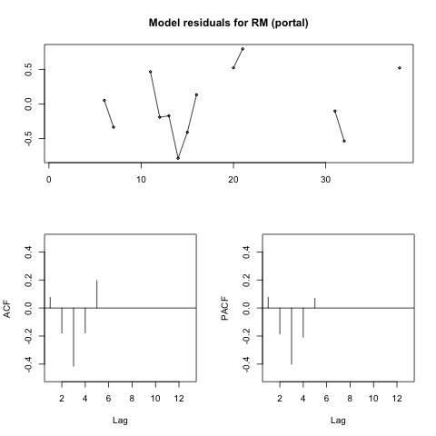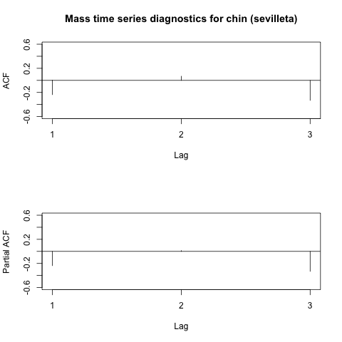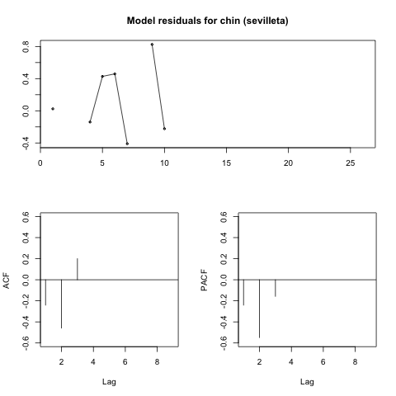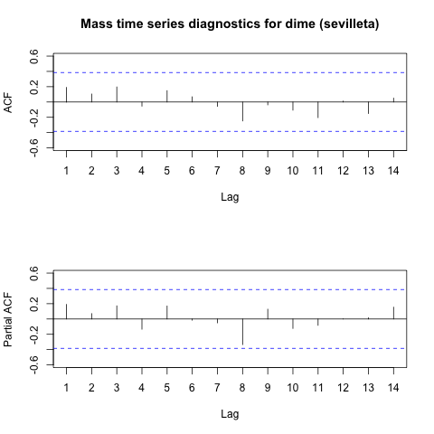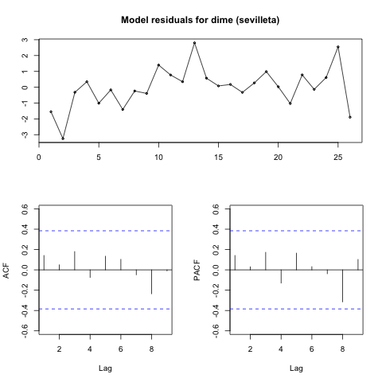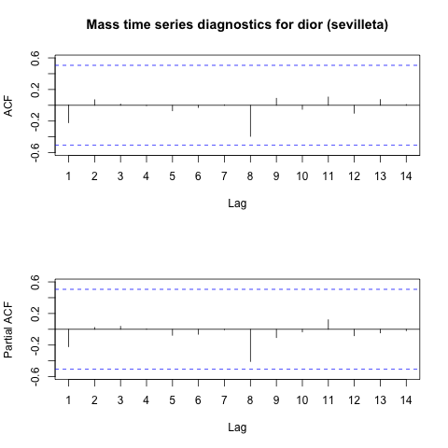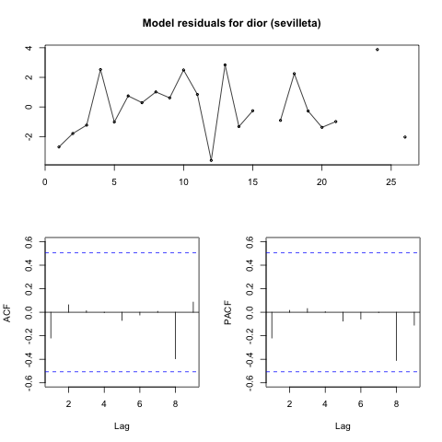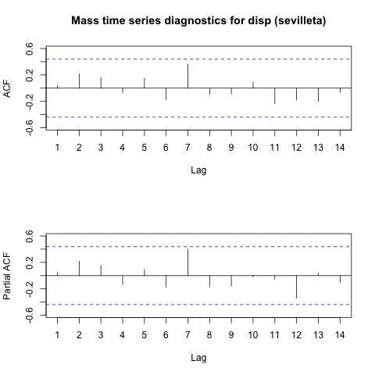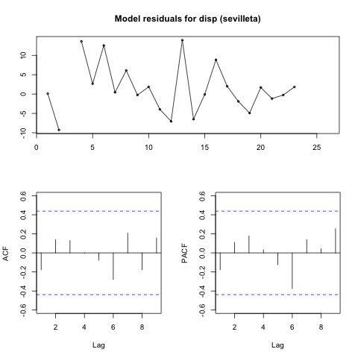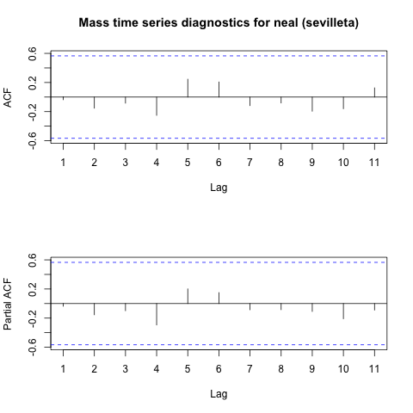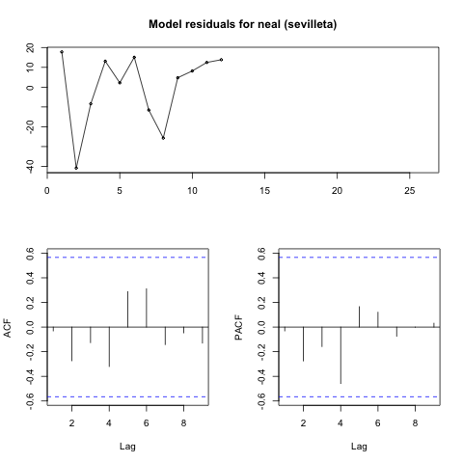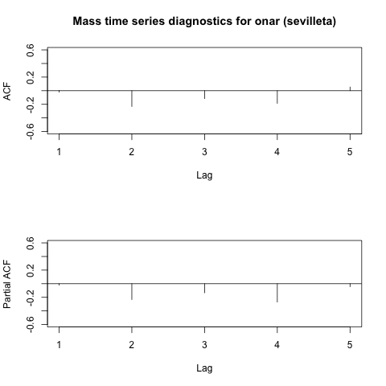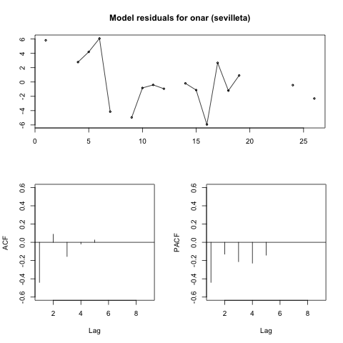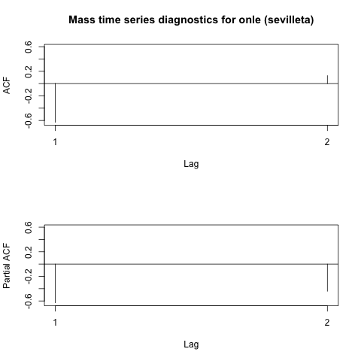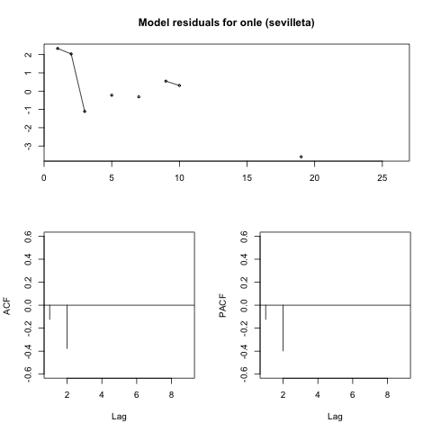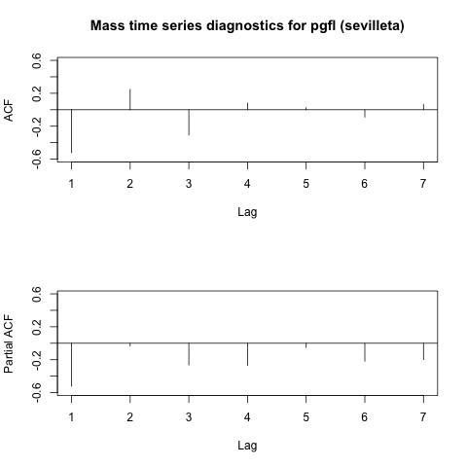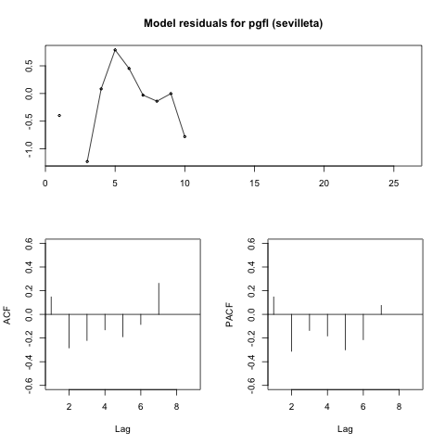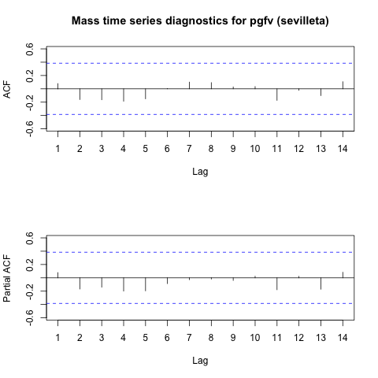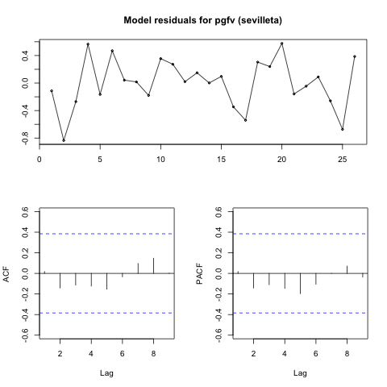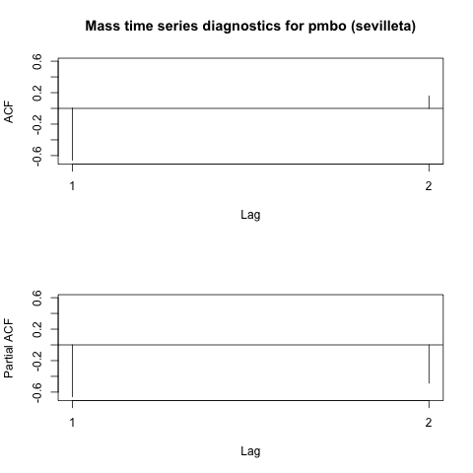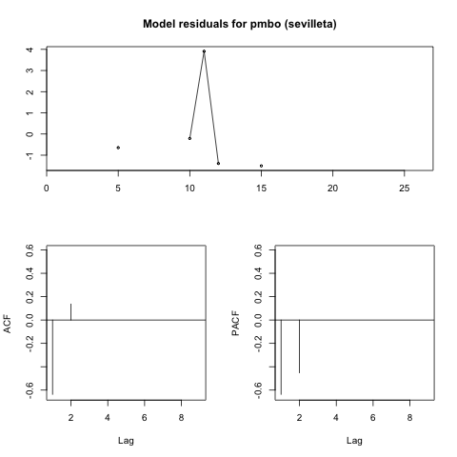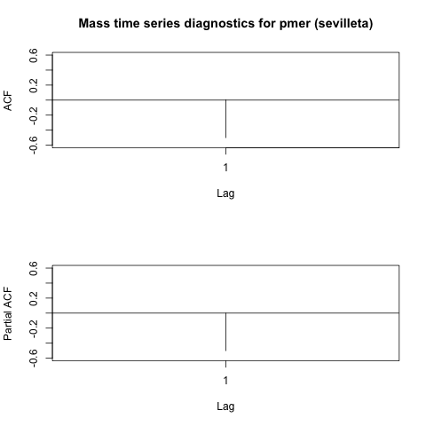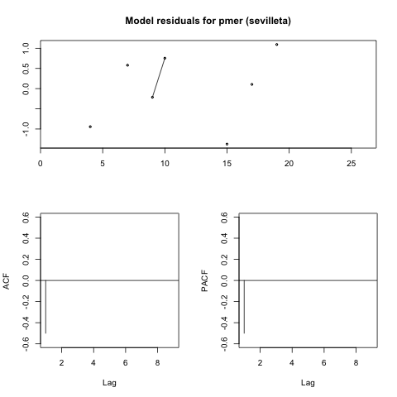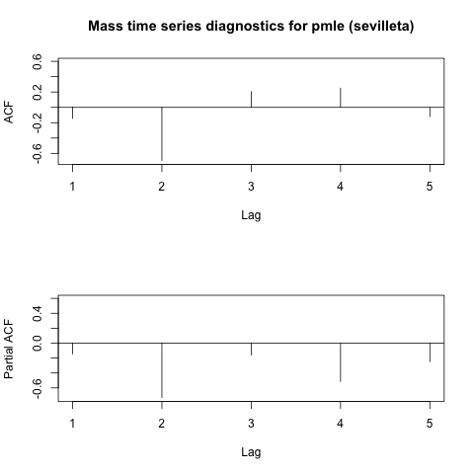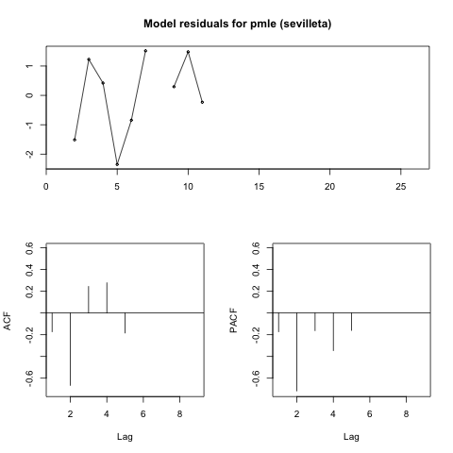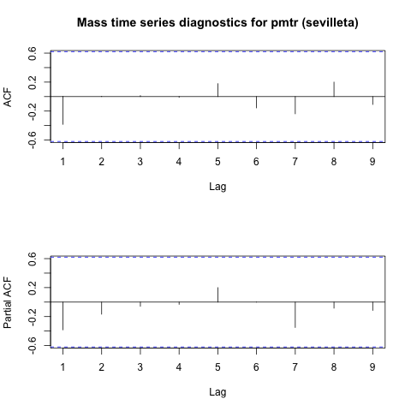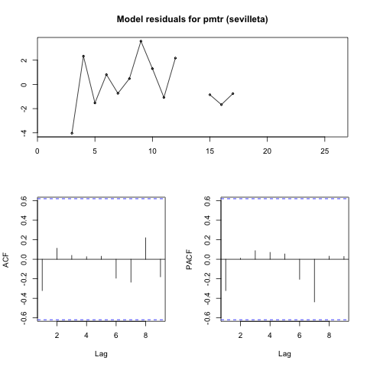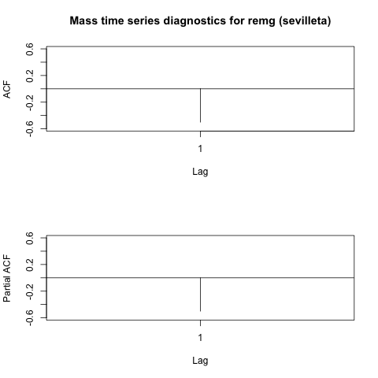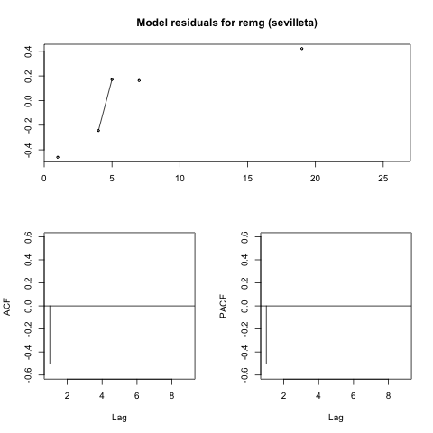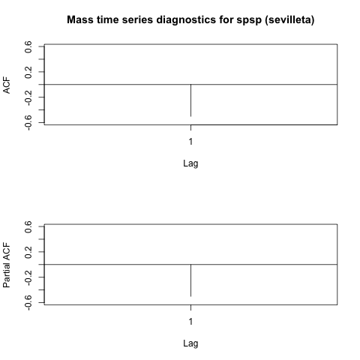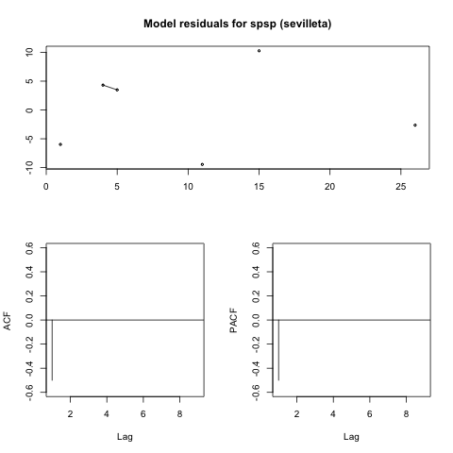

Figure B-3. Plots of autocorrelation and partial autocorrelation functions for each species mass time series and residuals plots for each species dynamic regression model for mass time series including temperature as an exogenous variable.

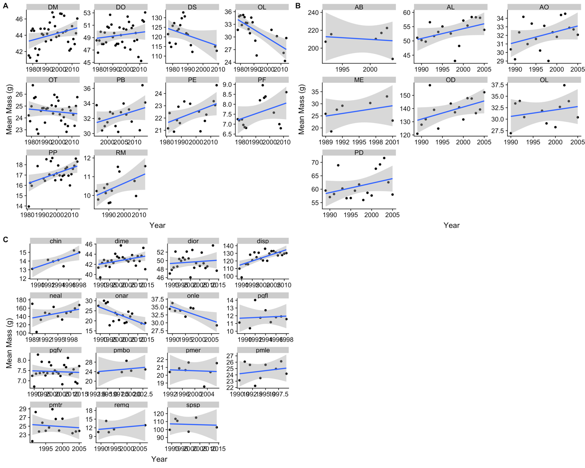

Figure B-4. Each species mean mass by year, including linear regression trend line.

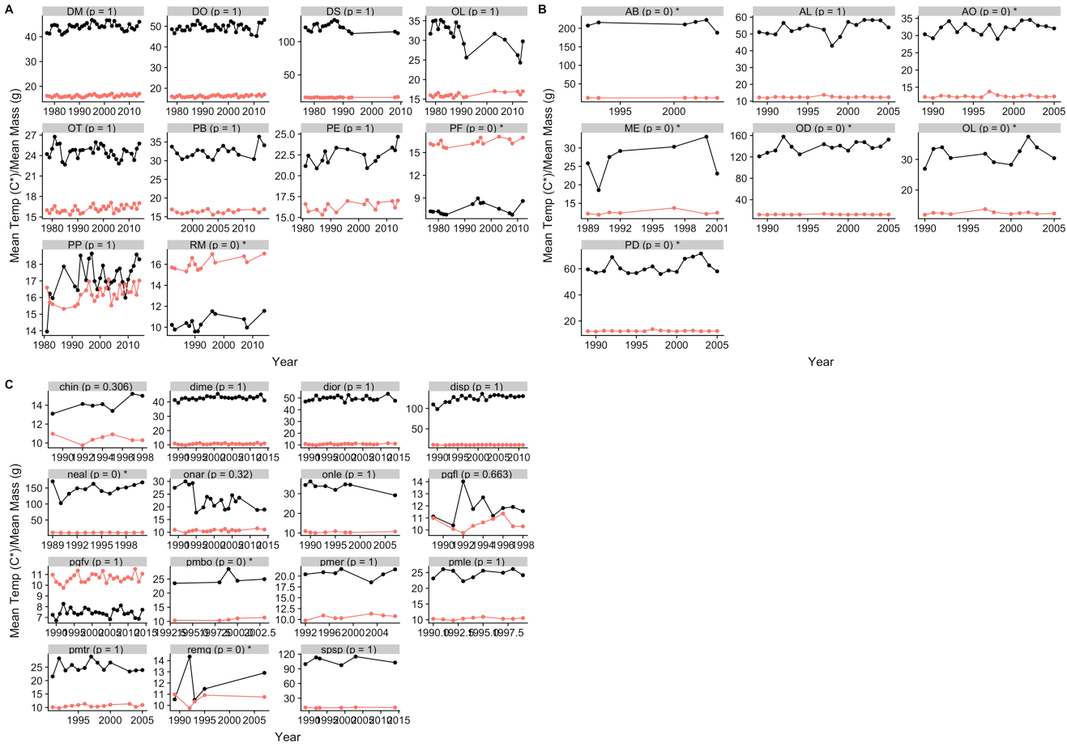

Figure B-5. Comparison of each species mass (black points and lines) with temperature time series (red points and lines), with dynamic regression model p-value shown at top of each plot.

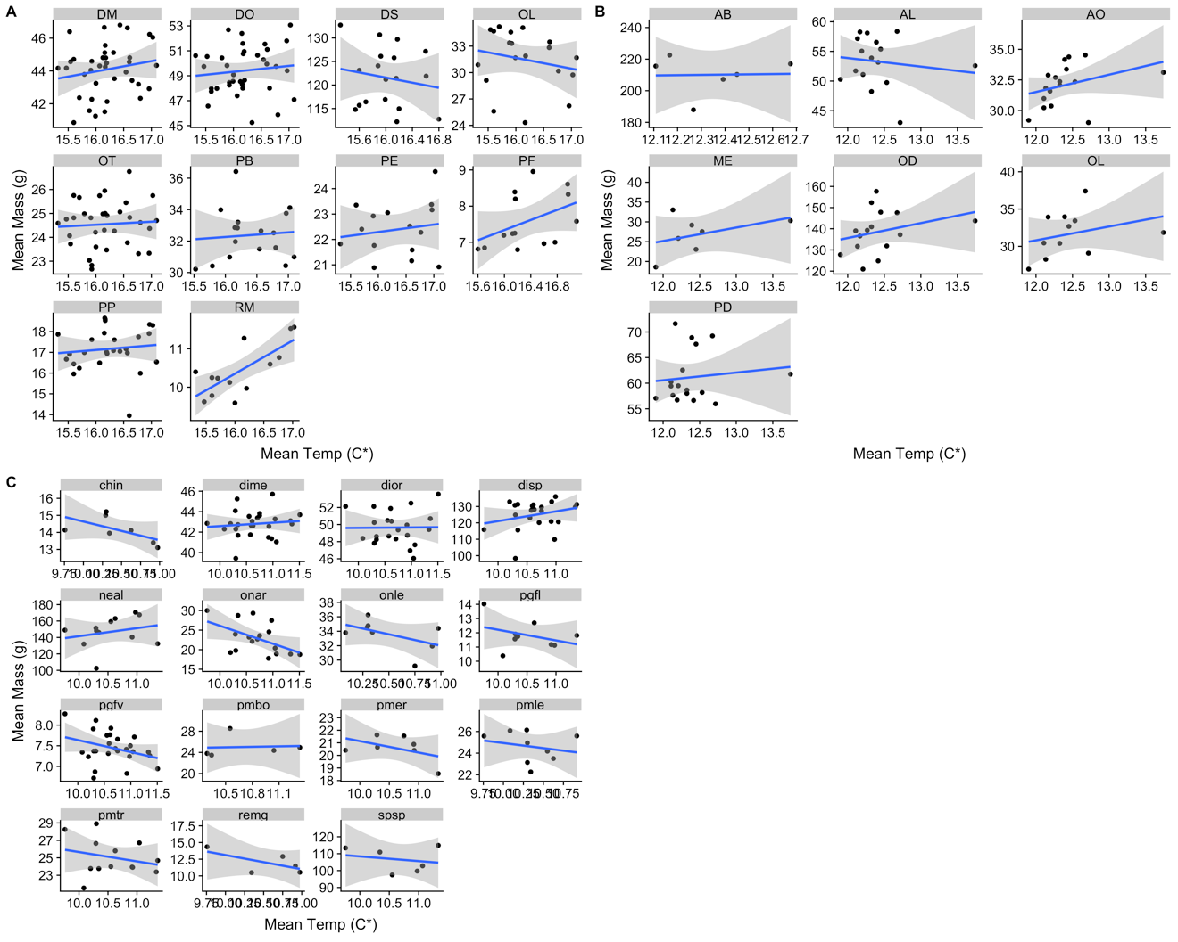

Figure B-6. Relationship between temperature and mass for each species, including linear regression trend line.

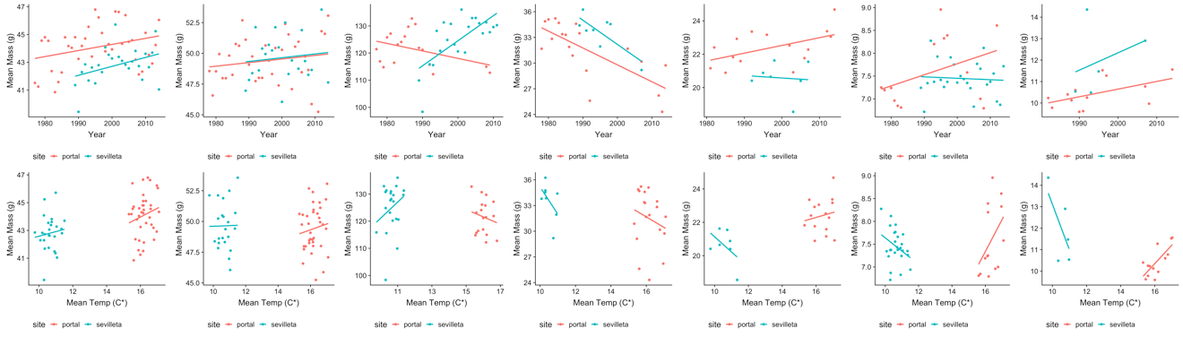

Figure B-7. Comparison of mean annual mass trends and temperature-mass relationship trends for all species that occur at more than one site.

Table B-1. Scientific names for all species with corresponding species codes.

| Individuals | Species |
| --- | --- |
| 128710 | 32 |

| Site | Individuals | Species | Years | Individuals (min) | Individuals (max) | Years (min) | Years (max) |
| --- | --- | --- | --- | --- | --- | --- | --- |
| Fray Jorge | 83670 | 7 | 17 | 15 | 9613 | 6 | 17 |
| Portal | 28293 | 10 | 38 | 15 | 635 | 13 | 38 |
| Sevilleta | 16747 | 15 | 26 | 15 | 706 | 5 | 26 |

APPENDIX C

SUPPLEMENTAL FIGURES FOR CHAPTER 4



Figure C-1. Non-mass size measurements for seven species from four data sources were converted to mass estimates using allometric equations drawn from the literature.



Figure C-2. Comparison to metabolic rates calculated from temperature-specific values of *b* for fishes. Figure corresponds to Actinopterygii panel in Fig. 4, with black points for only class-specific *b* and red points from temperature-specific *b* calculated using equation from Killen et al. (2010) using two experimental pairs (13° & 16°; 13° & 19°) for only species of fish in dataset, *Paralichthys olivaceus*. Magnitude of difference between points unknown due to limited amount data for comparison.



Figure C-3. Process of solving Equation 4-1 for mass.



Figure C-4. Plot of metabolic rate change with varying size residual against (A) the mass associated with the lower temperature of each experimental pair and (B) the lower temperature of each pair, neither of which vary systematically.



Figure C-5. Plots to assess assumptions for linear mixed model, including (A) linearity and homoscedasticity and (B, C) normality.



Figure C-6. Metabolic rate change including empirical size change for all points by taxonomic class, with the same axes as Fig. 4. The black line shows metabolic rate change with constant size (i.e., size does not change with temperature increase), and the linear fit to the points shown in red.

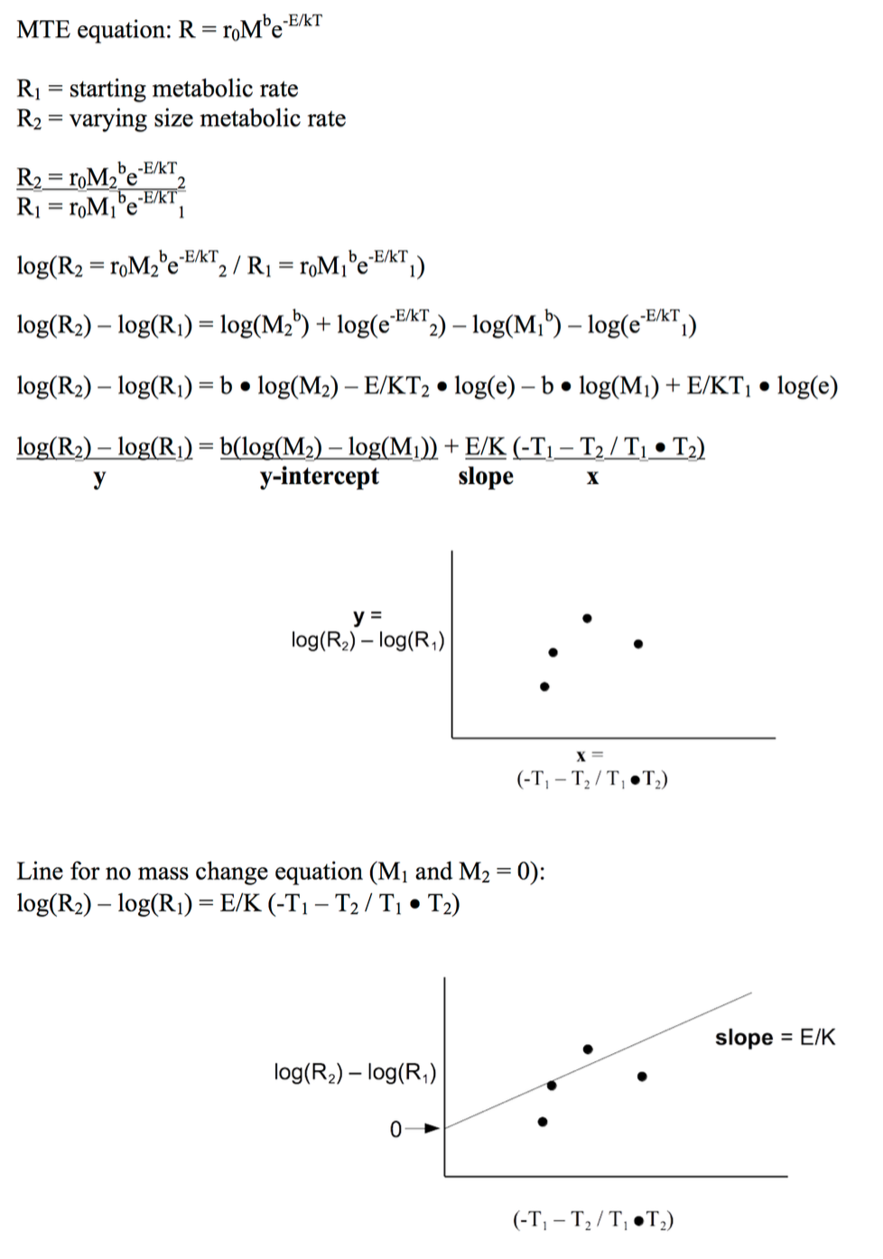

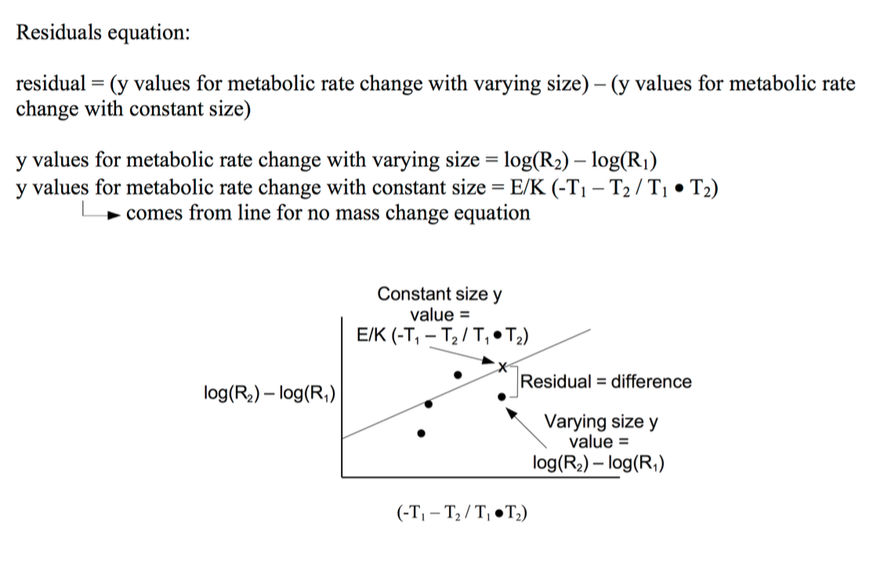

Figure C-7. Solving Equation 4-1 to get x-axis, y-axis, no size change line, and residuals for Figure 4.



Figure C-8. Plot of temperature difference for each pair against temperature axis in Fig. 4, showing this axis mostly varies depending on temperature difference (numerator of axis) and not on temperature product (denominator of axis).

LIST OF REFERENCES

Adams, D.C. & Church, J.O. (2008) Amphibians do not follow Bergmann’s rule. *Evolution*, **62**, 413–420.

Aguilera, L.E., Armas, C., Cea, A.P., Gutiérrez, J.R., Meserve, P.L. & Kelt, D.A. (2016) Rainfall, microhabitat, and small mammals influence the abundance and distribution of soil microorganisms in a Chilean semi-arid shrubland. *Journal of Arid Environments*, **126**, 37–46.

Anderson-Teixeira, K.J., Smith, F.A. & Ernest, S.K.M. (2012) *Climate Change*. *Metabolic Ecology: A Scaling Approach* (ed. by R.M. Sibly), J.H. Brown), and A. Kodric-Brown), pp. 280–292. Wiley-Blackwell, Chichester.

Angilletta, M.J. & Dunham, A.E. (2003) The temperature-size rule in ectotherms: Simple evolutionary explanations may not be general. *American Naturalist*, **162**, 332–342.

Angilletta, M. (2004) Temperature, growth rate, and body size in ectotherms: fitting pieces of a life-history puzzle. *Integrative and Comparative Biology*, **509**, 498–509.

Ashton, K. (2002) Patterns of within‐species body size variation of birds: strong evidence for Bergmann’s rule. *Global Ecology and Biogeography*, **11**, 505–523.

Ashton, K., Tracy, M. & Queiroz, A. De (2000) Is Bergmann’s rule valid for mammals? *The American Naturalist*, **156**, 390–415.

Atkinson, D. (1994) Temperature and organism size: a biological law for ectotherms? *Advances in Ecological Research*, **25**, 1–58.

Baker, R.R. (1969) The Evolution of the Migratory Habit in Butterflies. **38**, 703–746.

Barnett, R.J. (1977) Bergmann ’ s Rule and Variation in Structures Related to Feeding in the Gray Squirrel. *Evolution*, **31**, 538–545.

Bates, D., Maechler, M., Bolker, B. & Walker, S. (2015) Fitting Linear Mixed-Effects Models Using lme4. *Journal of Statistical Software*, **67**, 1–48.

Benajmini, Y. & Hochberg, Y. (1995) Controlling the False Discovery Rate : A Practical and Powerful Approach to Multiple Testing Author ( s ): Yoav Benjamini and Yosef Hochberg Source : Journal of the Royal Statistical Society . Series B ( Methodological ), Vol . 57 , No . 1 Published by : *J R Statist Soc B*, **57**, 289–300.

Bergmann, C. (1847) Ueber die Verhältnisse der Wärmeökonomie der Thiere zu ihrer Grösse. *Gottinger Studien*, **1**, 595–708.

Berven, K.A. (1982) The genetic basis of altitudinal variation in the wood frog Rana sylvatica II. An experimental analysis of larval development. *Oecologia*, **52**, 360–369.

Bickford, D.P., Sheridan, J. a. & Howard, S.D. (2011) Climate change responses: Forgetting frogs, ferns and flies? *Trends in Ecology and Evolution*, **26**, 553–554.

Blackburn, T., Gaston, K. & Loder, N. (1999) Geographic gradients in body size: a clarification of Bergmann’s rule. *Diversity and distributions*, 165–174.

Bloom, D., Wieczorek, J. & Russell, L. (2016) Vertnet_Aves_Sep2016.

Bloom, D., Wieczorek, J. & Russell, L. (2016) Vertnet_Reptilia_Sep2016.

Bloom, D., Wieczorek, J. & Russell, L. (2016) Vertnet_Mammalia_Sep2016.

Bloom, D., Wieczorek, J. & Russell, L. (2016) Vertnet_Amphibia_Sep2016.

Boyer, A.G., Cartron, J.-L.E. & Brown, J.H. (2010) Interspecific pairwise relationships among body size, clutch size and latitude: deconstructing a macroecological triangle in birds. *Journal of Biogeography*, **37**, 47–56.

Brose, U., Dunne, J.A., Montoya, J.M., Petchey, O.L., Schneider, F.D. & Jacob, U. (2012) Climate change in size-structured ecosystems. *Philosophical Transactions of the Royal Society B: Biological Sciences*, **367**, 2903–2912.

Brose, U., Jonsson, T. & Berlow, E. (2006) Consumer–Resource Body-Size Relationships In Natural Food Webs. *Ecology*.

Brown, J.H. & Nicoletto, P.F. (1991) Spatial Scaling of Species Composition: Body Masses of North American Land Mammals. *The American Naturalist*, **138**, 1478–1512.

Brown, J.H., Gillooly, J.F., Allen, A.P., Savage, V.M. & West, G.B. (2004) Toward a metabolic theory of ecology. *Ecology*, **85**, 1771–1789.

Brown, J.H. & Lee, A.K. (1969) Bergmann ’ s Rule and Climatic Adaptation in Woodrats ( Neotoma ). *Evolution*, **23**, 329–338.

Brown, J.H., Sibly, R.M. & Kodric-Brown, A. (2012) *Introduction: Metabolism as the Basis for a Theoretical Unification of Ecology*. *Metabolic Ecology: A Scaling Approach* (ed. by R.M. Sibly), J.H. Brown), and A. Kodric-Brown), pp. 1–6. Wiley-Blackwell, Chichester.

Brust, R.A. (1967) Weight And Development Time Of Different Stadia Of Mosquitoes Reared At Various Constant Temperatures. *The Canadian Entomologist*, **99**, 986–993.

Buckley, L.B., Urban, M.C., Angilletta, M.J., Crozier, L.G., Rissler, L.J. & Sears, M.W. (2010) Can mechanism inform species’ distribution models? *Ecology letters*, **13**, 1041–54.

Buckley, L.B., Nufio, C.R. & Kingsolver, J.G. (2014) Phenotypic clines, energy balances and ecological responses to climate change. *Journal of Animal Ecology*, **83**, 41–50.

Burges, H.D. & Cammell, M.E. (1964) Effect of temperature and humidity on Trogoderma anthrenoides (Sharp)(Coleoptera, Dermestidae) and comparisons with related species. *Bulletin of Entomological Research*, **55**, 313–325.

Burton, T., Killen, S.S., Armstrong, J.D. & Metcalfe, N.B. (2011) What causes intraspecific variation in resting metabolic rate and what are its ecological consequences? *Biological Sciences*, **278**, 3465–3473.

Calder, W.A. (1984) *Size, Function, and Life History*, Harvard University Press, Cambridge, MA.

Canale, C.I., Ozgul, A., Allain??, D. & Cohas, A. (2016) Differential plasticity of size and mass to environmental change in a hibernating mammal. *Global Change Biology*, **22**, 3286–3303.

Carotenuto, F., Diniz-Filho, J.A.F. & Raia, P. (2015) Space and time: The two dimensions of Artiodactyla body mass evolution. *Palaeogeography, Palaeoclimatology, Palaeoecology*, **437**, 18–25.

Caruso, N.M., Sears, M.W., Adams, D.C. & Lips, K.R. (2014) Widespread rapid reductions in body size of adult salamanders in response to climate change. *Global Change Biology*, **20**, 1751–1759.

Chown, S.L., Marais, E., Terblanche, J.S., Klok, C.J., Lighton, J.R.B. & Blackburn, T.M. (2007) Scaling of insect metabolic rate is inconsistent with the nutrient supply network model. *Functional Ecology*, **21**, 282–290.

Clauss, M., Dittmann, M.T., Müller, D.W.H., Meloro, C. & Codron, D. (2013) Bergmann′s rule in mammals: A cross-species interspecific pattern. *Oikos*, **122**, 1465–1472.

Coker, R.E. (1933) Influence of Temperature on Size of Freshwater Copepods (Cyclops). *International Review of Hydrobiology*, **29**, 406–436.

Constable, H., Guralnick, R., Wieczorek, J., Spencer, C., Peterson, A.T., Bart, H., Bates, J., Cotter, G., Hanken, J., Moritz, C., Simmons, N. & Trueb, L. (2010) VertNet: A new model for biodiversity data sharing. *PLoS Biology*, **8**, 1–4.

Dabrowski, K.R. (1986) Active metabolism in larval and juvenile fish: ontogenetic changes, effect of water temperature and fasting. *Fish Physiology and Biochemistry*, **1**, 125–144.

Dayan, T., Tchernov, E., Yom-tov, Y. & Simberloff, D. (1989) Ecological Character Displacement in Saharo-Arabian Vulpes : Outfoxing Bergmann ’ s Rule. *Oikos*, **55**, 263–272.

Dickie, L.M., Kerr, S.R. & P.R., B. (2018) Size-Dependent Processes Underlying Regularities in Ecosystem Structure. **57**, 233–250.

Dillon, M.E., Wang, G. & Huey, R.B. (2010) Global metabolic impacts of recent climate warming. *Nature*, **467**, 704–6.

Dixon, A.F.G., Chambers, R.J. & Dharma, T.R. (1982) Factors Affecting Size In Aphids With Particular Reference To The Black Bean Aphid, Aphis Fabae. *Entomologia Experimentalis et Applicata*, **32**, 123–128.

Ernest, S.K.M., Yenni, G.M., Erica, M., Meiners, J.M., Munger, J., Restrepo, C., Samson, D.A. & Michele, R. (2018) The Portal Project : a long-term study of a Chihuahuan desert ecosystem.

Faurby, S. & Araújo, M.B. (2016) Anthropogenic impacts weaken Bergmann’s rule. *Ecography*, 1–2.

Forster, J., Hirst, A.G. & Atkinson, D. (2012) Warming-induced reductions in body size are greater in aquatic than terrestrial species. *Proceedings of the National Academy of Sciences of the United States of America*, **109**, 19310–4.

Forster, J., Hirst, A.G. & Woodward, G. (2011) Growth and development rates have different thermal responses. *The American Naturalist*, **178**, 668–78.

Forster, J., Hirst, A.G. & Atkinson, D. (2011) How do organisms change size with changing temperature? The importance of reproductive method and ontogenetic timing. *Functional Ecology*, **25**, 1024–1031.

Freckleton, R., Harvey, P. & Pagel, M. (2003) Bergmann’s rule and body size in mammals. *The American Naturalist*, **161**, 821–825.

Fuentes, E.R. & Jaksić, F.M. (1979) Latitudinal Size Variation of Chilean Foxes: Tests of Alternative Hypotheses. *Ecology*, **60**, 43–47.

Fukami, T. & Wardle, D.A. (2005) Long-term ecological dynamics : reciprocal insights from natural and anthropogenic gradients. 2105–2115.

Gardner, J.L., Heinsohn, R. & Joseph, L. (2009) Shifting latitudinal clines in avian body size correlate with global warming in Australian passerines. *Proceedings: Biological Sciences*, **276**, 3845–3852.

Gardner, J.L., Peters, A., Kearney, M.R., Joseph, L. & Heinsohn, R. (2011) Declining body size: a third universal response to warming? *Trends in ecology & evolution*, **26**, 285–91.

Geist, V. (1987) Bergmann’s rule is invalid. *Canadian Journal of Zoology*, 1984–1987.

Gilbert, B., Tunney, T.D., Mccann, K.S., Delong, J.P., Vasseur, D.A., Savage, V., Shurin, J.B., Dell, A.I., Barton, B.T., Harley, C.D.G., Kharouba, H.M., Kratina, P., Blanchard, J.L., Clements, C., Winder, M., Greig, H.S. & O’Connor, M.I. (2014) A bioenergetic framework for the temperature dependence of trophic interactions. *Ecology Letters*, **17**, 902–914.

Gillooly, J.F., Brown, J.H., West, G.B., Savage, V.M. & Charnov, E.L. (2001) Effects of size and temperature on metabolic rate. *Science*, **293**, 2248–51.

Guralnick, R.P., Zermoglio, P.F., Wieczorek, J., LaFrance, R., Bloom, D. & Russell, L. (2016) The importance of digitized biocollections as a source of trait data and a new VertNet resource. *Database: The Journal of Biological Databases and Curation*, 1–13.

Hampton, S.E., Jones, M.B., Wasser, L.A., Schildhauer, M.P., Supp, S.R., Bruno, J., Hernandez, R.R., Boettiger, C., Collins, S.L., Gross, L.J., Fernández, D.S., Budden, A., White, E.P., Teal, T.K., Labou, S. & Aukema, J.E. (2017) Skills and knowledge for data-intensive environmental research. *BioScience*, **67**, 546–557.

Hampton, S.E., Strasser, C. a., Tewksbury, J.J., Gram, W.K., Budden, A.E., Batcheller, A.L., Duke, C.S. & Porter, J.H. (2013) Big data and the future of ecology. *Frontiers in Ecology and the Environment*, **11**, 156–162.

Hoffmann, A., Decher, J., Rovero, F., Schaer, J., Voigt, C. & Wibbelt, G. (2010) Field Methods and Techniques for Monitoring Mammals. *Manual on field recording techniques and protocols for All Taxa Biodiversity Inventories and Monitoring*, **8**, 482–529.

Holt, R.D. (1977) Predation, apparent competition, and the structure of prey communities. *Theoretical Population Biology*, **12**, 197–229.

Husby, A., Hille, S.M. & Visser, M.E. (2011) Testing Mechanisms of Bergmann’s Rule: Phenotypic Decline but No Genetic Change in Body Size in Three Passerine Bird Populations. *The American Naturalist*, **178**, 202–213.

Huston, M.A. & Wolverton, S. (2011) Regulation of animal size by eNPP, Bergmann’s rule, and related phenomena. *Ecological Monographs*, **81**, 349–405.

International, B. (2017) Migratory status of bird species of the world.

Irlich, U.M., Terblanche, J.S., Blackburn, T.M. & Chown, S.L. (2009) Insect rate-temperature relationships: environmental variation and the metabolic theory of ecology. *The American Naturalist*, **174**, 819–835.

James, F.C. (1970) Geographic Size Variation in Birds and Its Relationship to Climate. *Ecology*, **51**, 365–390.

Kelt, D.A., Meserve, P.L., Gutiérrez, J.R., Milstead, W.B. & Previtali, M.A. (2013) Long-term monitoring of mammals in the face of biotic and abiotic influences at a semiarid site in north-central Chile. *Ecology*, **94**, 977.

Kendeigh, S.C. (1969) Tolerance of cold and Bergmann’s rule. *The Auk*, **86**, 13–25.

Killen, S.S., Atkinson, D. & Glazier, D.S. (2010) The intraspecific scaling of metabolic rate with body mass in fishes depends on lifestyle and temperature. *Ecology Letters*, **13**, 184–193.

Kingsolver, J.G. & Huey, R.B. (2008) Size, temperature, and fitness: Three rules. *Evolutionary Ecology Research*, **10**, 251–268.

Kironde, H., D. Morris, B., Goel, A., Zhang, A., Narasimha, A., Negi, S., J. Harris, D., Gertrude Digges, D., Kumar, K., Jain, A., Pal, K., Amipara, K., Simran Singh Baweja, P. & P. White, E. (2017) Retriever: Data Retrieval Tool. *The Journal of Open Source Software*, **2**, 451.

Kitching, R., Scheermeyer, E., Jones, R. & Pierce, N. (1999) *Biology of Australian Butterflies*,.

Kleiber, M. (1932) Body size and metabolism. *Hilgardia*, **6**, 315–351.

Klok, C.J. & Harrison, J.F. (2013) The temperature size rule in arthropods: Independent of macro-environmental variables but size dependent. *Integrative and Comparative Biology*, **53**, 557–570.

Koricheva, J., Gurevitch, J. & Mengersen, K. (2013) *Handbook of meta-analysis in ecology and evolution*,.

Lamb, R.J. & Gerber, G.H. (1985) Effects of temperature on the development, growth, and survival of larvae and pupae of a north-temperate chrysomelid beetle. *Oecologia*, **67**, 8–18.

Langvatn, R. & Albon, S.D. (1986) Geographic Clines in Body-Weight of Norwegian Red Deer - A Novel Explanation of Bergmann Rule. *Holarctic Ecology*, **9**, 285–293.

Lemoine, N.P. & Burkepile, D.E. (2012) Temperature-induced mismatches between consumption and metabolism reduce consumer fitness. *Ecology*, **93**, 2483–2489.

Lock, A.R. & McLaren, I.A. (1970) The Effect Of Varying And Constant Temperatures On The Size Of A Marine Copepod. *Limnology and Oceanography*, **15**, 638–640.

Lomolino, M. V. (2005) Body size evolution in insular vertebrates: Generality of the island rule. *Journal of Biogeography*, **32**, 1683–1699.

Lomolino, M. V. & Perault, D.R. (2007) Body size variation of mammals in a fragmented, temperate rainforest. *Conservation Biology*, **21**, 1059–1069.

Makarieva, A.M., Gorshkov, V.G., Li, B.-L., Chown, S.L., Reich, P.B. & Gavrilov, V.M. (2008) Mean mass-specific metabolic rates are strikingly similar across life’s major domains: Evidence for life’s metabolic optimum. *Proceedings of the National Academy of Sciences of the United States of America*, **105**, 16994–16999.

Marquet, P., Labra, F. & Maurer, B. (2004) Metabolic ecology: linking individuals to ecosystems. *Ecology*, **85**, 1794–1796.

Marti, O.G. & Carpenter, J.E. (2008) Chemical Desilking of *Cactoblastic cactorum* Berg Pupae. *Journal of Entomological Science*, **43**, 344–347.

McIntyre, P.B., Flecker, A.S., Vanni, M.J., Hood, J.M., Taylor, B.W. & Thomas, S.A. (2008) Fish Distributions and Nutrient Cycling in Streams: Can Fish Create Biogeochemical Hotspots? *Ecology*, **89**, 2335–2346.

McKie, B.G. & Cranston, P.S. (2005) Size matters: systematic and ecological implications of allometry in the responses of chironomid midge morphological ratios to experimental temperature manipulations. *Canadian Journal of Zoology*, **83**, 553–568.

McNab, B.K. (2010) Geographic and temporal correlations of mammalian size reconsidered: a resource rule. *Oecologia*, **164**, 13–23.

McNab, B.K. (1971) On the ecological significance of Bergmann’s rule.

McNamara, J.M., Higginson, A.D. & Verhulst, S. (2016) The influence of the starvation-predation trade-off on the relationship between ambient temperature and body size among endotherms. *Journal of Biogeography*, **43**, 809–819.

Meiri, S. (2011) Bergmann’s rule-what’s in a name? *Global Ecology and Biogeography*, **20**, 203–207.

Meiri, S. & Dayan, T. (2003) On the validity of Bergmann’s rule. *Journal of Biogeography*, 331–351.

Meiri, S., Dayan, T. & Simberloff, D. (2004) Carnivores, biases and Bergmann’ s rule. *Biological Journal of the Linnean Society*, **81**, 579–588.

Meiri, S. & Thomas, G.H. (2007) The geography of body size - Challenges of the interspecific approach. *Global Ecology and Biogeography*, **16**, 689–693.

Menge, B.A. (1972) Competition for Food between Two Intertidal Starfish Species and its Effect on Body Size and Feeding. *Ecology*, **53**, 635–644.

Millien, V., Kathleen Lyons, S., Olson, L., Smith, F. a, Wilson, A.B. & Yom-Tov, Y. (2006) Ecotypic variation in the context of global climate change: revisiting the rules. *Ecology letters*, **9**, 853–69.

Morris, B.D. & White, E.P. (2013) The EcoData Retriever: Improving Access to Existing Ecological Data. *PLoS ONE*, **8**, 1–7.

Newsome, S. (2016) Small Mammal Mark-Recapture Population Dynamics at Core Research Sites at the Sevilleta National Wildlife Refuge, New Mexico (1989 - present).

O’Connor, M.P., Kemp, S.J., Agosta, S.J., Hansen, F., Sieg, A.E., Wallace, B.P., McNair, J.N. & Dunham, A.E. (2007) Reconsidering the mechanistic basis of the metabolic theory of ecology. *Oikos*, **116**, 1058–1072.

O’Gorman, E.J., Pichler, D.E., Adams, G., Benstead, J.P., Cohen, H., Craig, N., Cross, W.F., Demars, B.O.L., Friberg, N., Gíslason, G.M., Gudmundsdóttir, R., Hawczak, A., Hood, J.M., Hudson, L.N., Johansson, L., Johansson, M.P., Junker, J.R., Laurila, A., Manson, J.R., Mavromati, E., Nelson, D., Ólafsson, J.S., Perkins, D.M., Petchey, O.L., Plebani, M., Reuman, D.C., Rall, B.C., Stewart, R., Thompson, M.S.A. & Woodward, G. (2012) *Impacts of Warming on the Structure and Functioning of Aquatic Communities: Individual- to Ecosystem-Level Responses*. *Advances in Ecological Research* (ed. by G. Woodward), U. Jacob), and E.J. O’Gorman), pp. 81–176. Elsevier.

O’Connor, M.I., Gilbert, B. & Brown, C.J. (2011) Theoretical Predictions for How Temperature Affects the Dynamics of Interacting Herbivores and Plants. *The American Naturalist*, **178**, 626–638.

Oetken, M., Jagodzinski, L.S., Vogt, C., Jochum, A. & Oehlmann, J. (2009) Combined effects of chemical and temperature stress on *Chironomus riparius* populations with differing genetic variability. *Journal of Environmental Science and Health, Part A*, **44**, 955–962.

Ohlberger, J. (2013) Climate warming and ectotherm body size - from individual physiology to community ecology. *Functional Ecology*, **27**, 991–1001.

Ohlberger, J., Edeline, E., Vøllestad, L.A., Stenseth, N.C. & Claessen, D. (2011) Temperature-Driven Regime Shifts in the Dynamics of Size-Structured Populations. *The American Naturalist*, **177**, 211–223.

Ohlberger, J., Mehner, T., Staaks, G. & Hölker, F. (2012) Intraspecific temperature dependence of the scaling of metabolic rate with body mass in fishes and its ecological implications. *Oikos*, **121**, 245–251.

Olive, P.J.W. (1995) Annual breeding cycles in marine invertebrates and environmental temperature: Probing the proximate and ultimate causes of reproductive synchrony. *Journal of Thermal Biology*, **20**, 79–90.

Parmesan, C. & Yohe, G. (2003) A globally coherent fingerprint of climate change impacts across natural systems. *Nature*, **421**, 37.

Partridge, L. (1994) Evolution and Development of Body Size and Cell Size in Drosophila melanogaster in Response to Temperature. **48**, 1269–1276.

Pauly, D. (1980) On the Interrelationships between Natural Mortality, Growth Parameters, and Mean Environmental Temparature in 175 Fish Stocks. *Journal du Conseil*, **39**, 175–192.

Peters, R.H. (1983) *The Ecological Implications of Body Size*, Cambridge University Press, Cambridge.

Price, C.A., Weitz, J.S., Savage, V.M., Stegen, J., Clarke, A., Coomes, D.A., Dodds, P.S., Etienne, R.S., Kerkhoff, A.J., Mcculloh, K., Niklas, K.J., Olff, H. & Swenson, N.G. (2012) Testing the metabolic theory of ecology. *Ecology Letters*, **15**, 1465–1474.

Rall, B.C., Vucic-Pestic, O., Ehnes, R.B., EmmersoN, M. & Brose, U. (2010) Temperature, predator-prey interaction strength and population stability. *Global Change Biology*, **16**, 2145–2157.

Ray, C. (1960) The application of Bergmann’s and Allen’s rules to the poikilotherms. *Journal of Morphology*, **106**, 85–108.

Rensch, B. (1938) Some problems of geographical variation and species-formation. *Proceedings of the Linnean Society of London*, **150**, 275–278.

Riemer, K., Anderson-teixeira, K.J., Smith, F.A., Harris, D.J. & Ernest, S.K.M. (2018) Body size shifts influence effects of increasing temperatures on ectotherm metabolism. 958–967.

Riemer, K., Guralnick, R.P. & White, E.P. (2018) No general relationship between mass and temperature in endothermic species. *eLife*, **7**, 1–16.

Salewski, V., Hochachka, W.M. & Fiedler, W. (2010) Global warming and Bergmann’s rule: do central European passerines adjust their body size to rising temperatures? *Oecologia*, **162**, 247–260.

Sand, H., Cederlund, G. & Danell, K. (1995) Geographical and latitudinal variation in growth patterns and adult body size of Swedish moose (Alces alces). *Oecologia*, **102**, 433–442.

Schmidt-Nielsen, K. (1984) *Scaling: Why is animal size so important?*, Cambridge University Press, Cambridge.

Seabold, S. & Perktold, J. (2010) Statsmodels: econometric and statistical modeling with Python. *Proceedings of the 9th Python in Science Conference*, 57–61.

Seebacher, F., White, C. & Franklin, C. (2015) Physiological plasticity increases resilience of ectothermic animals to climate change. *Nature Climate Change*, **5**, 61–66.

Sheridan, J.A. & Bickford, D. (2011) Shrinking body size as an ecological response to climate change. *Nature Climate Change*, **1**, 401–406.

Smith, F., Betancourt, J. & Brown, J. (1995) Evolution of body size in the woodrat over the past 25,000 years of climate change. *SCIENCE*.

Smith, F., Browning, H. & Shepherd, U. (1998) The influence of climate change on the body mass of woodrats Neotoma in an arid region of New Mexico, USA. *Ecography*.

Smith, F.A., Boyer, A.G., Brown, J.H., Costa, D.P., Dayan, T., Ernest, S.K.M., Evans, A.R., Fortelius, M., Gittleman, J.L., Hamilton, M.J., Harding, L.E., Lintulaakso, K., Lyons, S.K., McCain, C., Okie, J.G., Saarinen, J.J., Sibly, R.M., Stephens, P.R., Theodor, J. & Uhen, M.D. (2010) The evolution of maximum body size of terrestrial mammals. *Science (New York, N.Y.)*, **330**, 1216–1219.

Stacey, D.A. & Fellowes, M.D.E. (2002) Temperature and the development rates of thrips: Evidence for a constraint on local adaptation? *European Journal of Entomology*, **99**, 399–404.

Steudel, K., Porter, W.P. & Sher, D. (1994) The biophysics of Bergmann’s rule: a comparison of the effects of pelage and body size variation on metabolic rate. *Canadian Journal of Zoology*, **72**, 70–77.

Stillwell, R.C. (2010) Are latitudinal clines in body size adaptive? *Oikos*, **119**, 1387–1390.

Stirling, I. & Derocher, A.E. (2012) Effects of climate warming on polar bears: A review of the evidence. *Global Change Biology*, **18**, 2694–2706.

Sweeney, B.W. & Vannote, R.L. (1978) Size variation and the distribution of hemimetabolous aquatic insects: two thermal equilibrium hypotheses. *Science*, **200**, 444–446.

Team, R.C. (2016) R: A language and environment for statistical computing.

Team, R.C. (2016) R: A Language and Environment for Statistical Computing.

Teplitsky, C. & Millien, V. (2013) Climate warming and Bergmann’s rule through time: is there any evidence? *Evolutionary applications*, **7**, 156–68.

Teplitsky, C., Mills, J. a, Alho, J.S., Yarrall, J.W. & Merilä, J. (2008) Bergmann’s rule and climate change revisited: disentangling environmental and genetic responses in a wild bird population. *Proceedings of the National Academy of Sciences of the United States of America*, **105**, 13492–6.

Van Buskirk, J., Mulvihill, R.S. & Leberman, R.C. (2010) Declining body sizes in North American birds associated with climate change. *Oikos*, **119**, 1047–1055.

van der Have, T.M. & de Jong, G. (1996) Adult Size in Ectotherms: Temperature Effects on Growth and Differentiation. *Journal of Theoretical Biology*, **183**, 329–340.

Vannote, R.L. & Sweeney, B.W. (1980) Geographic Analysis of Thermal Equilibria: A Conceptual Model for Evaluating the Effect of Natural and Modified Thermal Regimes on Aquatic Insect Communities. *The American Naturalist*, **115**, 667–695.

Vasseur, D. & McCann, K. (2005) A Mechanistic Approach for Modeling Temperature‐Dependent Consumer‐Resource Dynamics. *The American Naturalist*, **166**, 184–198.

Voorhies, W. Van (1996) Bergmann Size Clines : A Simple Explanation for Their Occurrence in Ectotherms. *Evolution*, **50**, 1259–1264.

Walters, R.J. & Hassall, M. (2006) The Temperature-Size Rule in ectotherms: May a general explanation exist after all? *The American Naturalist*, **167**, 510–523.

Watt, C., Mitchell, S. & Salewski, V. (2010) Bergmann’s rule; a concept cluster? *Oikos*, **119**, 89–100.

West, G.B., Brown, J.H. & Enquist, B.J. (1997) A general model for the origin of allometric scaling laws in biology. *Science*, **276**, 122–6.

White, C.R., Frappell, P.B. & Chown, S.L. (2012) An information-theoretic approach to evaluating the size and temperature dependence of metabolic rate. *Proceedings of the Royal Society B: Biological Sciences*, **279**, 3616–21.

Whiteley, N. & Faulkner, L.S. (2005) Temperature influences whole-animal rates of metabolism but not protein synthesis in a temperate intertidal isopod. *Physiological and biochemical zoology : PBZ*, **78**, 227–238.

Wieczorek, J., Bloom, D., Guralnick, R., Blum, S., Döring, M., Giovanni, R., Robertson, T. & Vieglais, D. (2012) Darwin Core: An Evolving Community-Developed Biodiversity Data Standard. *PLoS ONE*, **7**, e29715.

Willmott, C.J. & Matsuura, K. (2001) Terrestrial Air Temperature and Precipitation: Monthly and Annual Time Series (1950-1999).

Winker, K. (2000) Obtaining, Preserving, and Preparing Bird Specimens. *Journal of Field Ornithology*, **71**, 250–297.

Winter, B. (2013) Linear models and linear mixed effects models in R with linguistic applications. *arXiv:1308.5499*.

Wolkovich, E.M., Cook, B.I., Allen, J.M., Crimmins, T.M., Betancourt, J.L., Travers, S.E., Pau, S., Regetz, J., Davies, T.J., Kraft, N.J.B., Ault, T.R., Bolmgren, K., Mazer, S.J., McCabe, G.J., McGill, B.J., Parmesan, C., Salamin, N., Schwartz, M.D. & Cleland, E.E. (2012) Warming experiments underpredict plant phenological responses to climate change. *Nature*, **485**, 494–7.

Woodward, G., Ebenman, B., Emmerson, M., Montoya, J.M., Olesen, J.M., Valido, A. & Warren, P.H. (2005) Body size in ecological networks. *Trends in Ecology and Evolution*, **20**, 402–9.

Yom-Tov, Y. & Geffen, E. (2006) Geographic variation in body size: The effects of ambient temperature and precipitation. *Oecologia*, **148**, 213–218.

Yom-Tov, Y. & Geffen, E. (2011) Recent spatial and temporal changes in body size of terrestrial vertebrates: Probable causes and pitfalls. *Biological Reviews*, **86**, 531–541.

Yvon-Durocher, G. & Allen, A.P. (2012) Linking community size structure and ecosystem functioning using metabolic theory. *Philosophical Transactions of the Royal Society B: Biological Sciences*, **367**, 2998–3007.

Zuo, W., Moses, M.E., West, G.B., Hou, C. & Brown, J.H. (2012) A general model for effects of temperature on ectotherm ontogenetic growth and development. *Proceedings of the Royal Society B: Biological Sciences*, **279**, 1840–1846.

BIOGRAPHICAL SKETCH

Kristina Riemer graduated with a Bachelor of Arts in biology from Lawrence University in 2012. After doing research on fish behavior as an intern at Oak Ridge National Laboratory, she started her doctoral work at Utah State University in 2013 with advisor Dr. Ethan White. In 2015, she transferred to University of Florida and completed her PhD with the same advisor. She began working as a scientific programmer at the University of Arizona in January 2019.

1. * This chapter is reprinted with permission from Riemer K, Guralnick RP, White EP. 2018. No general relationship between mass and temperature in endothermic species. 7:1-16. doi: 10.7554/eLife.27166
2. * This chapter is reprinted with permission from Riemer K, Anderson-Teixeira KJ, Smith FA, Harris DJ, Ernest SKM. Body size shifts influence effects of increasing temperatures on ectotherm metabolism. *Global Ecol Biogeogr*. 2018; 27:958-967. https://doi.org/10.1111/geb.12757